Azure Bootcamp

App Dev

Guide

2017/18

© 2017 Microsoft Corporation. All rights reserved. This document is confidential and proprietary to Microsoft. Internal use only. This document is for informational purposes only. MICROSOFT MAKES NO WARRANTIES, EXPRESS OR IMPLIED, IN THIS SUMMARY.

This document is provided "as-is." Information and views expressed in this document, including URL and other Internet Web site references, may change without notice. You bear the risk of using it.

Some examples are for illustration only and are fictitious. No real association is intended or inferred.

# Agile continuous delivery hackathon leader guide

## Background

Supplied in the lab is a set of jobs collected from a NYC web site that are stored in Azure Search. By search in the site, the user can then select one job advertisement and then click on apply button to apply for the job. The web site will send a REST call to API Management that will forward the request to the API app that hosts the REST API. The API app will put the application on a Service Bus queue for further processing. In this way the API App can continue to serve more requests instead of waiting for CosmosDB to store the data. The Azure Function triggers on an incoming message on the Service Bus queue (no polling) and retrieves the message from the Service Bus queue and saves the data in the CosmosDB.

## Architecture

The goal of the exercise is to create the following architecture:

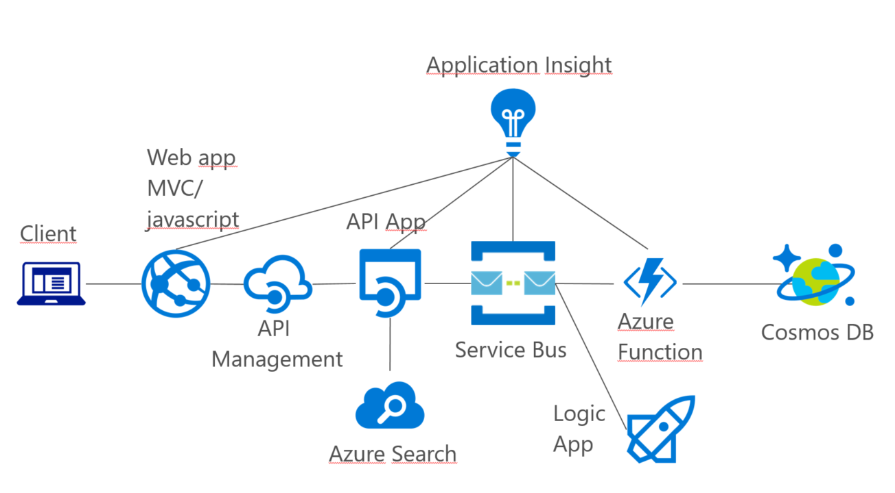

## Azure

## Exercise 1: Development Environment setup

### Overview

In this lab, you will create a developer environment and download the required files for this course if you do not already have one that meets the requirements.

#### Task 1: Configure a development environment

The development environment is made of an Azure Image that you deploy in your subscription.

1. Open the Azure portal and click on the ‘+’ sign in the left corner and type in “Storage account”

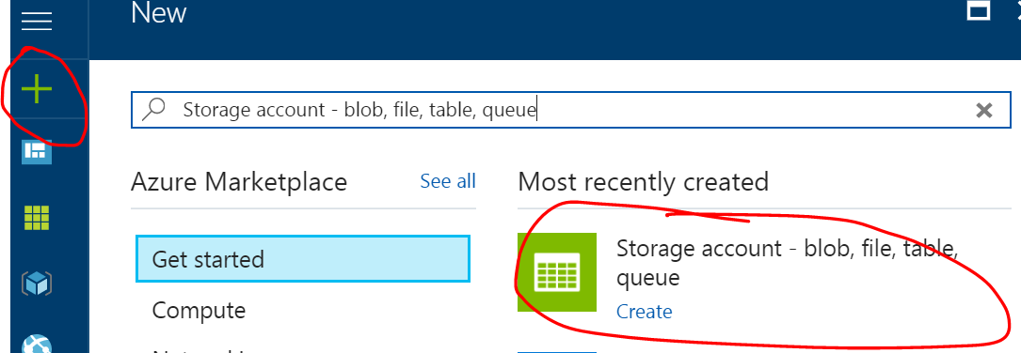

1. Give it a name and use the “General Purpose” account kind and put it in a new resource group called **MyHackatonVM**. Make sure to select **Premium disk** which makes the copy sequence faster.

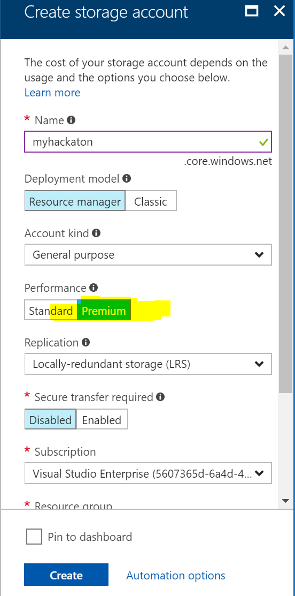

1. Wait for the storage account to be created and then create a **container** called **vhd** in the storage account by first clicking on the “Blobs”

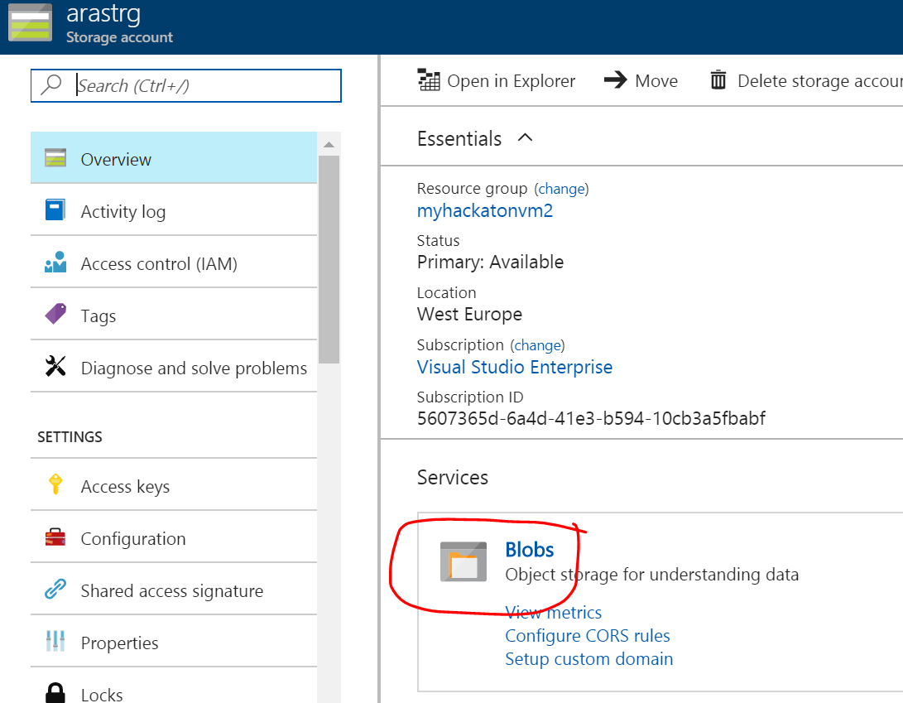

1. Then create the container:

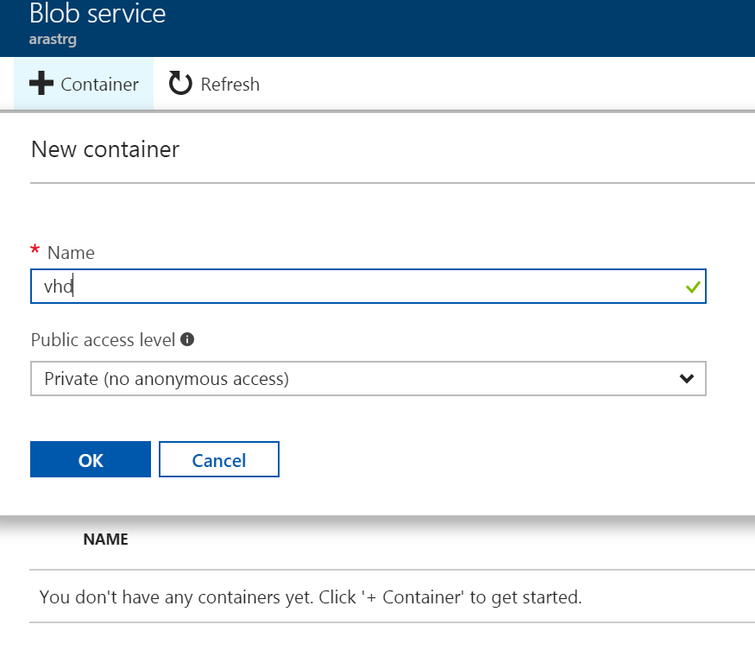

1. Gather some information:

* **<account name>** = the name of the storage created above, in the example above “myhackaton”
* **<account key>** = the secrect key of you account se point 6 below.
* **<Subscription Id or Name>** = You can find this in the portal see picture below:

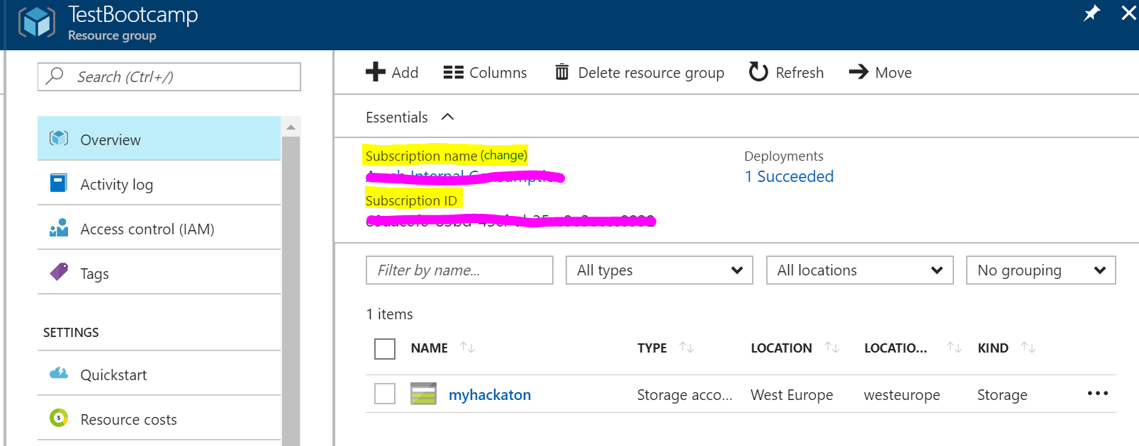

* **<Resource group name>** = Created in step 6 below

1. Get the account key for the storage account:

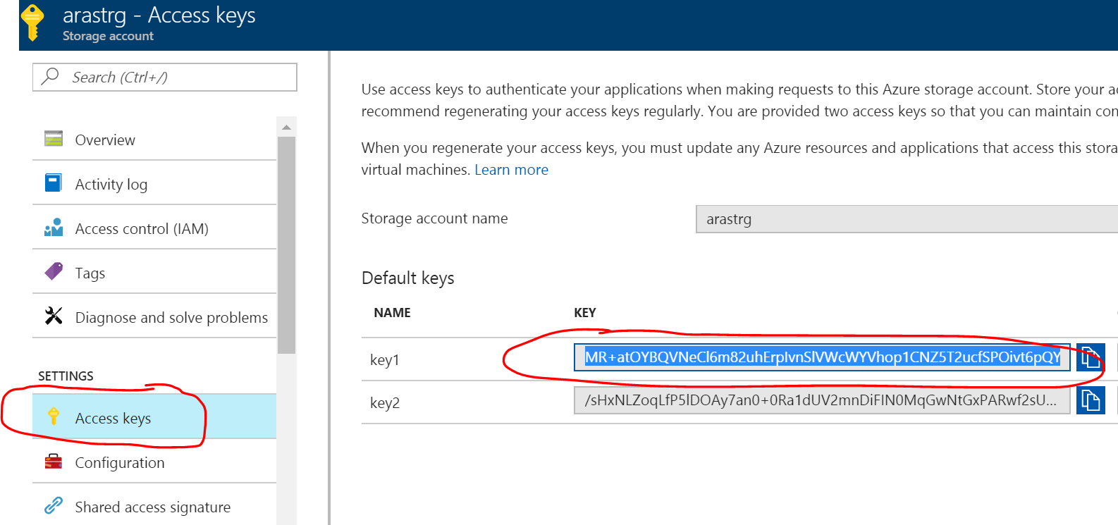

1. Click on the icon below to open a Bash shell within the portal:

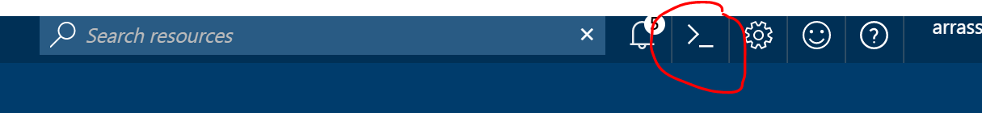

1. Type in: >**azure account set “<name or Id of your subscription>”**

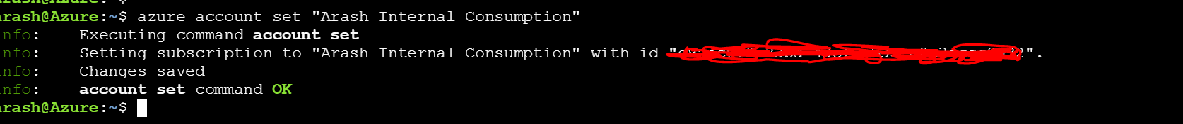

1. Then copy and run – remember to replace the bold:

>**az storage blob copy start** --destination-blob hackaton.vhd --destination-container vhd --account-key **<your account key>** --account-name **<your account name>** --source-account-key YtLwVf8GyRuTjzbBOG6dDauR75C5SwdAp8DGVHZWb8uovPkyxf22ypJ5r6YWqLCULy4vAxfpCdE+Ap8WwT0ECQ== --source-account-name studentvmgen --source-blob student_tobe_genarlized.vhd --source-container vhds

Then wait for the copy to finish, it takes about **20 min**:

>**az storage blob show** --name hackaton.vhd --container-name vhd --account-name **<your account name>**

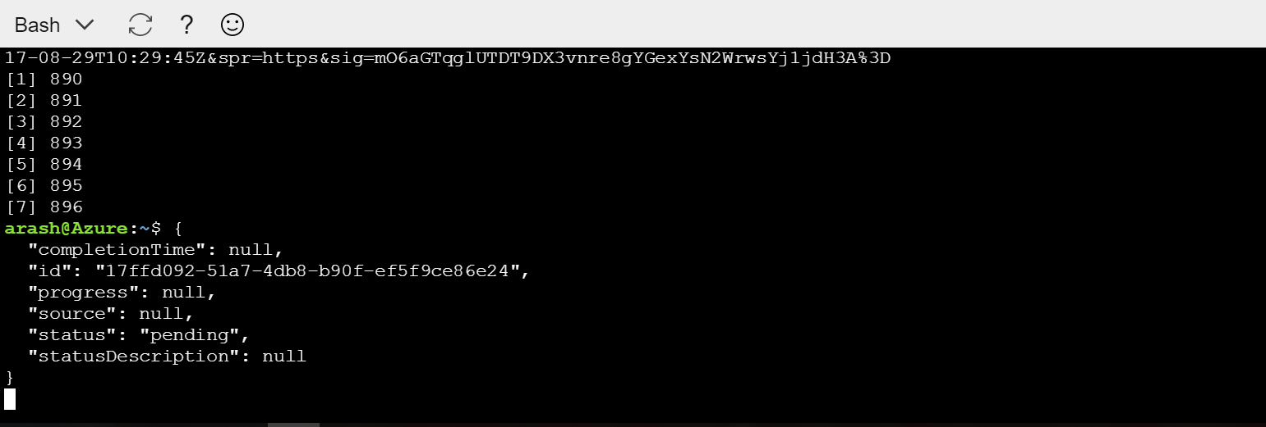

1. Then type:

> **az image create** -g **<your resource group>** -n myhackatonImage --os-type Windows --source [https://**<your account name>**.blob.core.windows.net/vhd/hackaton.vhd](https://myvm.blob.core.windows.net/vhd/hackaton.vhd)

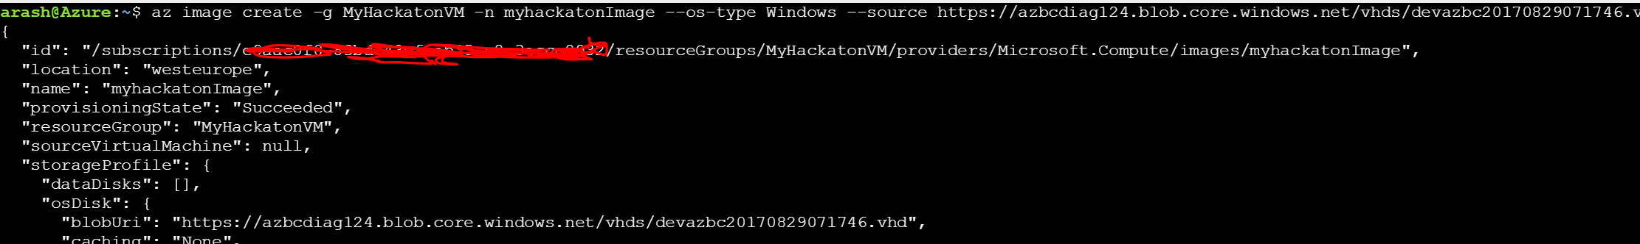

1. You should now have an Image in your MyHackatonVM resource group in your subscription:

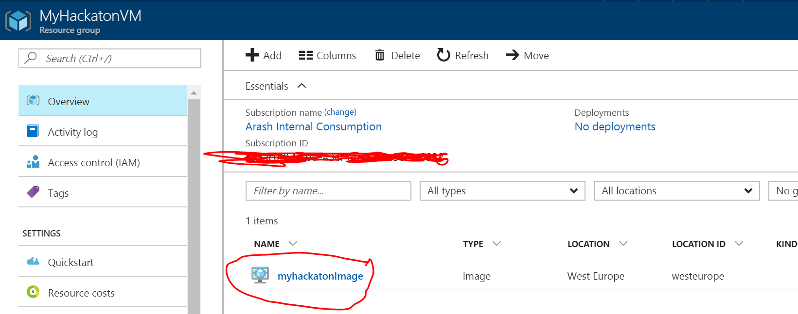

1. Click on the image and choose “Create VM”

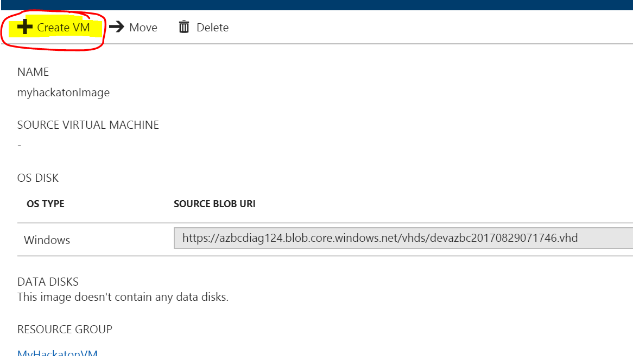

1. Enter the parameters to create the VM – it’s highly recommended to use at least 7 GB of RAM and 1 core.

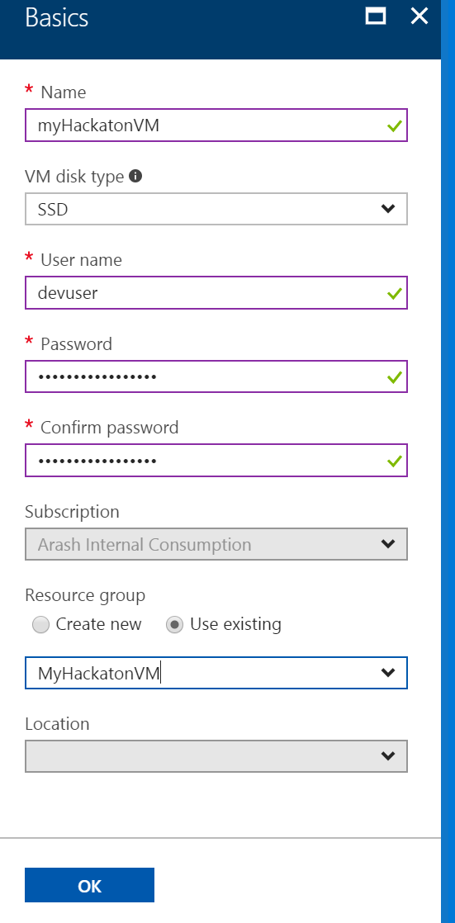

1. There should now be artifacts created in your resource group to create the VM for the lab. The VM contains Visual Studio 2017 Enterprise, Azure Powershell and Application Insight debugger.
2. Wait for the deployment to finish, then log on to the VM with your credentials you gave as input in the create phase.

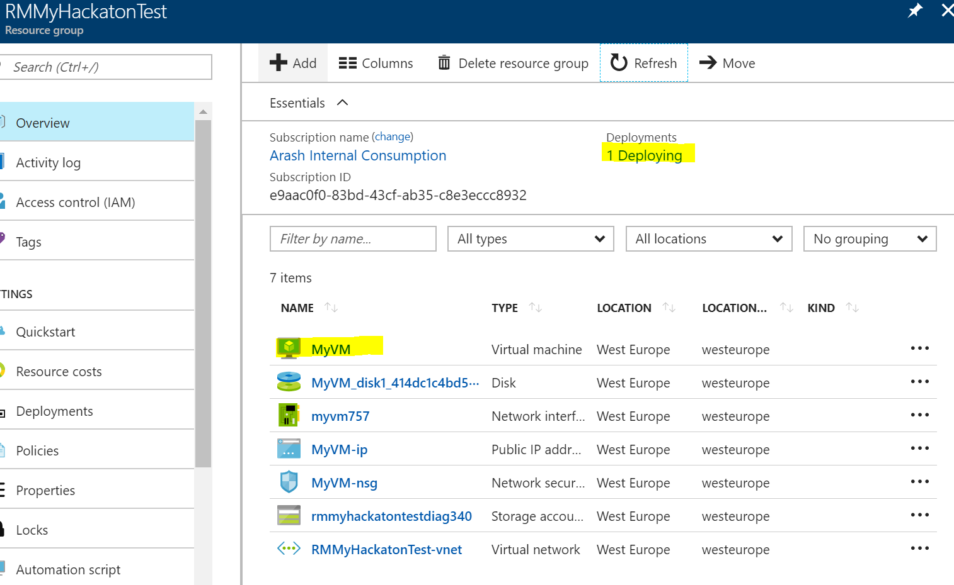

1. Connect to the VM and enter your credentials:

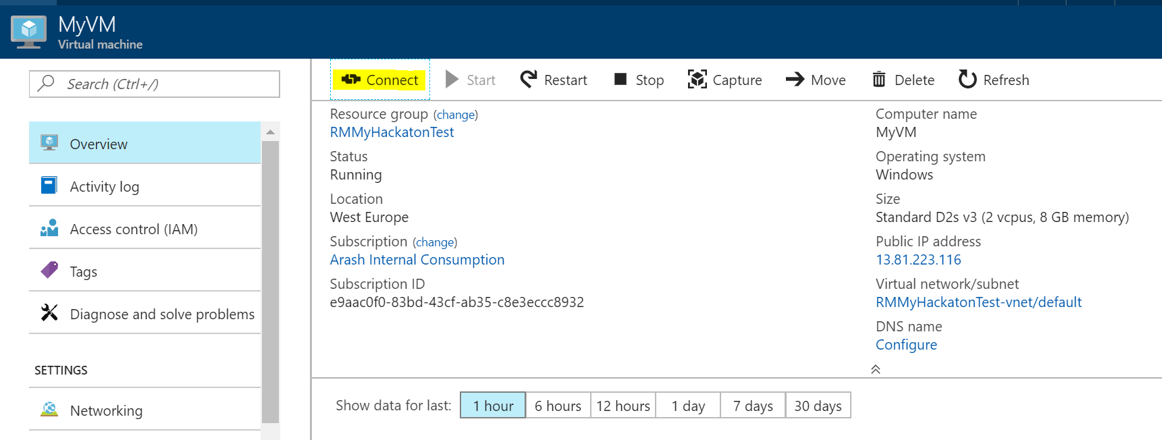

#### Task 2: Disable IE enhanced security

Note: Sometimes this image has IE ESC disabled, and sometimes it does not.

1. On the new VM, you just created click the Server Manager icon.



Click Local Server.

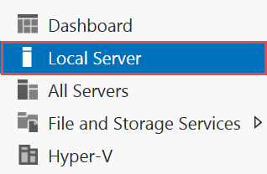

1. On the right side of the pane, click **On** by IE Enhanced Security Configuration.



1. Change to **Off** for Administrators and click **OK**.

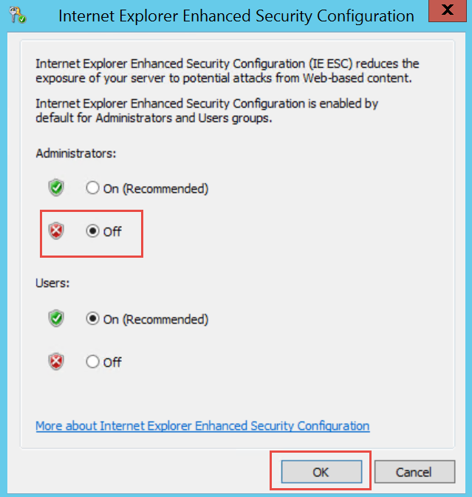

#### Task 3: Validate connectivity to Azure

1. From within the virtual machine, Launch Visual Studio 2017 and validate that you can login with your Microsoft Account when prompted.
2. Validate connectivity to your Azure subscription. Launch Visual Studio, open Server Explorer from the View menu, and ensure that you can connect to your Azure subscription.

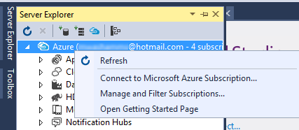

**Download the exercise files**

1. Download the exercise files for the training (from within the virtual machine).
   1. Create a new folder on your computer named **C:\Hackathon**
   2. Download the support files (.zip format), @@@@ ADD THIS!!! to the new folder.
   3. Extract the contents to the same folder.

Tip: In the labs when adding resources to the Azure Resource Manager template, ensure there are no spaces at the end of the resource names. Visual Studio will include the space in all of the code it generates.

## Exercise 2: Azure setup with portal

### Overview

In this exercise you will create all the resources needed for this hackathon. You will be using the Azure portal to create each resource using the naming convention mentioned above

In general, creating resources are done using the + sign in the portal as the image below shows:

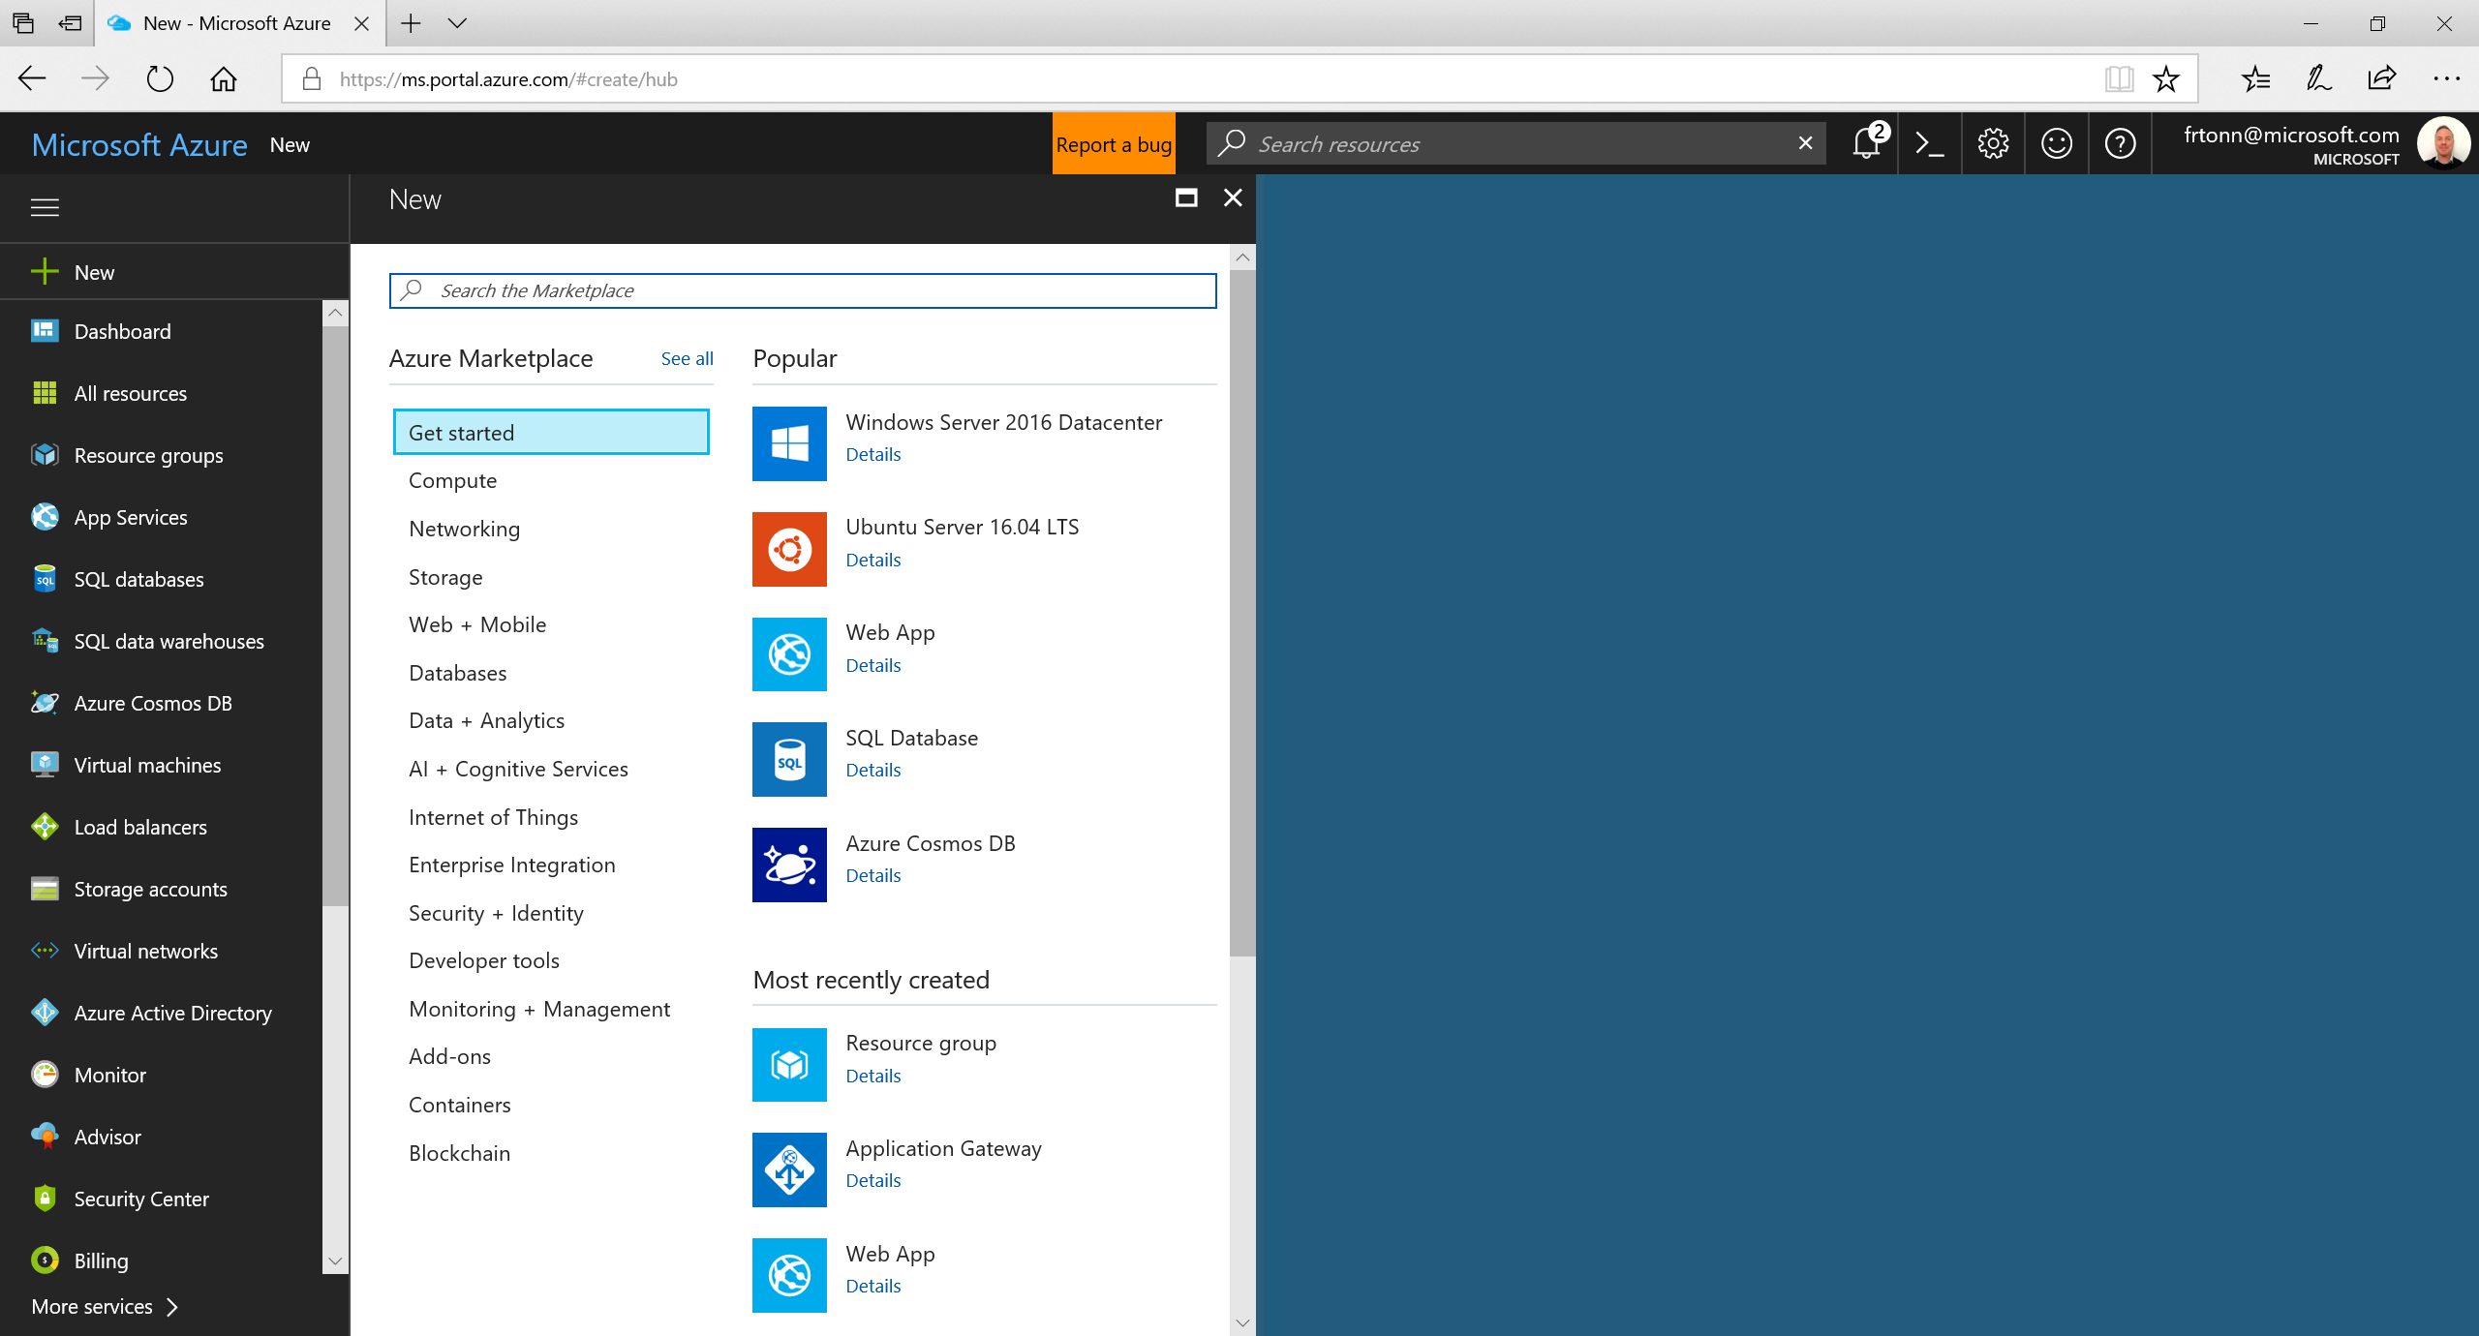

### Task 1: Create a Resource Group

The resource group will act as a container for all the artifacts where are going to create. Create a new resource group and use the naming convention below:   
<initials>-<resource type>-azbc.   
The abbreviation for Resource group is “rg”.   
In the example below the resource group is called “frto-rg-azbc”

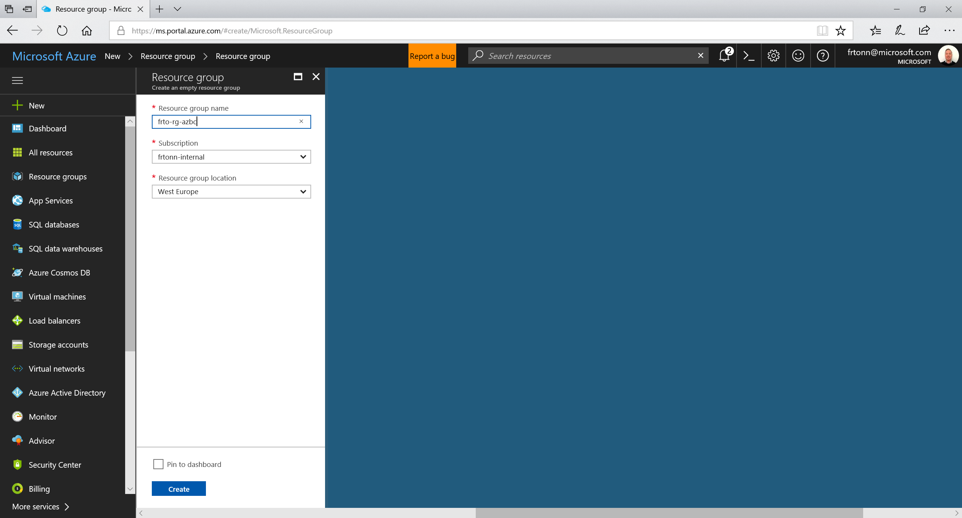

### Task 2: Create an App Service Plan

All resources created in Azure lives in a Resource Group, and for all resources we will create we will use the Resource Group we created above. The abbreviation for App Service Plan is “asp”.

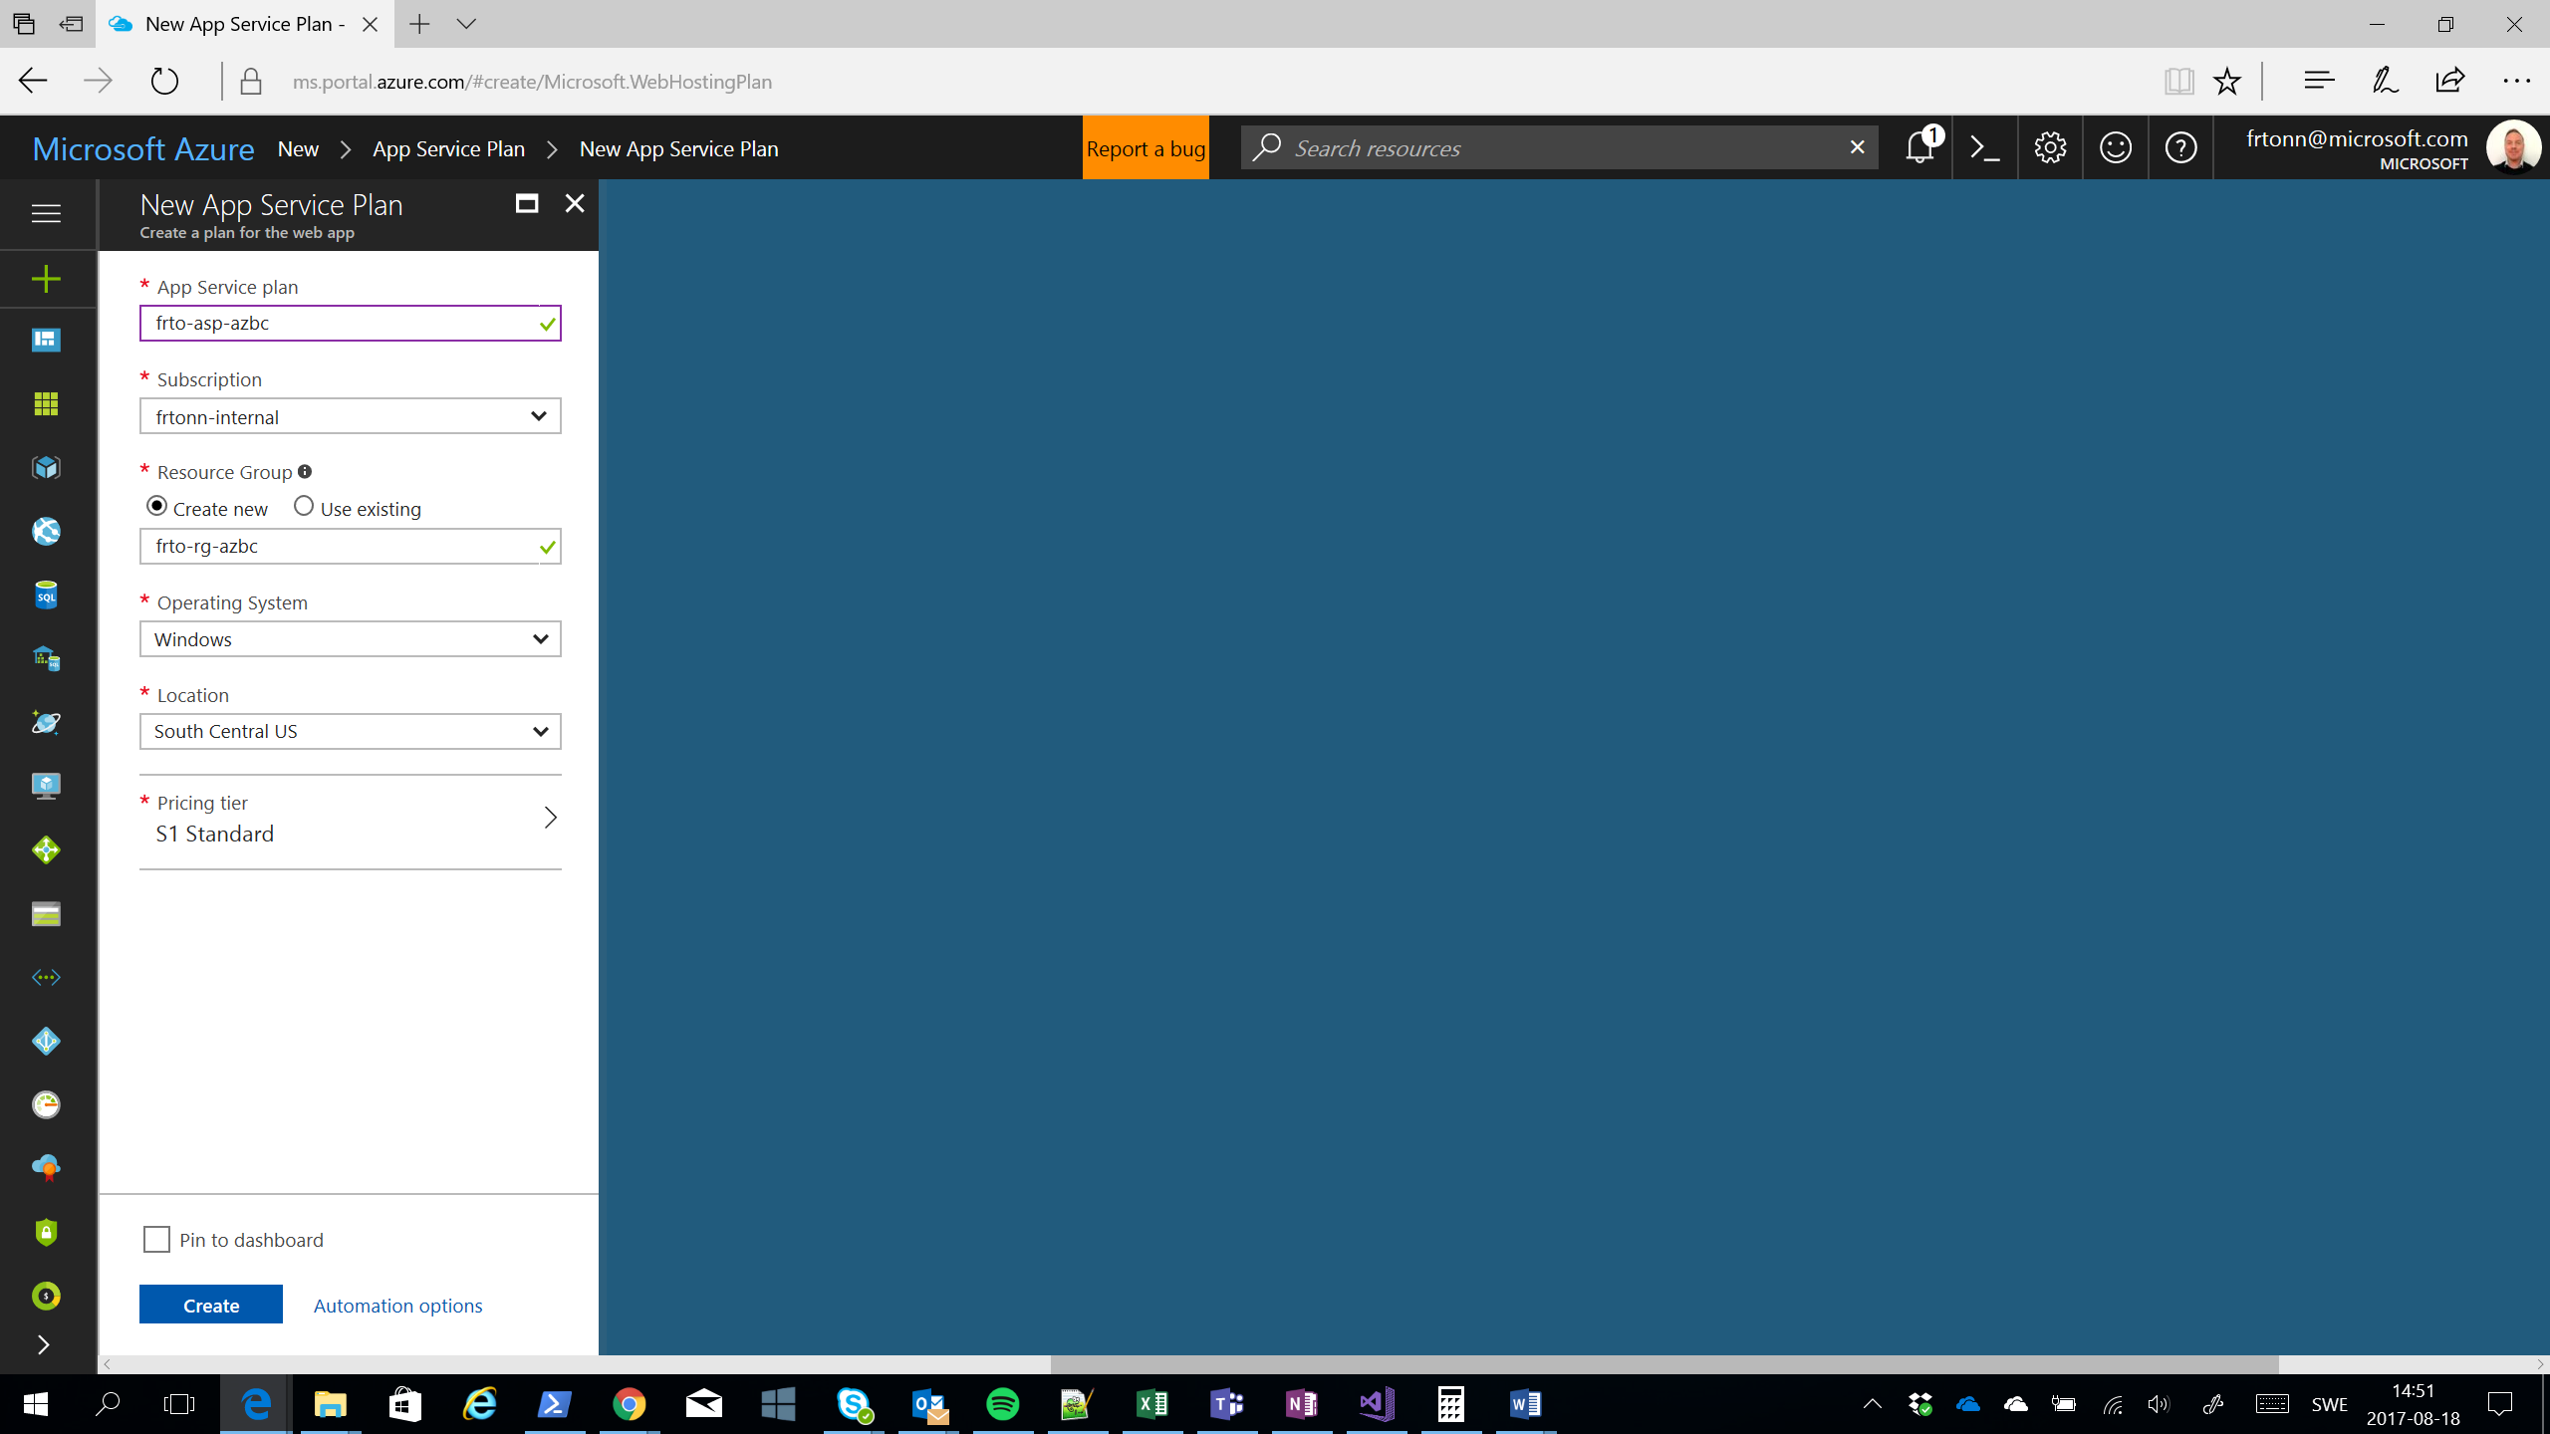

### Task 3: Create an API Management Service

The abbreviation we use for API Management is “apim”, so the name in the example below will be frto-apim-azbc. You should also specify a name for the organization and an administrative e-mail address. Just make up a name for the organization and use your own mail address.

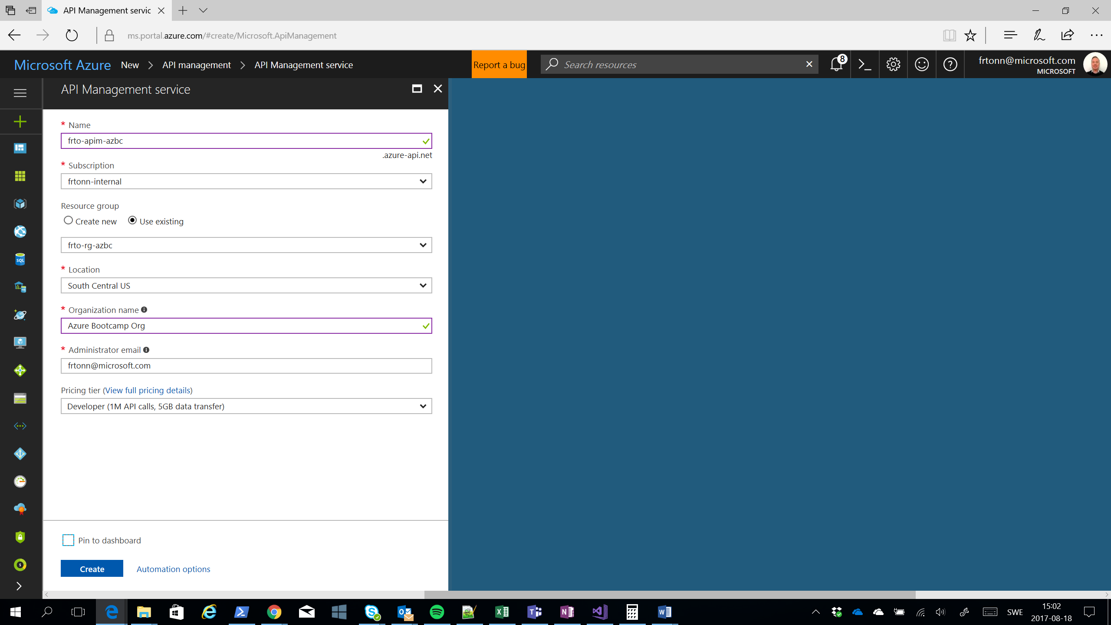

### Task 4: Create a Web App

The abbreviation for Web App is “wa” so the name in the sample below is frto-wa-azbc. You should also make sure you choose Windows as the OS and for App Service Plan, you should choose the plan you just created.

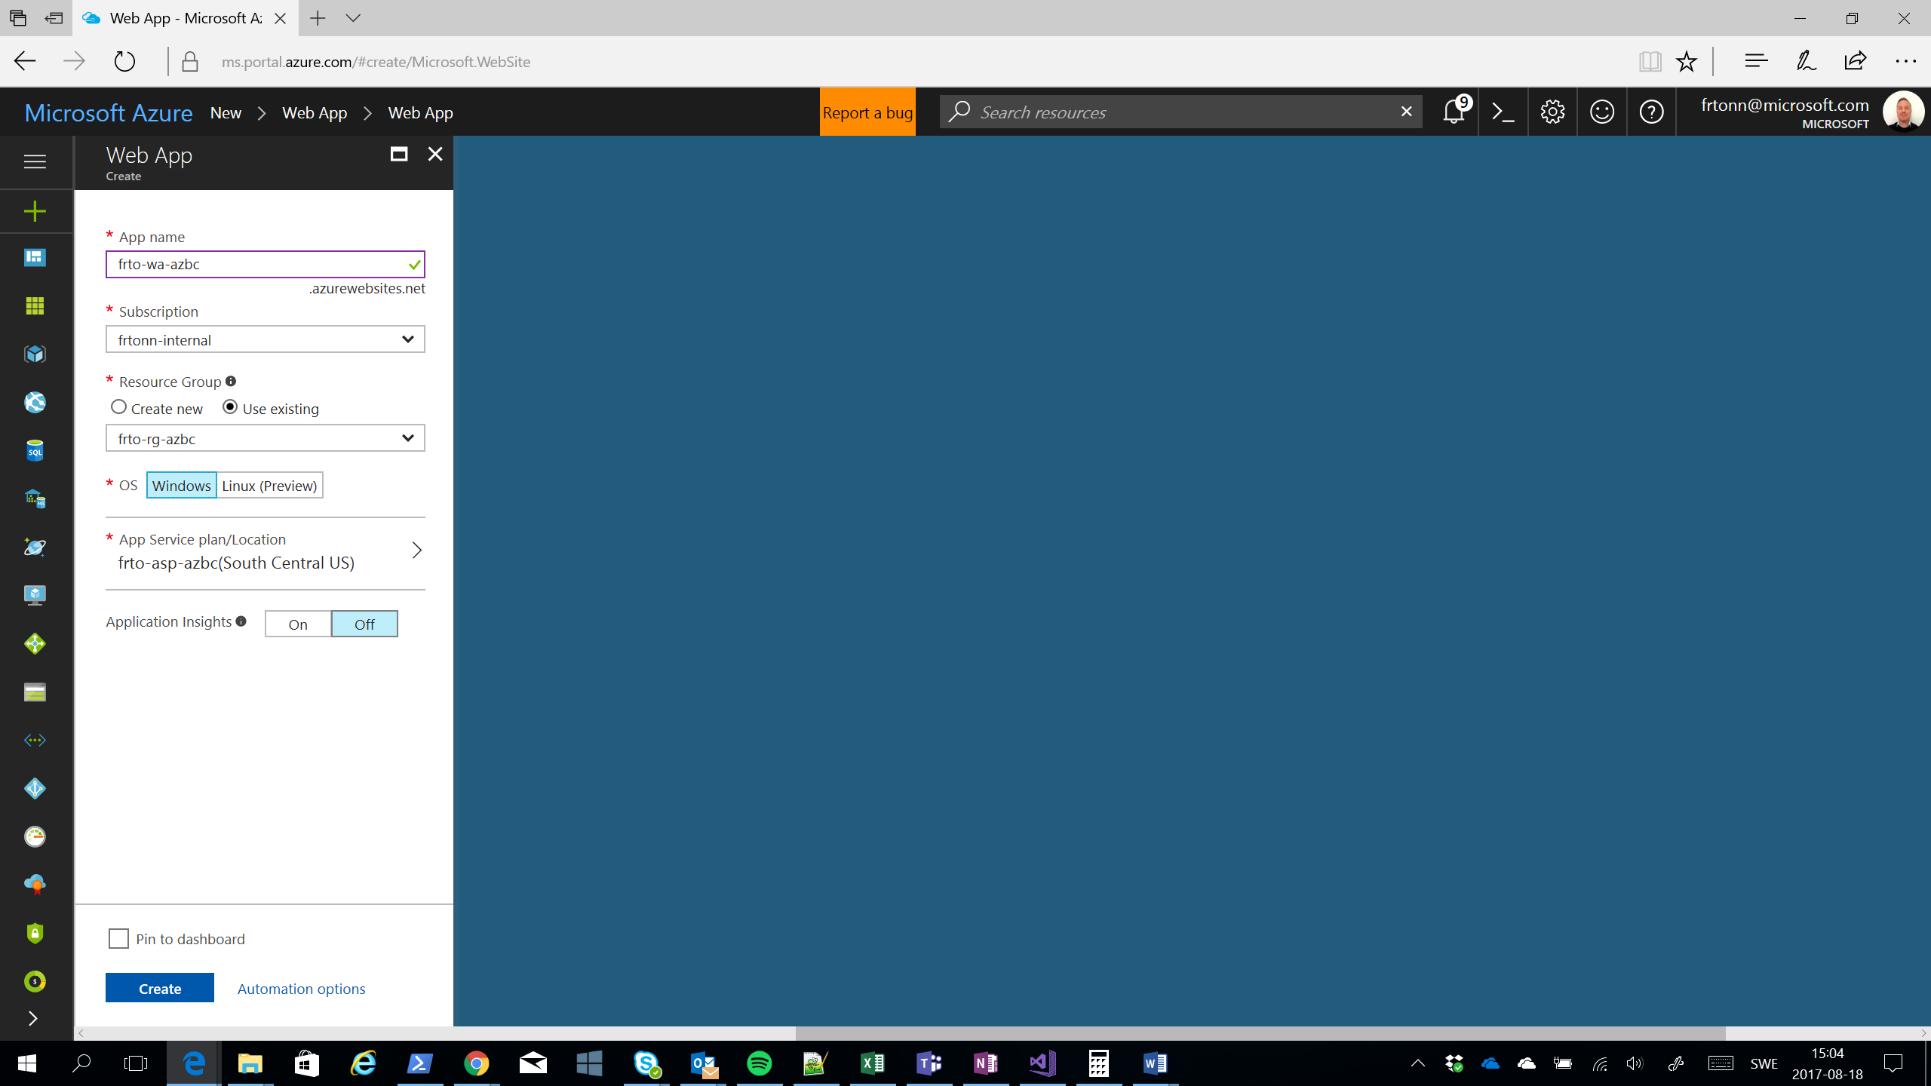

### Task 5: Create API App

The abbreviation for API App is “api” so the name in the sample below is frto-api-azbc. You should also make sure you choose Windows as the OS and for App Service Plan, you should choose the plan you just created.

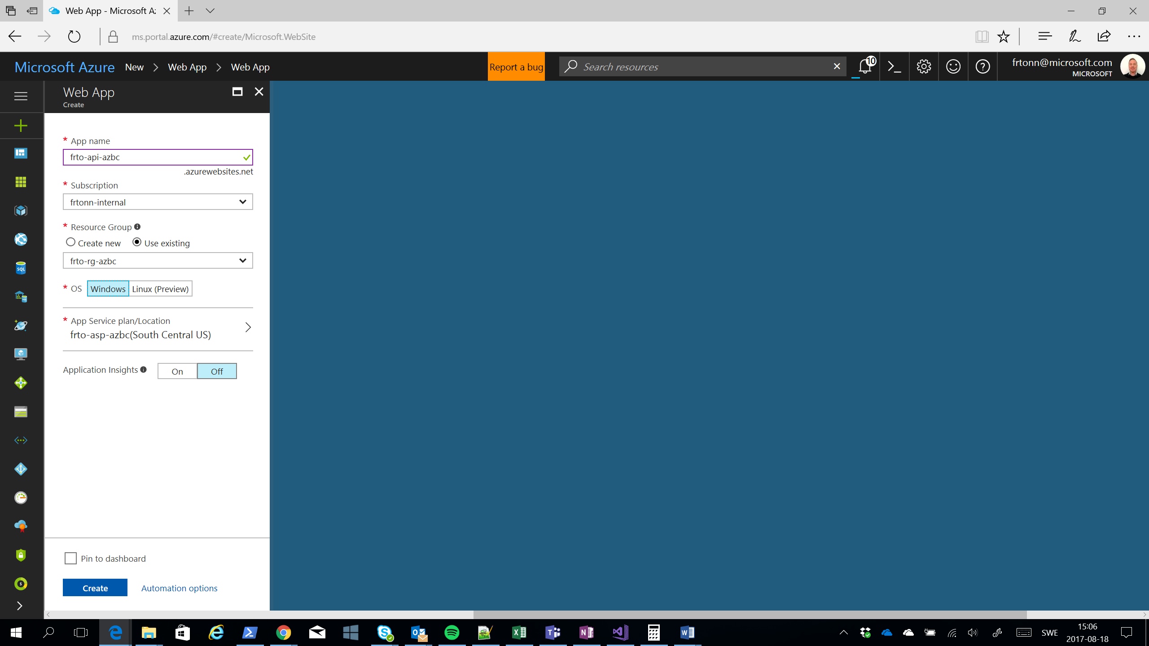

### Task 6: Create Azure Search

Create a new Azure Search Service and use the abbreviation “as” to name the resource so that in the example below you get frto-as-azbc

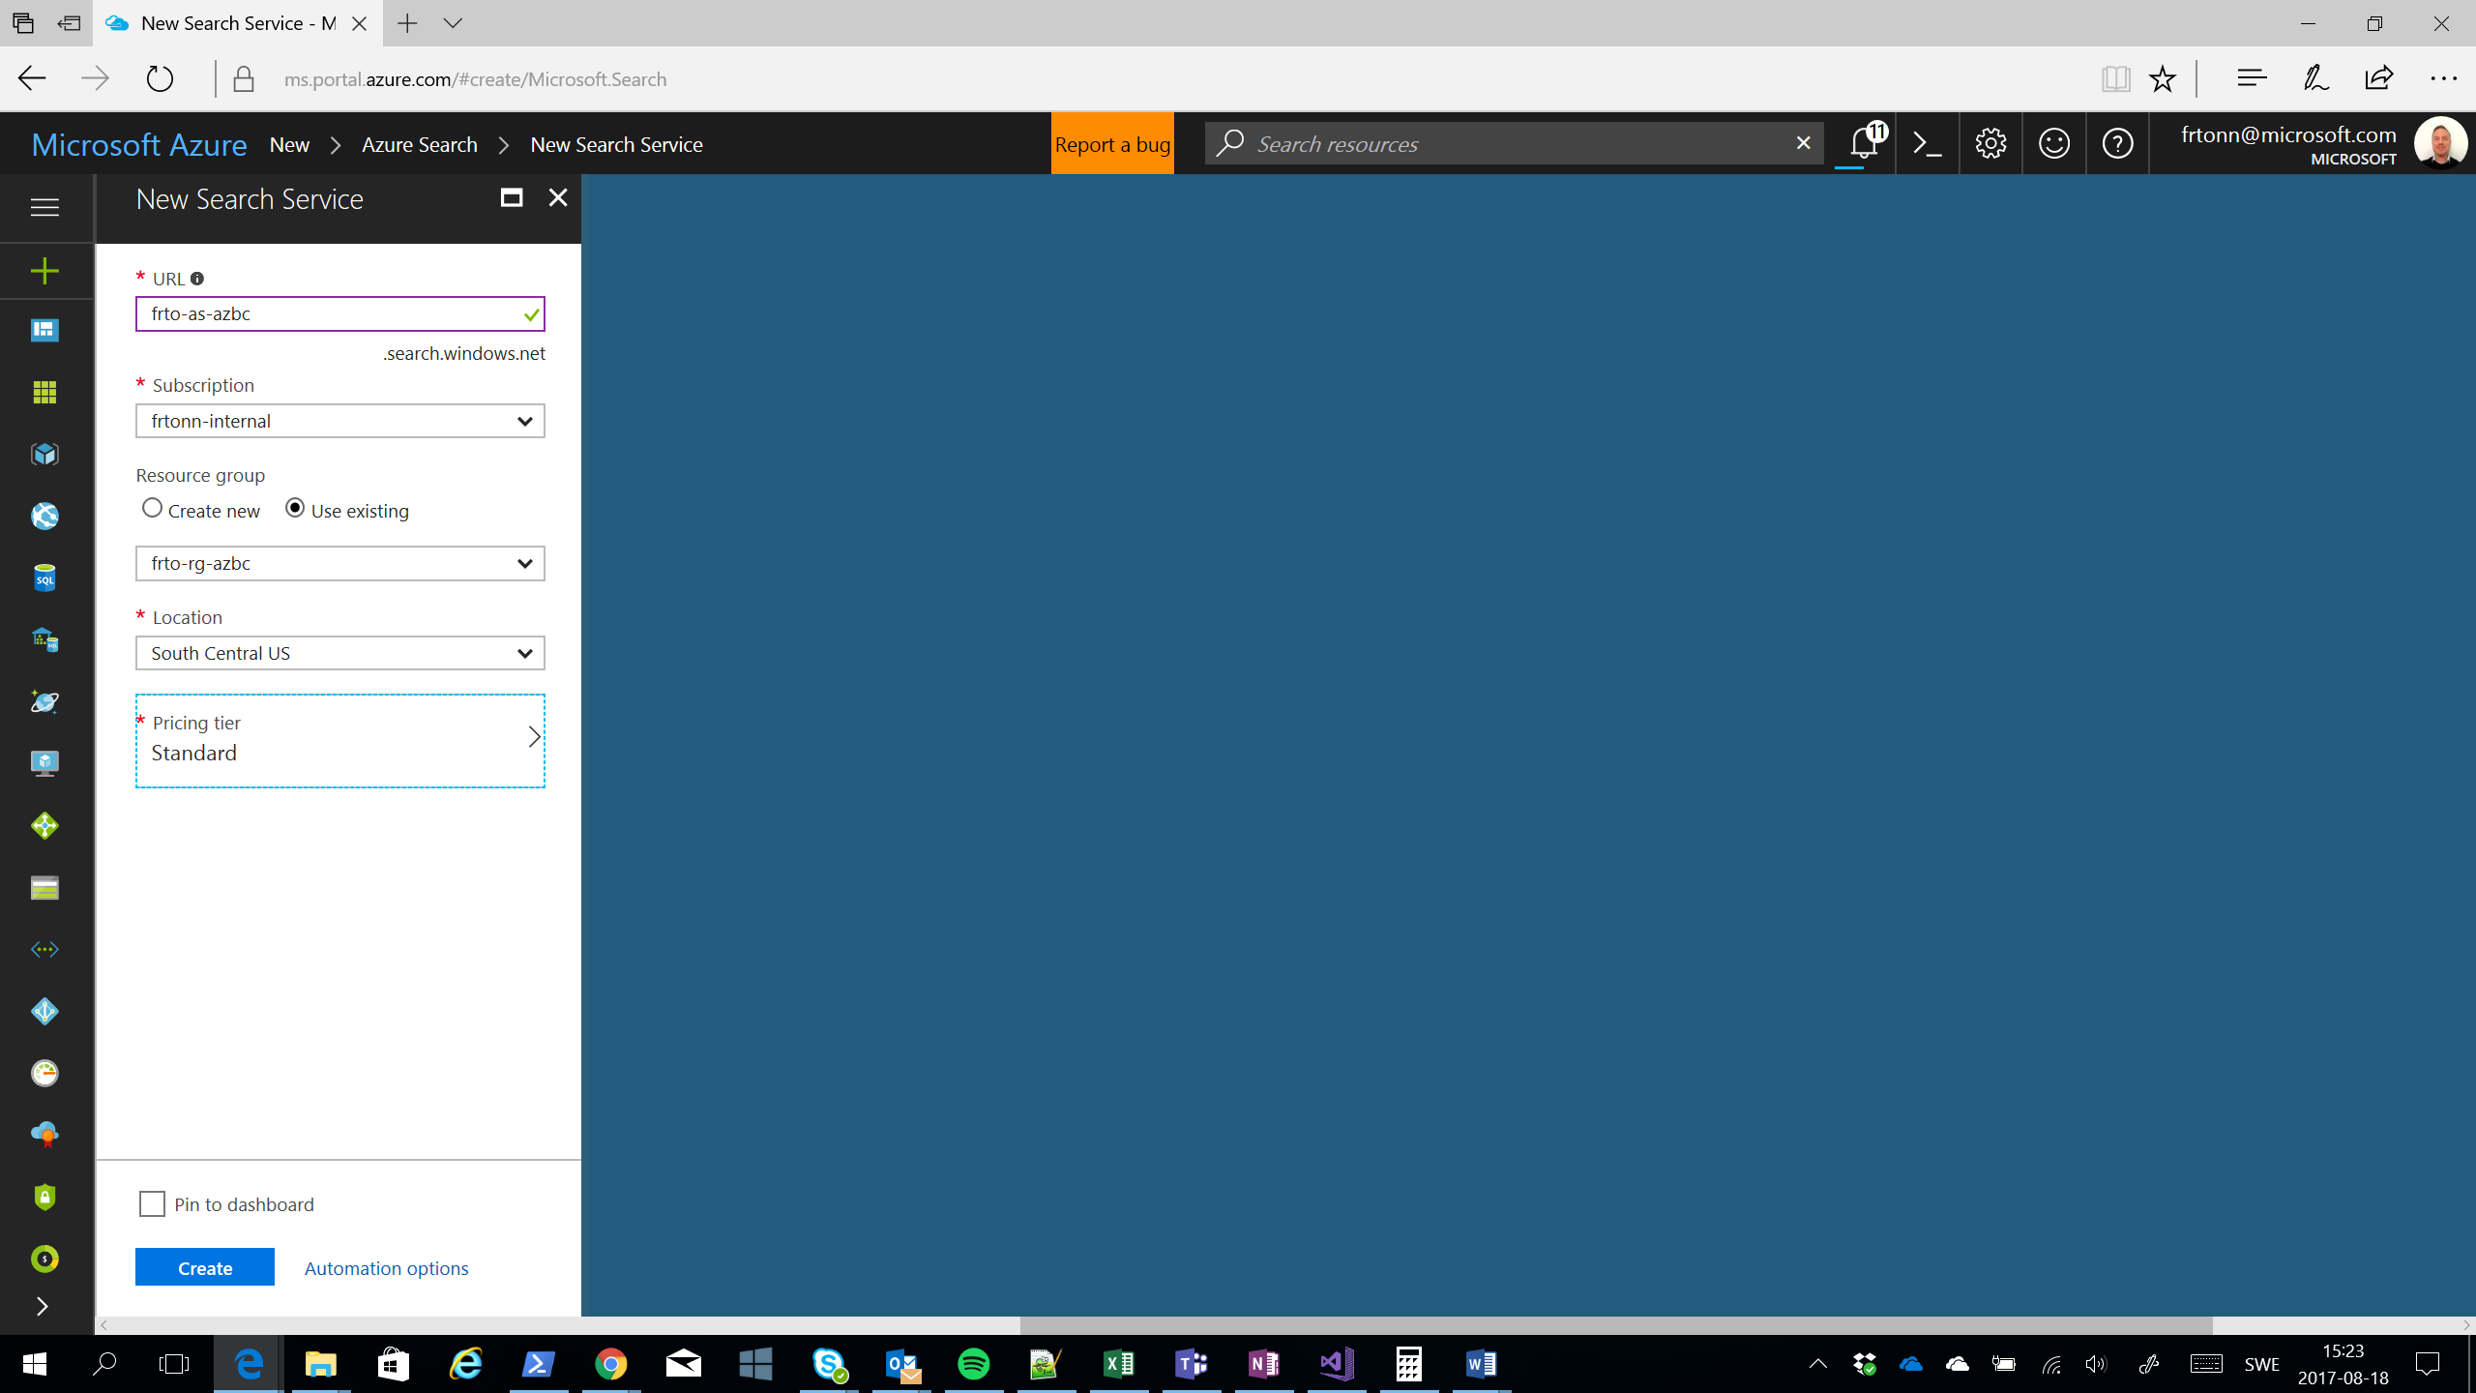

### Task 7: Create a Service Bus

Create a new Service bus and use the abbreviation “sb” (frto-sb-azbc).

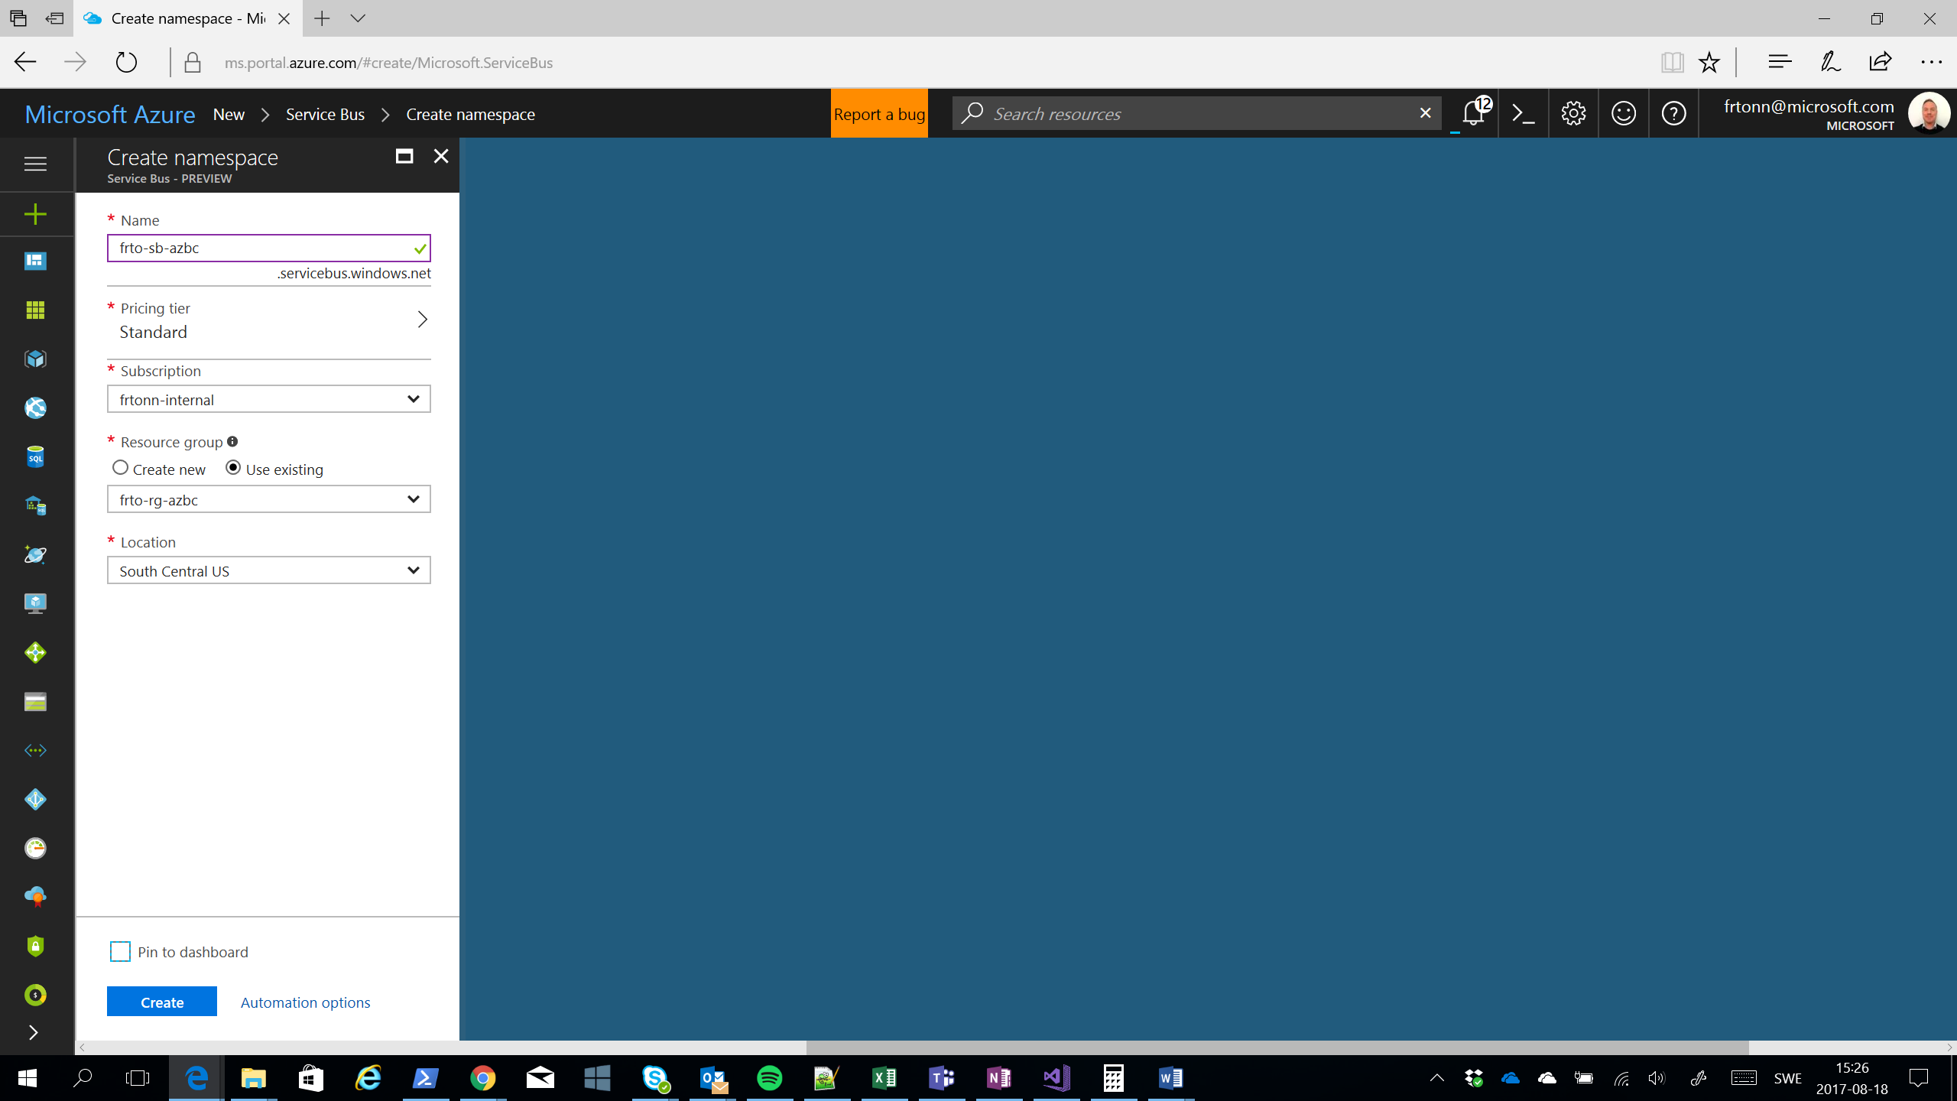

### Task 8: Create a new Service Bus Queue for the new Service Bus

Open the newly created Service Bus and open the portal blade for Queues and click the add Queue button. No abbreviation is used for queues. Create two queues, one called “jobapplications” and the other “notifications”

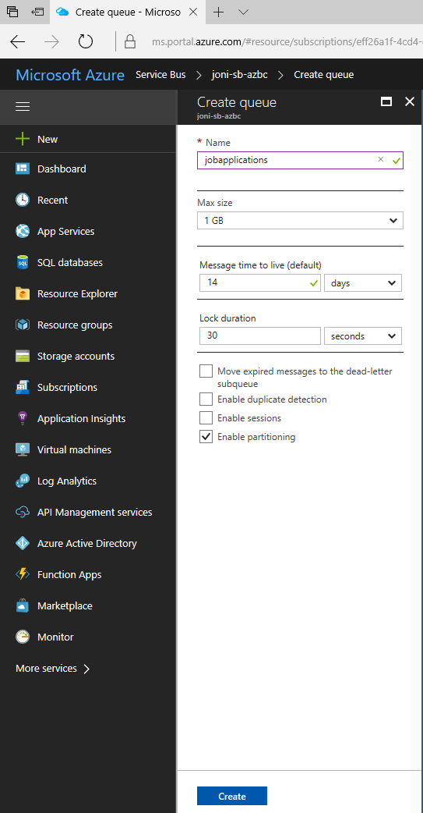

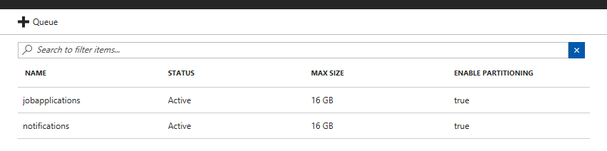

### Task 9: Create a Storage Account

The name of a storage account is a little different from the other resources. It can only contain the letter a-z and the number 0-9 and no other characters. Using the naming convention, we have so far where Storage Account is abbreviated with “stg” the name becomes **frtostgazbc.**

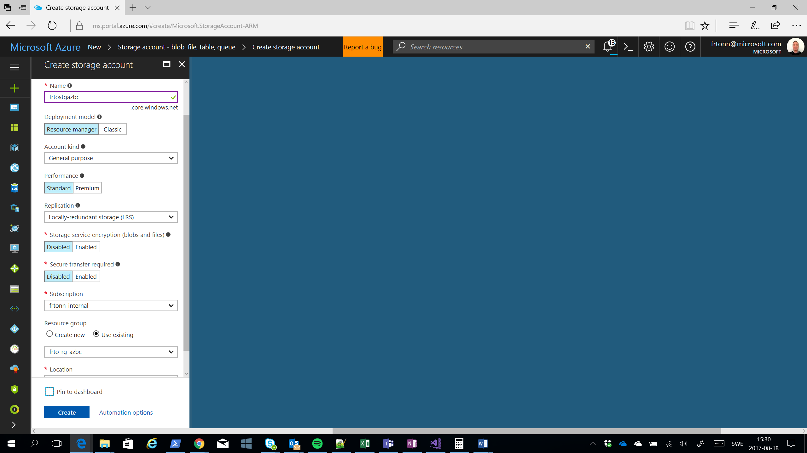

### Task 10: Create a new Azure Functions

We abbreviate Azure Functions “af” so the example name becomes frto-af-azbc. You can either run the function using the Consumption Plan as in the image below, or you can choose the App Service Plan you created earlier. Remember to choose the Storage Account you just created.

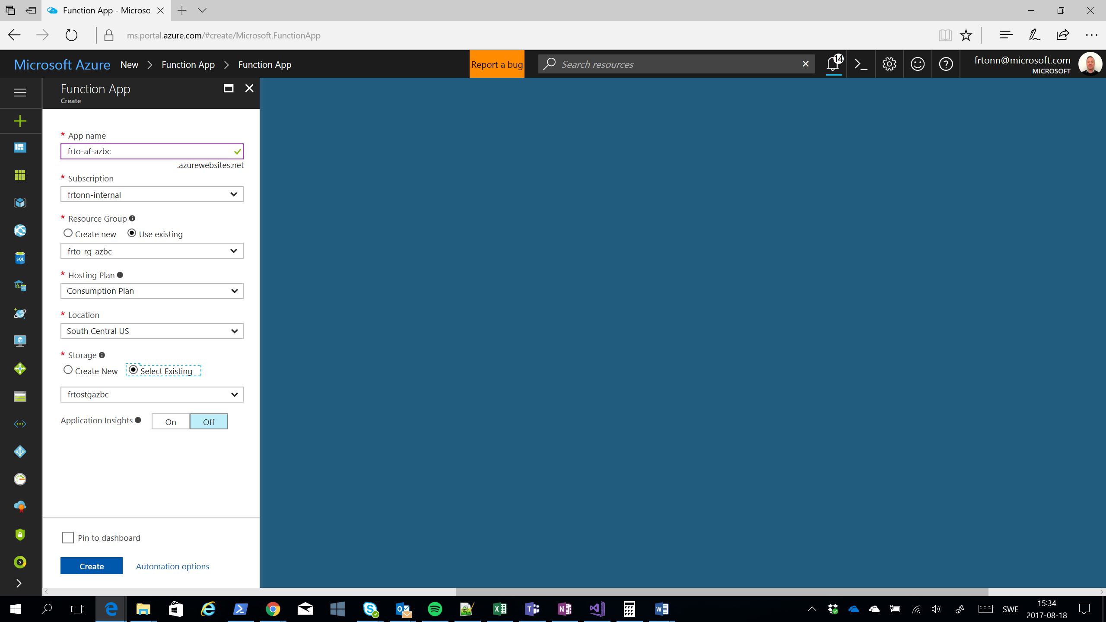

### Task 11: Create a new instance of CosmosDB

Create an instance of CosmosDB and choose the SQL (Document) API. The abbreviation for CosmosDB is “cdb” so the example name becomes frto-cdb-azbc.

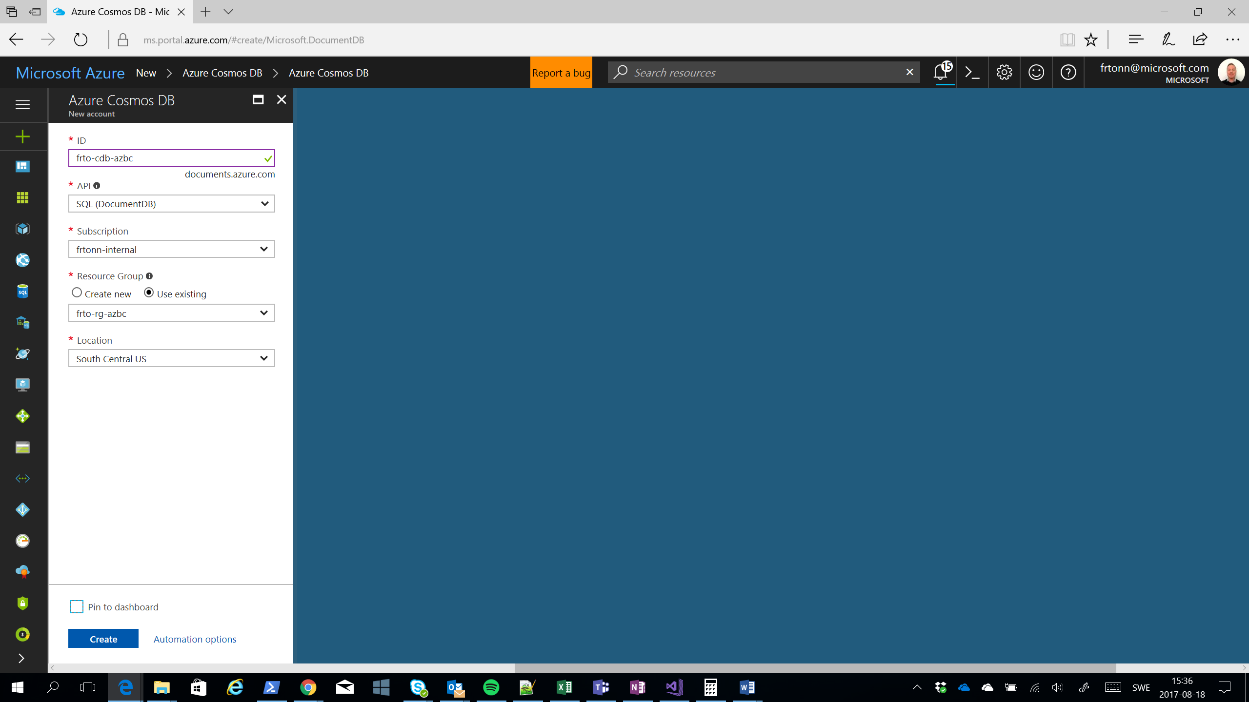

### Task 12: Create a new instance of Application Insights

Finally create an instance of Application Insights, abbreviated “ai”.

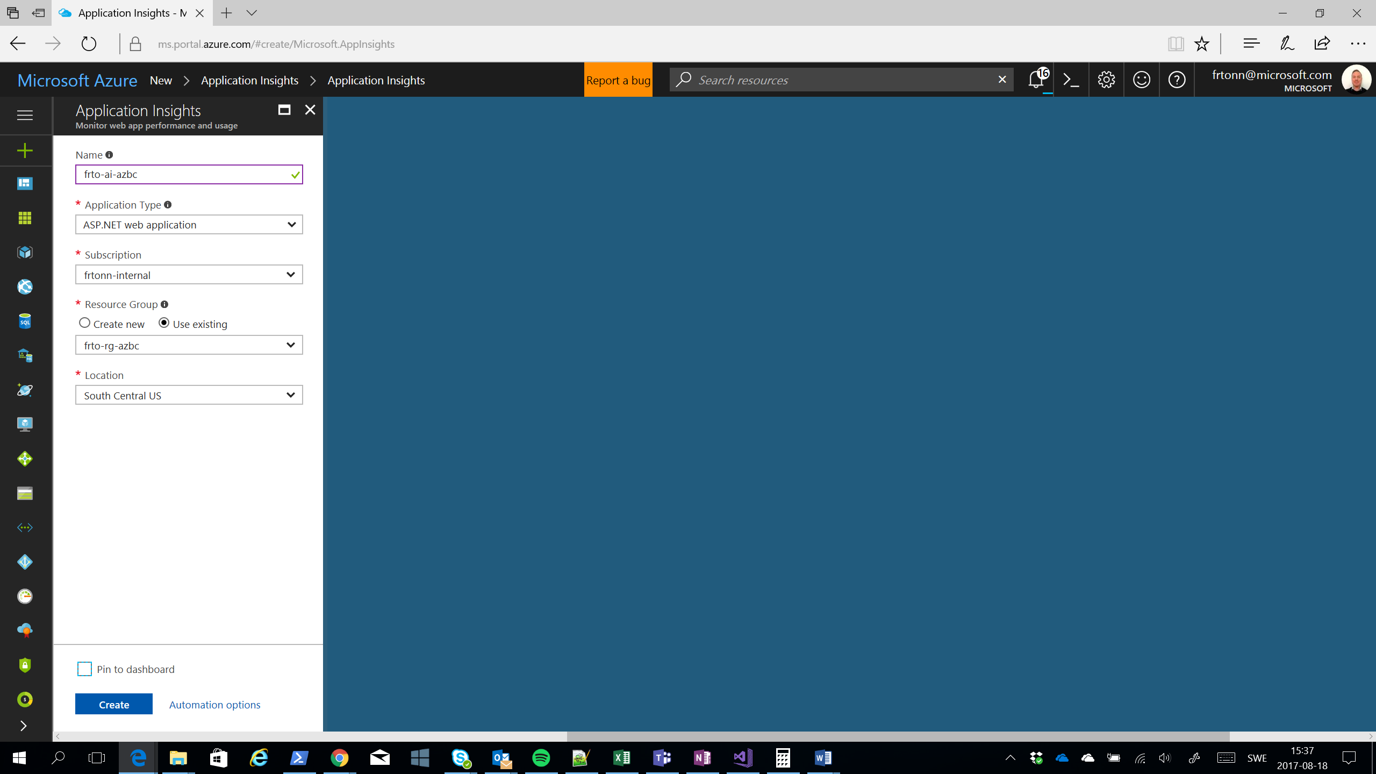

### Task 13: Create a Logic App

Create a logic app that will send a notification via email. The abbreviation for Logic Apps is “la” so the example name becomes frto-la-azbc.

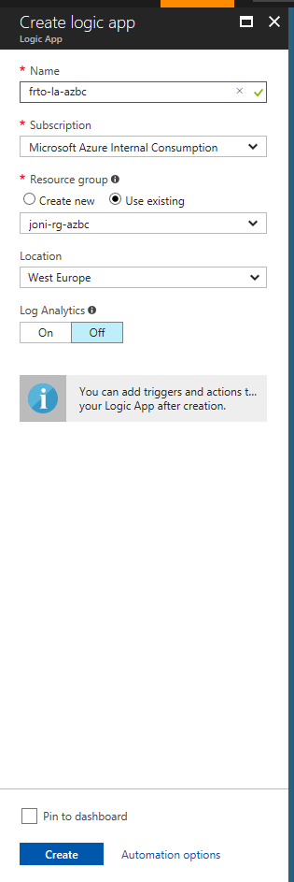

### End result

When you are done with all tasks you should have a Resource Group with the following list of resources plus the Logic App.

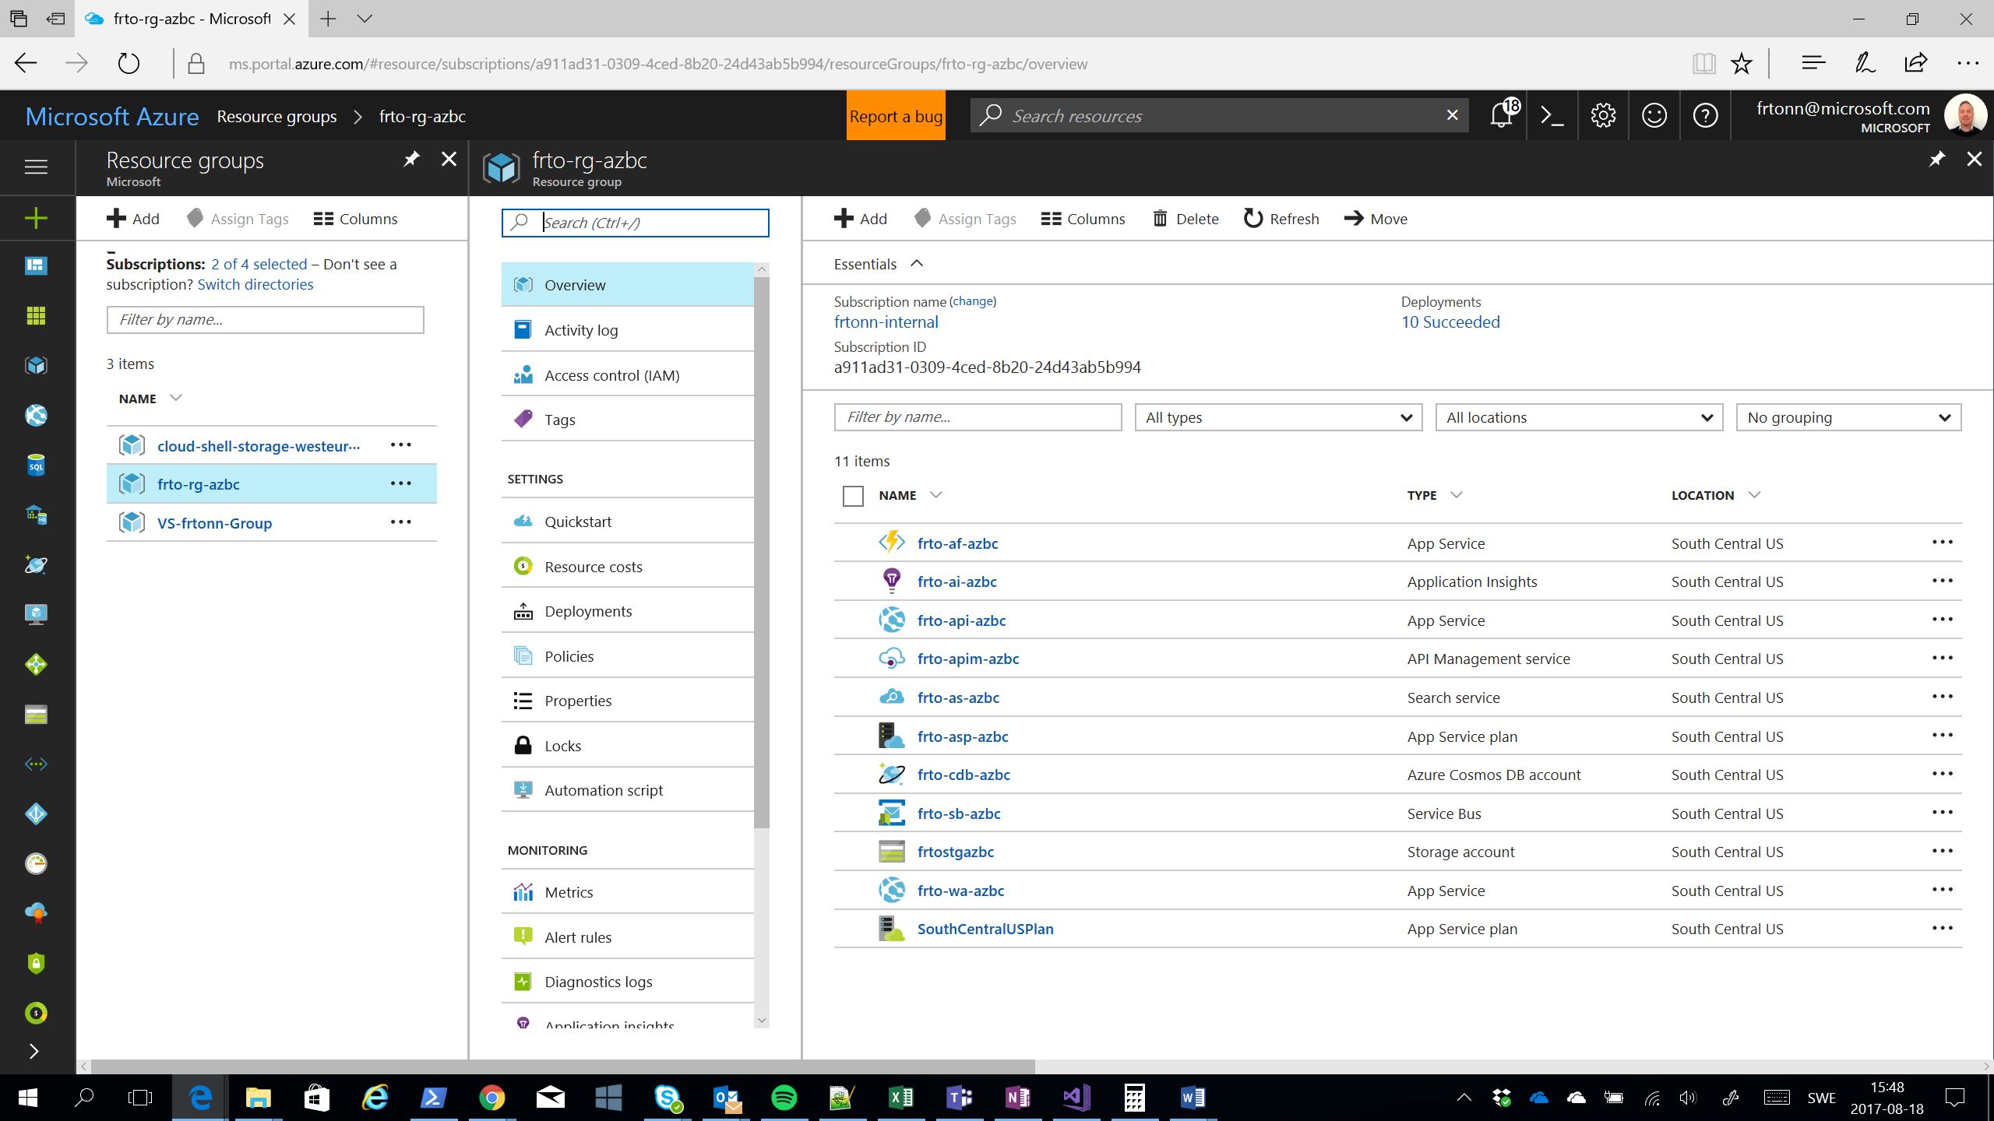

## Exercise 3: Deploy solution manually to Azure

In this exercise, you will deploy the solution **manually** to Azure using Visual Studio.

### Hints

Configure the following files with appropriate values. Get the values from the Azure portal under the different services.

|  |  |  |  |
| --- | --- | --- | --- |
| **Project** | **File** | **Key** | **Description** |
| NYCJobsWeb | ApplicationInsights.config | InstrumentationKey | Application insights key |
| NYCJobsWeb | Web.config | Ocp-Apim-Subscription-Key | APIM key |
| NYCJobsWeb | Web.config | NYCJobsApi | URI to web api |
| NYCJobsApi | ApplicationInsights.config | InstrumentationKey | Application insights key |
| NYCJobsApi | Web.config | SearchServiceName | Name of Azure Search instance |
| NYCJobsApi | Web.config | SearchServiceApiKey | Key of Azure Search Instance |
| NYCJobsApi | Web.config | ServiceBusConnection | Endpoint to Service bus |
| NYCJobsLogicApp | LogicApp.parameters.json | servicebus_1_connectionString | Endpoint to Service bus |

**Hints**:

APIM (API-Managaement) key

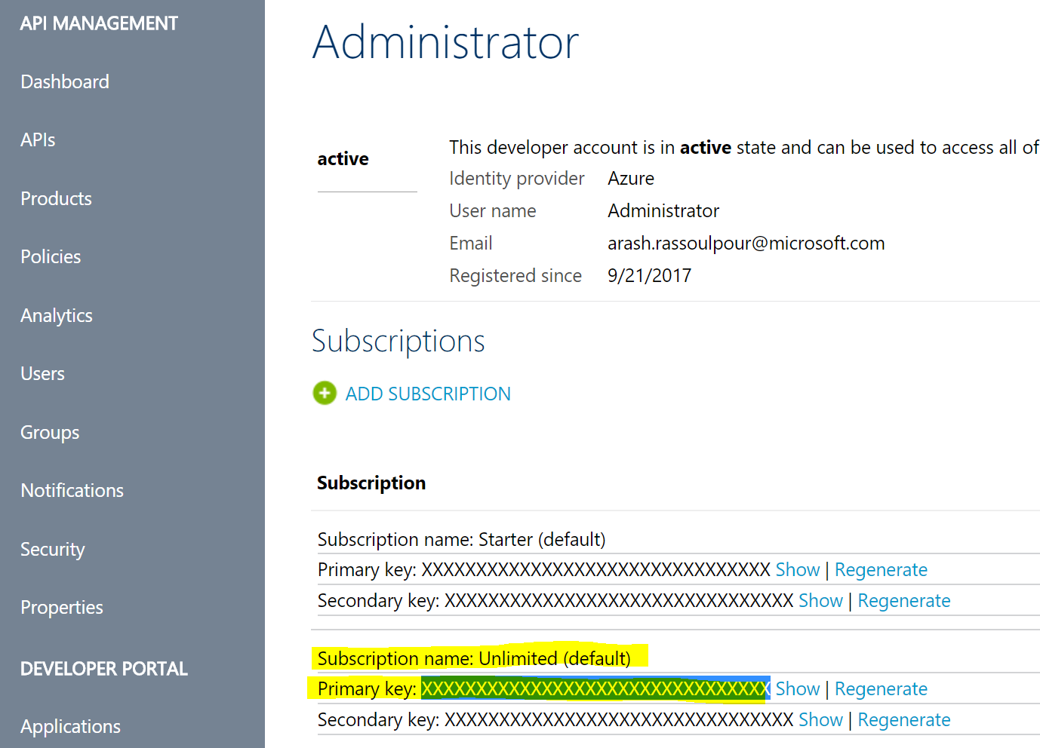

InstrumentationKey

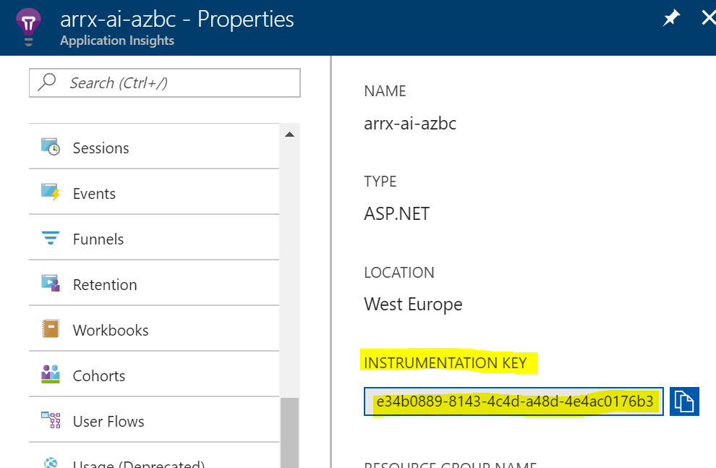

Service Bus key

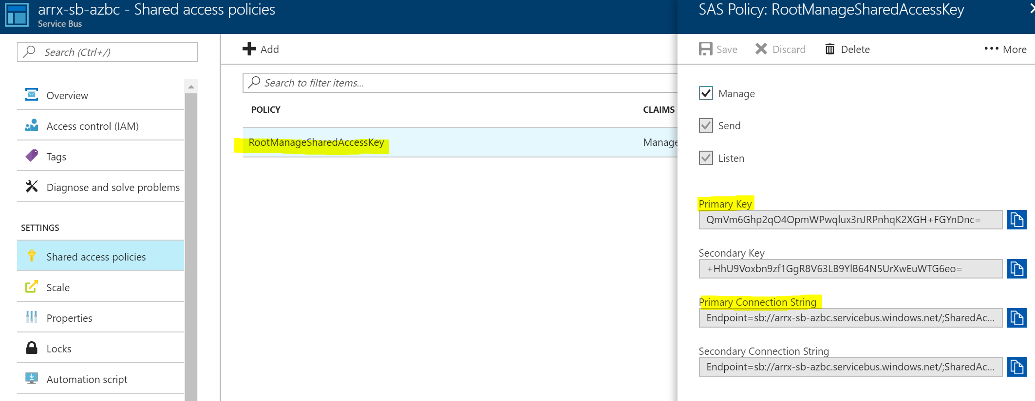

### Task 0: Get the source code.

Download the source code from **[INSERT LINK HERE]** . Unzip the package and place it under c:\azbc\manual\

### Task 1: Add the instrumentation key to the web app’s configuration

In this exercise, you will connect the Azure Application Insights resource that you created previously with the web app so that it can record diagnostic and analytics information.

1. Make sure you have the instrumentation key from the output in the first exercise.
2. Open Visual Studio and then open the solution found in **C:\Hackathon\NYCJobsWeb.sln**

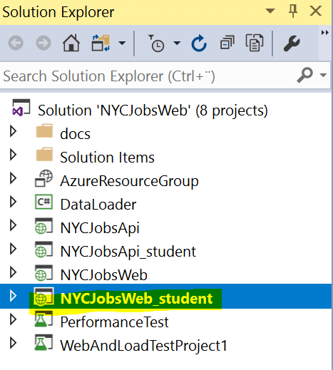

1. There are two API and Web projects, one kind that ends with **_student**. This is the one we are going to work with, the other are the final solutions examples that you can use to get hints if wanted. Right-click on **NYCJobsWeb_student** project and select **Manage nuget packages.**
2. Search for **Application Insight Web** and choose **Install.**

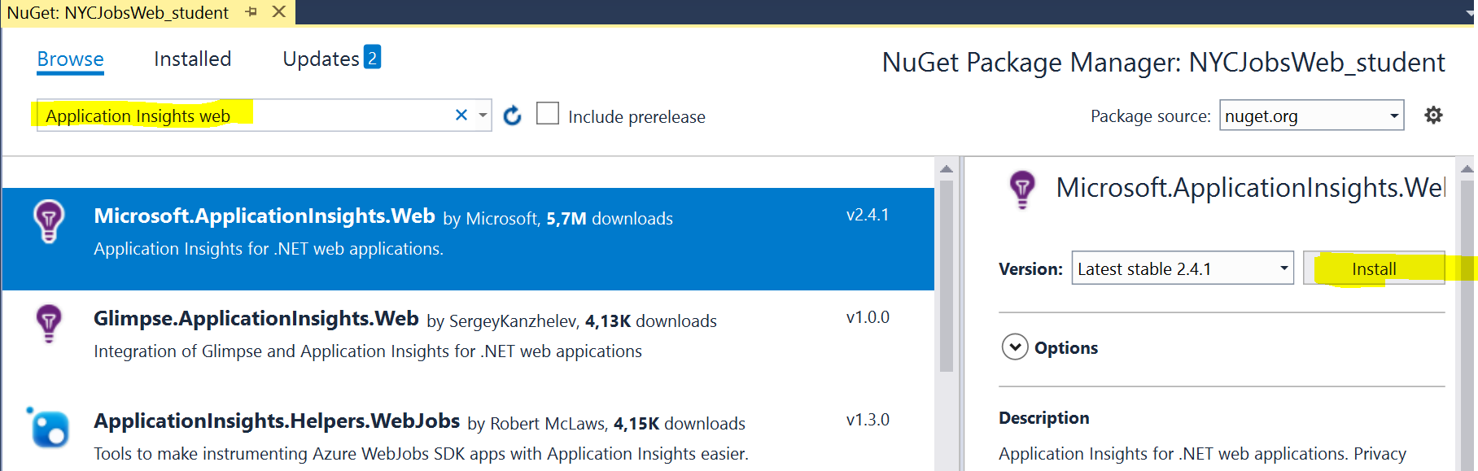

1. Open the file called ApplicationInsights.config.
2. Near the top of the file, you will see a location to paste in the instrumentation key. Paste it in and save your files.  
     
   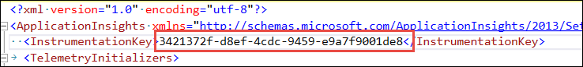
3. Do the same procedure for **NYCJobsApi_student** project

### Task 4: Deploy projects

1. Right click **NYCJobsApi_student** 🡪 Publish…

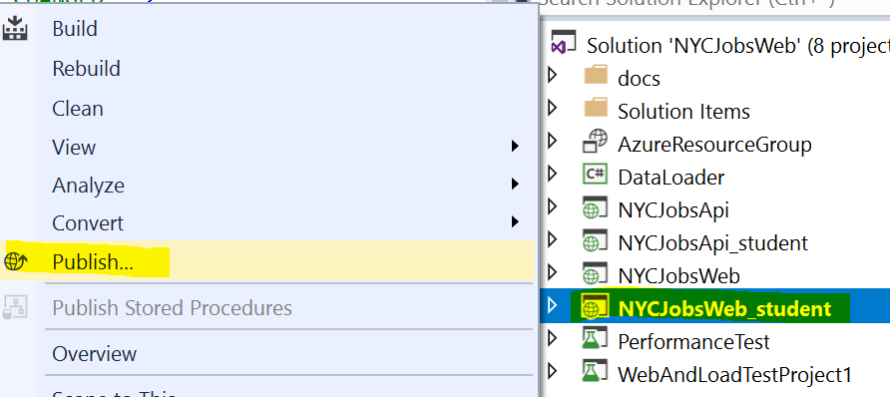

1. Select Existing 🡪 Publish
2. Choose the API created earlier

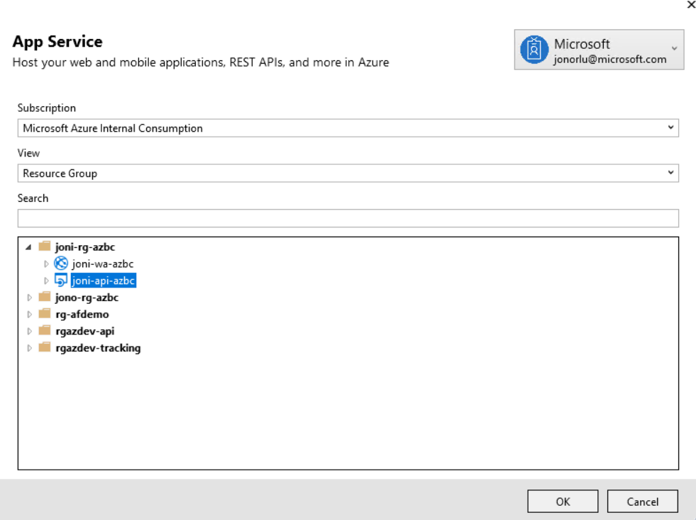

1. Do the same for **NYCJobsWeb_student** project but choose the Web app instead.
2. Configure and deploy the **Logic App**. Make sure to change the **Service Bus** connection endpoint.

### Task 2: Add Application Insight to Azure Function

Go to Appsettings for the function and set application insight key from the one you have deployed in your solution previous.

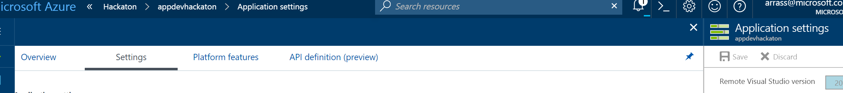

Set the Application Insight settings with the key from your Application Insight – you should only have one application insight. The notation is **APPINSIGHTS_INSTRUMENTATIONKEY** = {**Instrumentation Key**}.

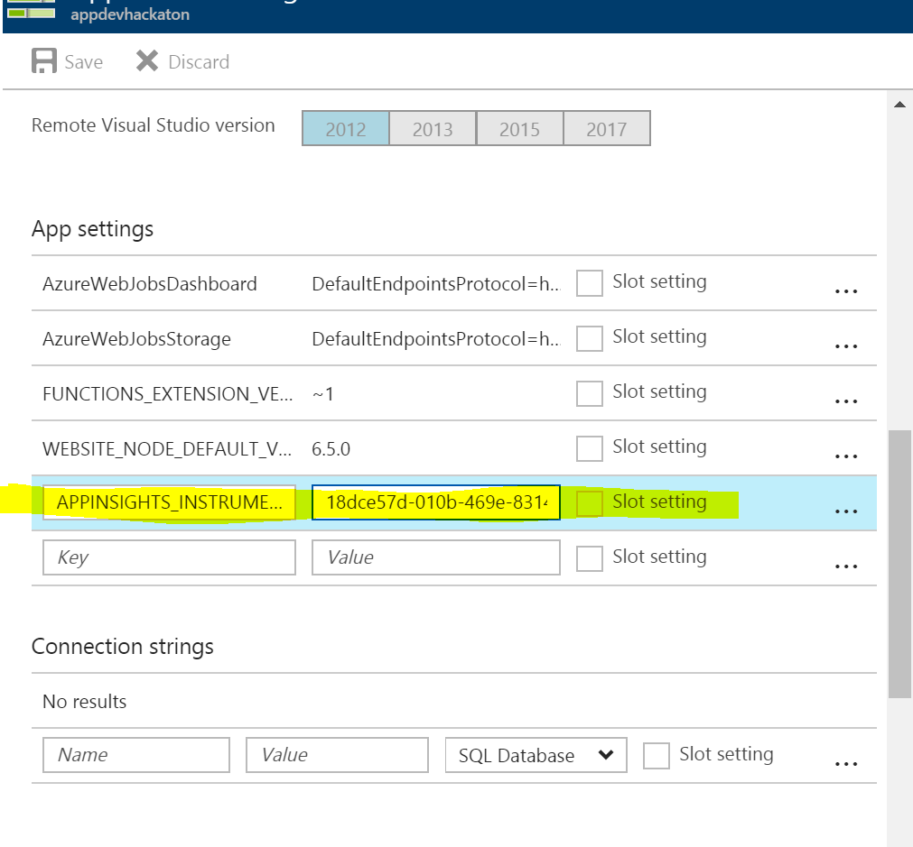

_____________________________________________________________________________________________

### Task 2: Import data to Azure Search

1. Open NYCJobsWeb solution in administrative mode.
2. Configure Azure Search Name and key. Get the key from Search Service 🡪 [Your search service] 🡪 Keys 🡪 Primary key

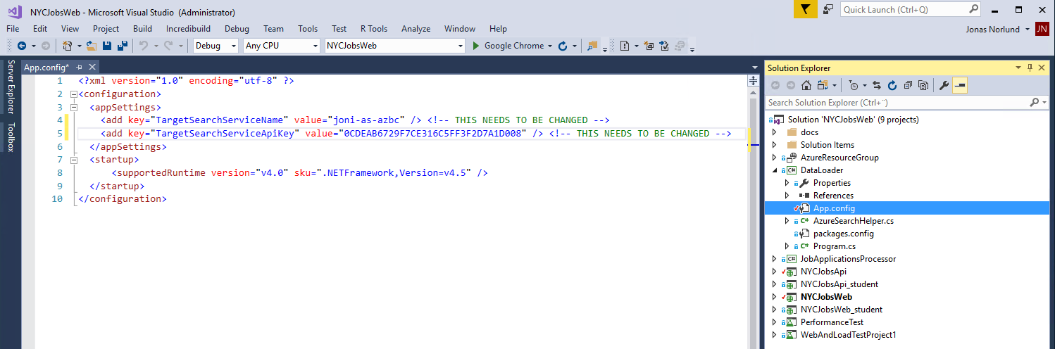

1. Debug the DataLoader project. This creates data in Azure Search from files in the solution.

### Task 5: Configure API Management

1. Use a browser and go to your API app, add “swagger” in the end of the URI.
2. Copy the URI in the top of the window.

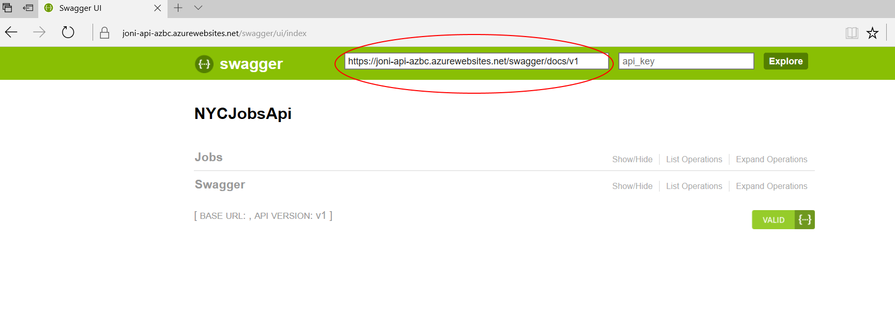

1. Go to the Azure Portal and your API App 🡪 API Definition 🡪 Paste the URI 🡪 Save

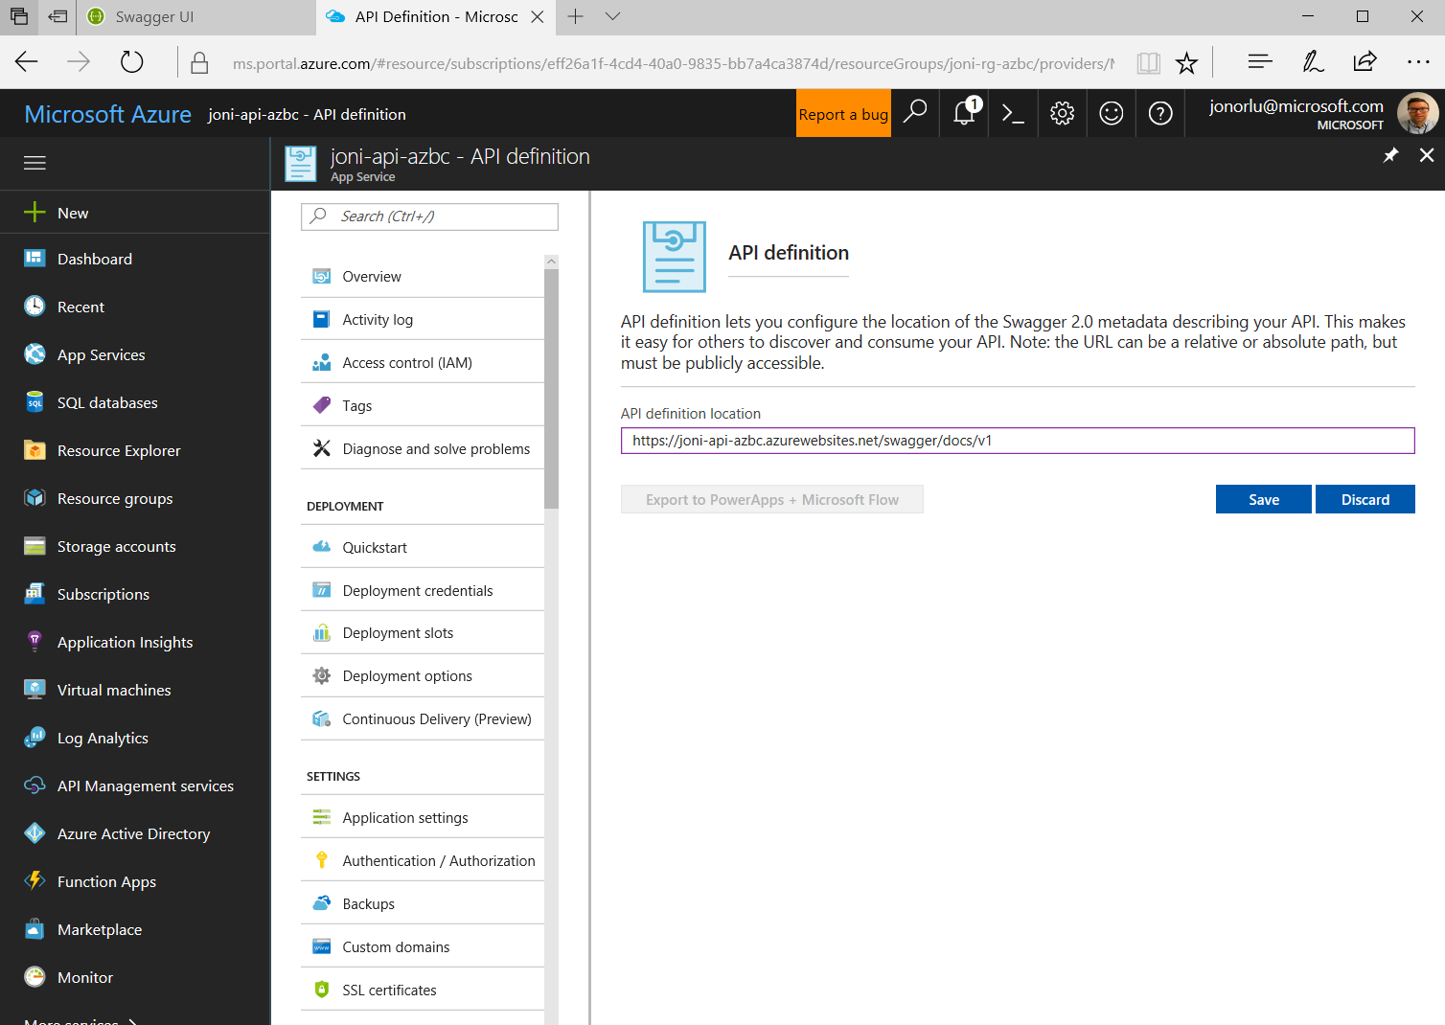

1. Go to the Azure Portal API Management Services

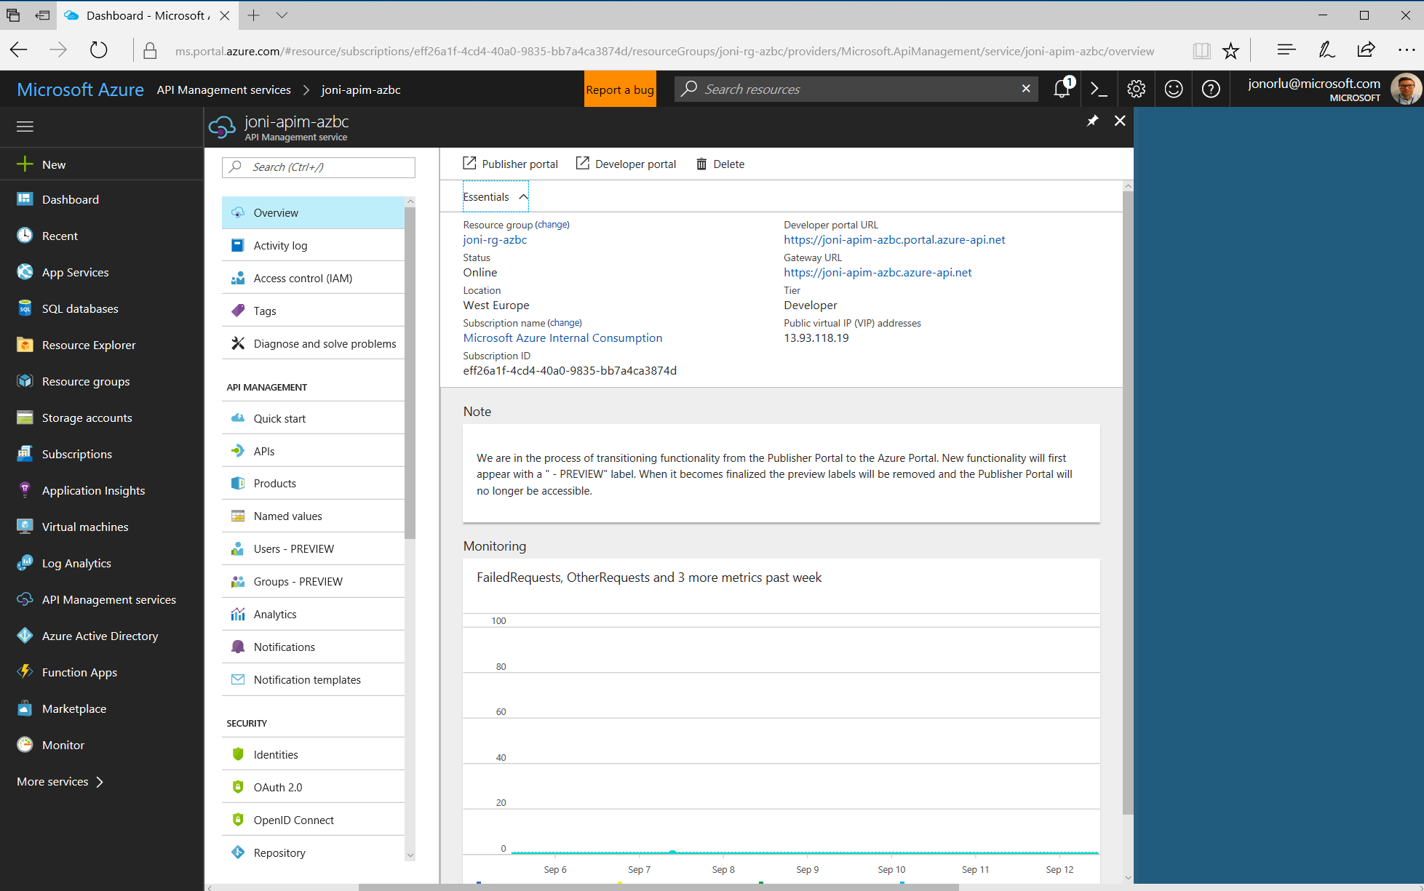

1. Choose APIs 🡪 API App 🡪 Select your API app and give it a name.

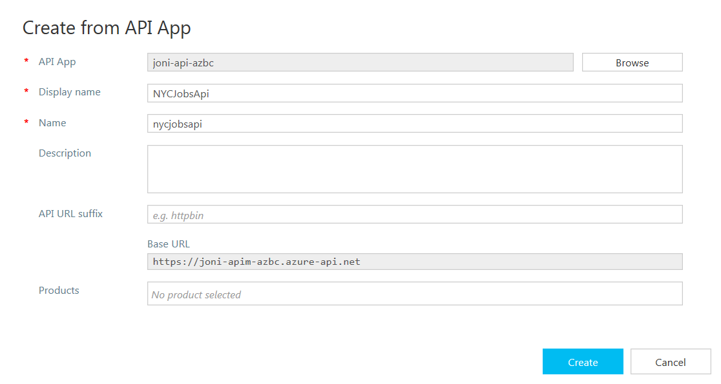

### Task 6: Configure Web app and API

1. Change the URI in the Web App web.config to the base url in API Management. In the example above it would be <https://joni-apim-azbc.azure-api.net>. Make sure the “**Ocp-Apim-Subscription-Key**” in the Web.config are correct, The value can be found under API Management Services 🡪 Users Preview 🡪 Administrator 🡪 Unlimited subscription🡪 Use the context menu to copy/show the primary key.
2. **Publish** the **Web App**
3. Get the service bus connection string. Service Bus 🡪 Shared access policies 🡪 RootManagedSharedAccessKey 🡪 Primary Connection String

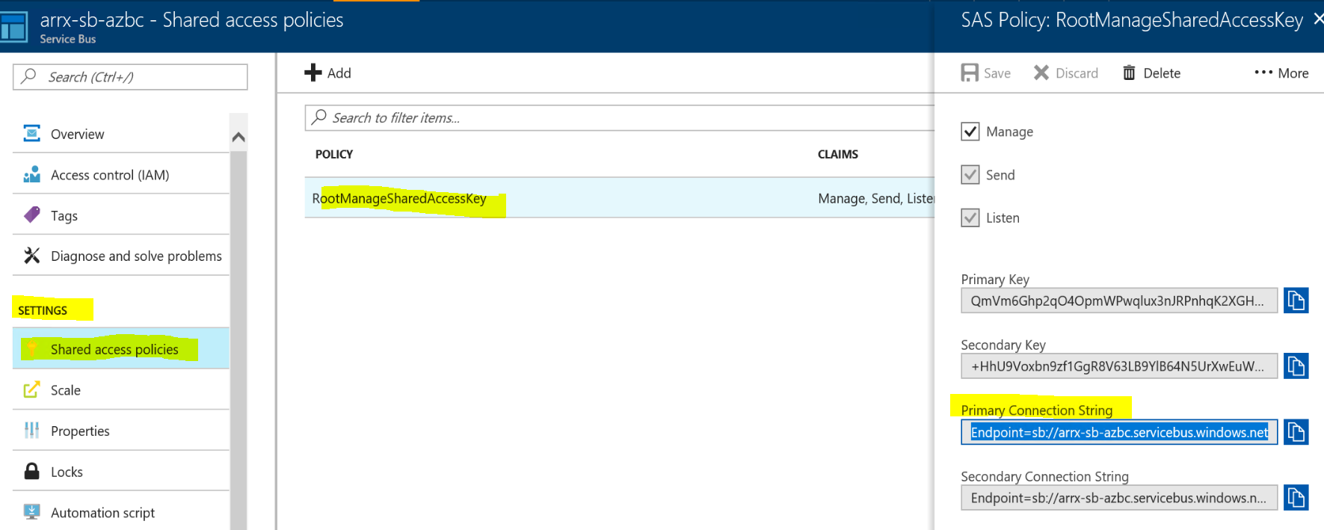

1. Open **Web.config** for the **NYCJobsApi_student** and put the connection string

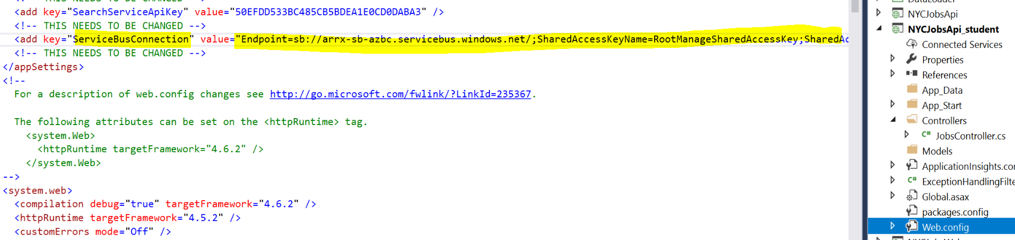

1. **Publish** the **API** after the Web.config has been changed.

### Task 7: Configure Azure Function

1. Choose Integrate and delete the Azure Queue Storage Trigger
2. New trigger 🡪 Azure Service Bus   
     
   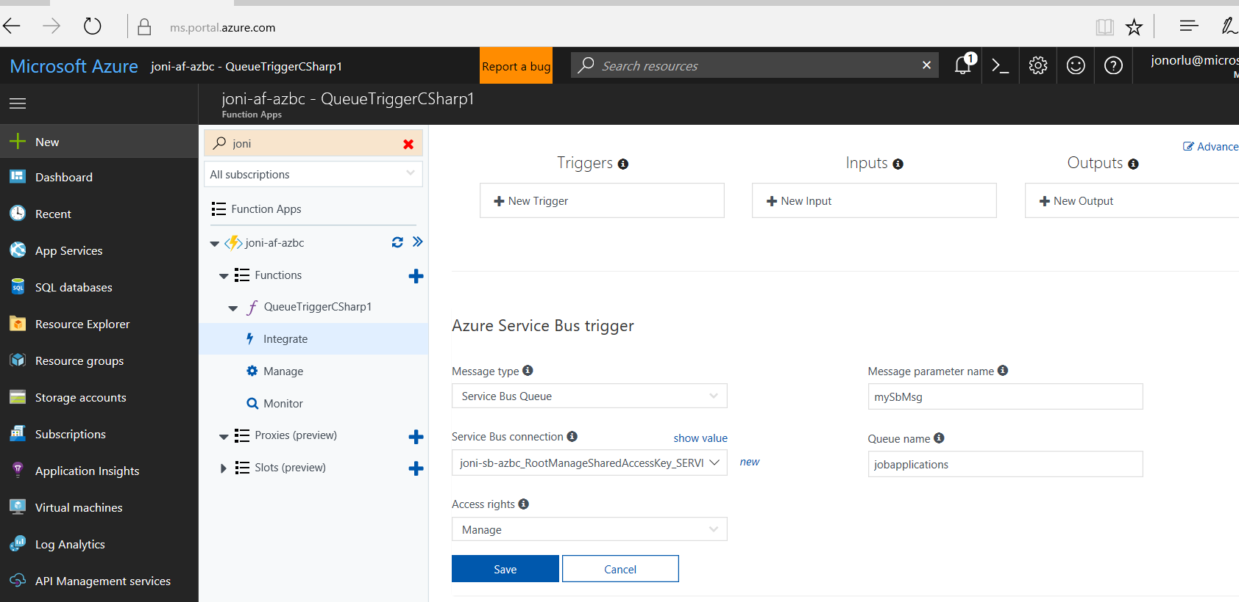
3. New output 🡪 Choose Cosmos DB, make sure you click in **“If true, create CosmosDB database and collection”**

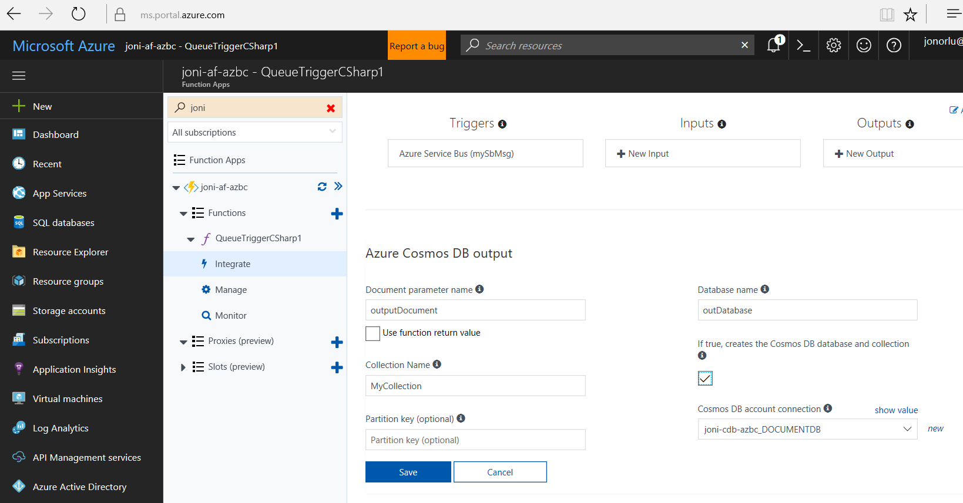

1. Add code to the Azure function

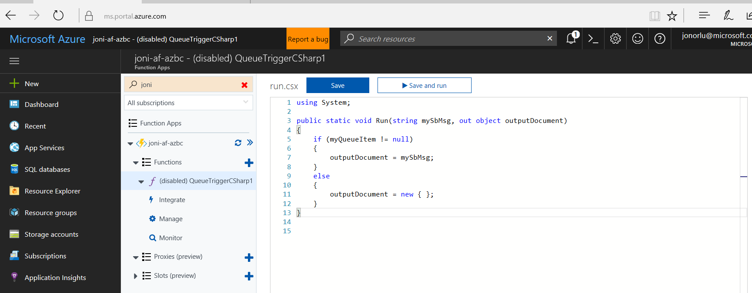

using System;

public static void Run(string myQueueItem, out object outputDocument)

{

if (myQueueItem != null)

{

outputDocument = myQueueItem;

}

else

{

outputDocument = new { };

}

}

1. Test your function by running test and send in a JSON document as test like { “test” : “hej” }

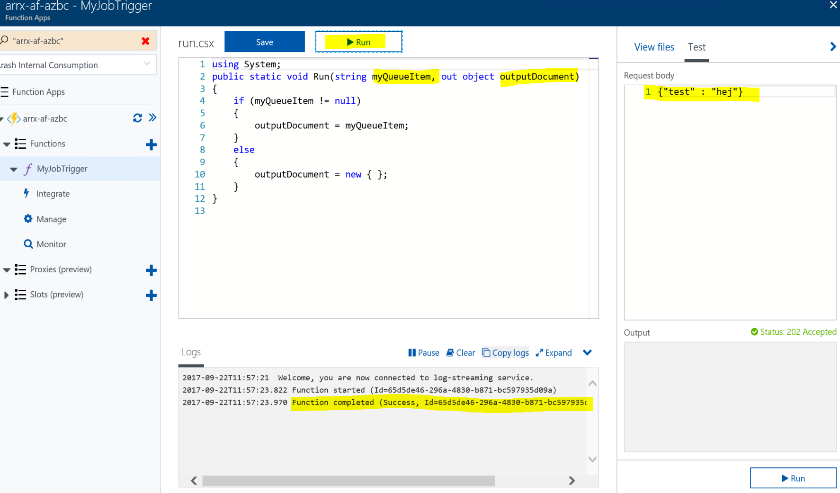

1. Go to your CosmosDB and see your message

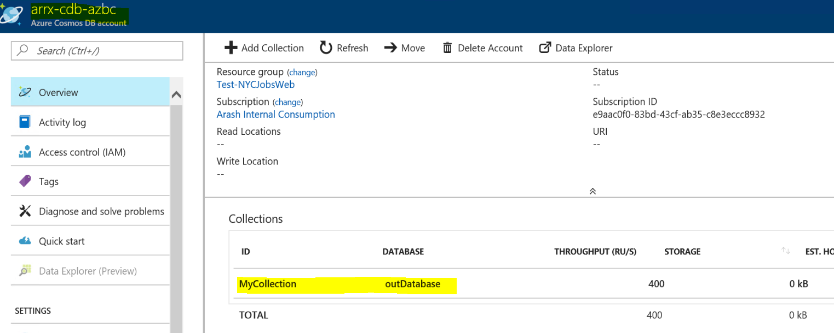

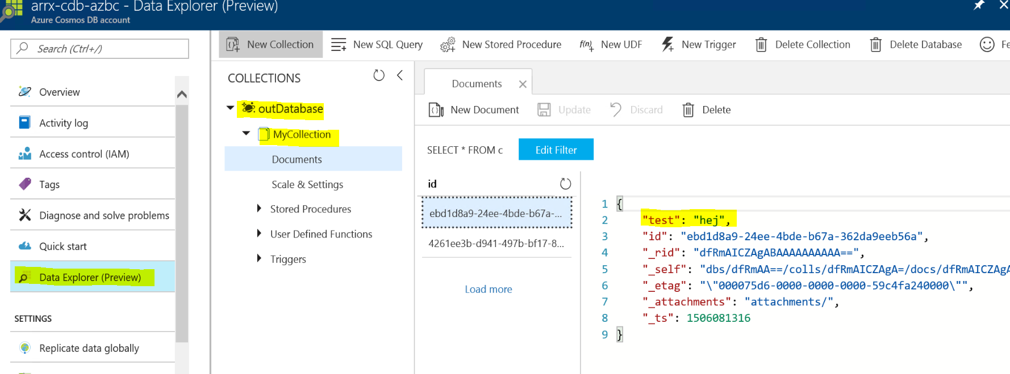

### Task 8: Test the solution

1. Surf to the web site and click on a job offer
2. Scroll to the bottom and fill in your email address
3. Click Apply Now!

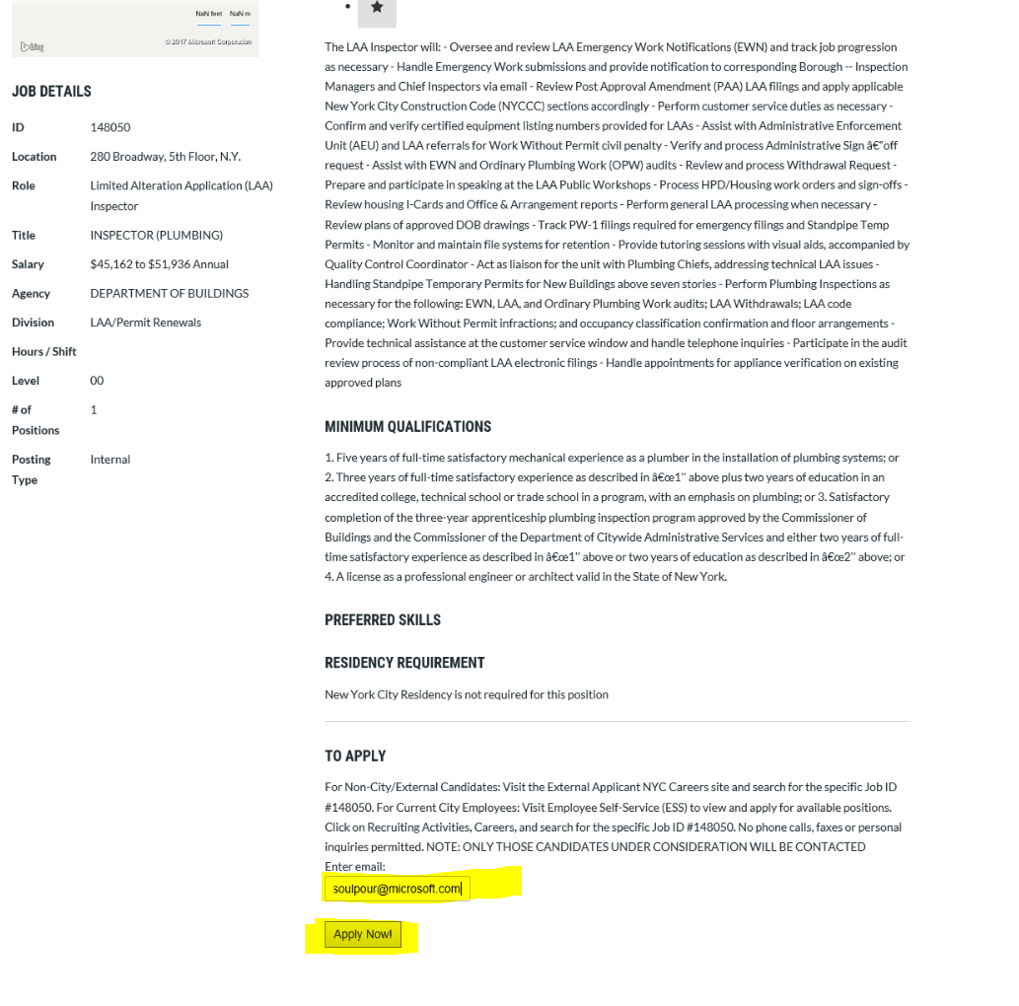

1. Check the Logic App and make sure there has been a triggered fired. You should have received an email from a very suspect person [Jonas.Norlund@microsoft.com](mailto:Jonas.Norlund@microsoft.com).

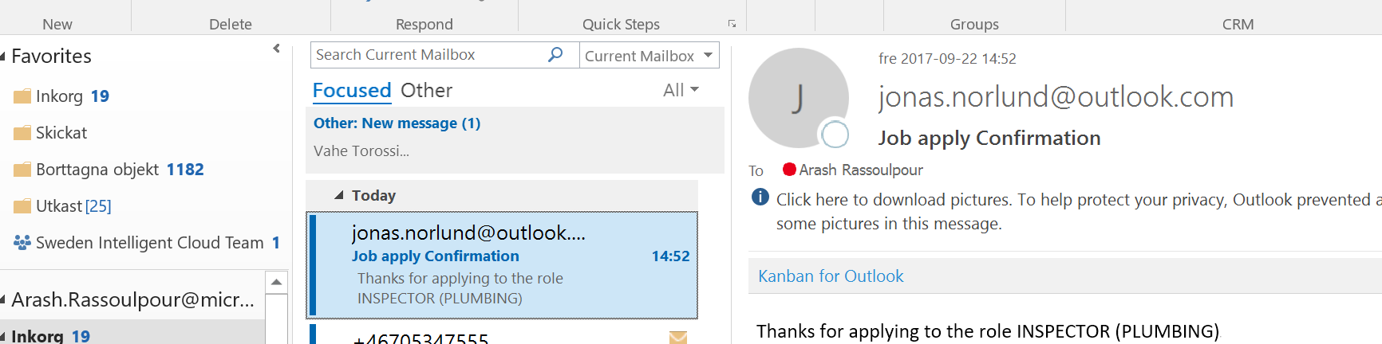

Logic App overview:

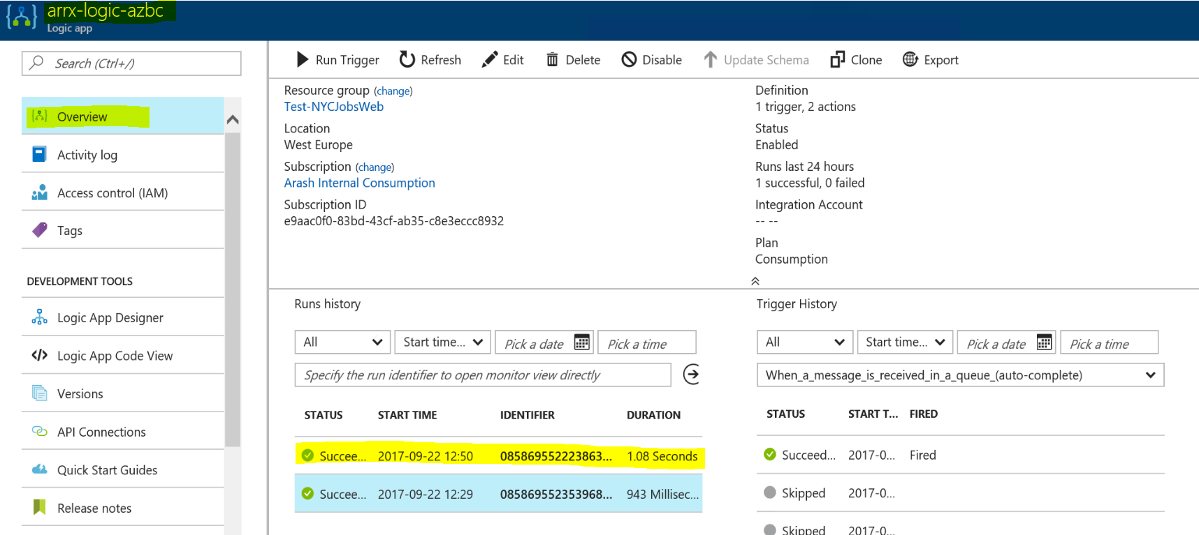

1. The CosmosDB should have the data stored as well.

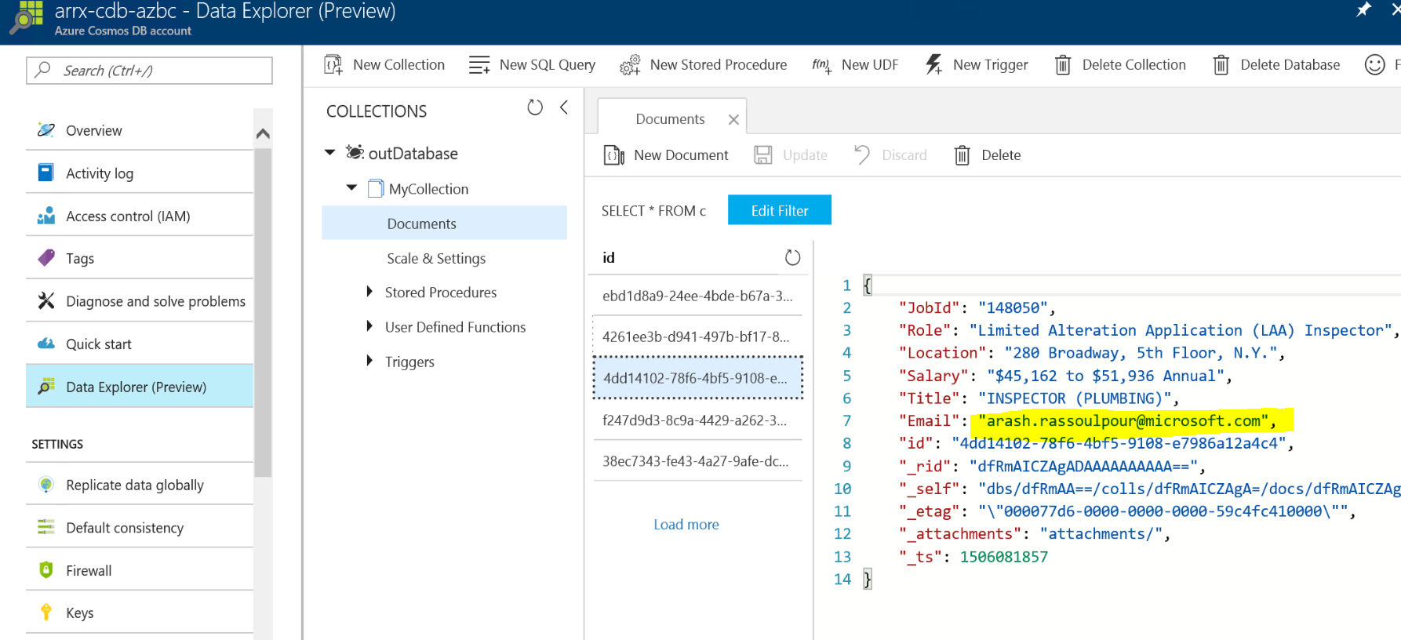

## Exercise 4: Create Visual Studio Team Services Team Project and Git Repository

### Overview

In this exercise, you will create and configure a Visual Studio Team Services account along with an Agile Team Project.

### Task 1: Create Visual Studio Team Services Account

1. Browse to the Visual Studio site at <http://visualstudio.com>
2. If you do not already have an account, click **Get started for free**  
   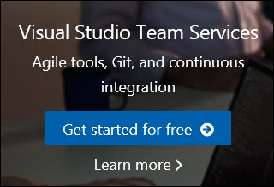
3. Authenticate with a Microsoft account.
4. Choose a name for your visualstudio.com account. Choose **Git** for the source code and then click Continue.  
   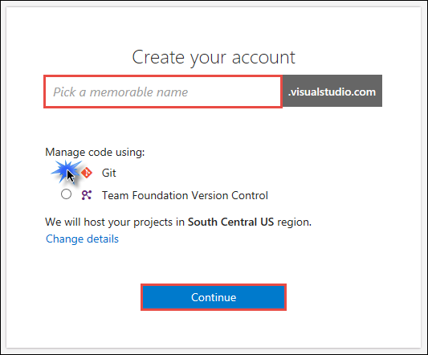
5. Close the congratulations window if it appears.  
   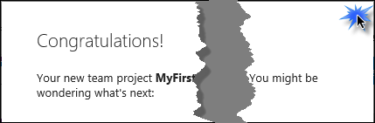
6. On the **Create your first team** project page, set the following values:
   1. Project name: **MyFirstProject**
   2. Process template: **Agile**
   3. Version control: **Git**  
       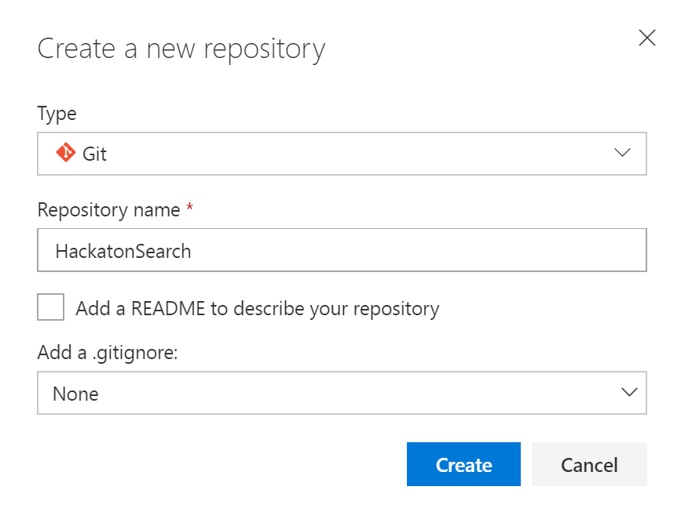
7. Click **Create**

### Task 2: Add the Hackaton Search source code repositories to Visual Studio Team Services

In this Task, you will configure the Visual Studio Team Services Git repository. You will configure the remote repository using Git and then push the source code up to Visual Studio Team Services through the command line tools.

1. Download the sourcecode from **https:<> - @@@ DEFINE!.**
2. Extract the files into **C:\HackatonSearch\**
3. In the support files, open a Git bash command prompt in the **C:\HackathonSearch\**
4. Initialize a local Git repository by running the following commands at the command prompt:

git init

git add *

git commit -m "adding files"

If a “.git” folder and local repository already exists in the HackatonSearch folder, then you’ll need to delete the “.git” folder first before running the above commands to initialize the Git repository.

1. Leave that command prompt window open and switch back to the web browser window for Visual Studio Team Services from the previous Task.  
   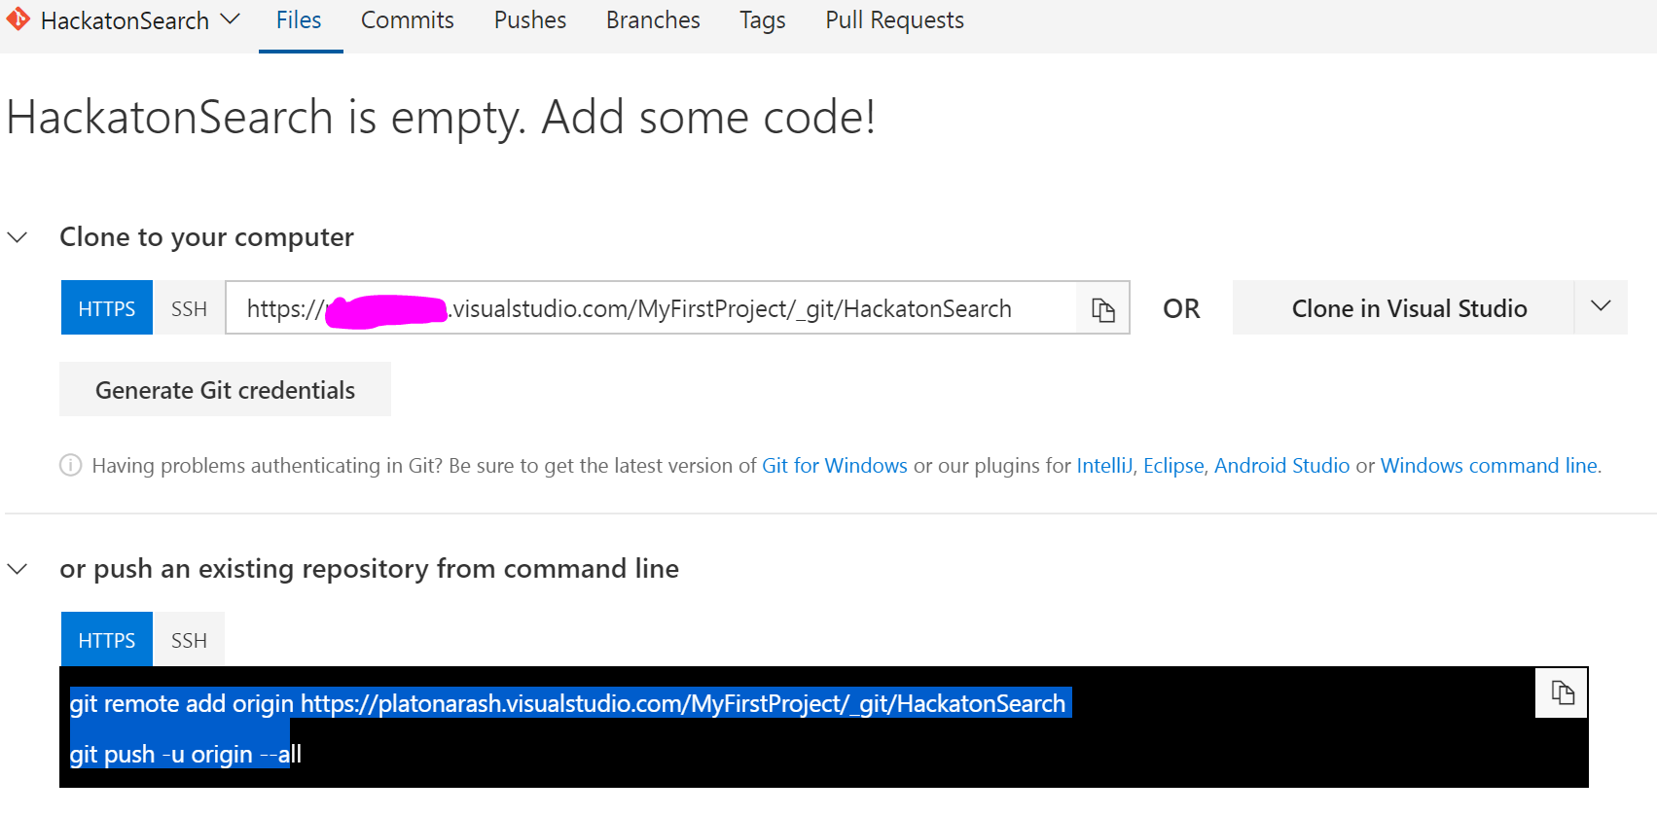
2. Scroll down the page and find the section that provides Git command line instructions.  
     
   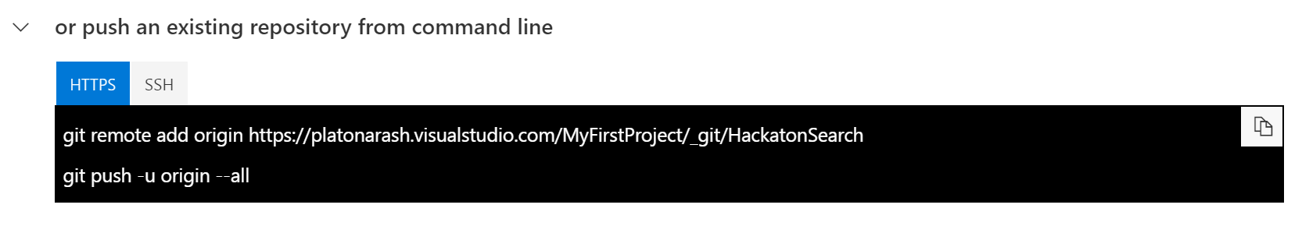
3. Copy the first command under the **Push an existing repository** heading and then paste it in your command window and press the Enter key.  
     
   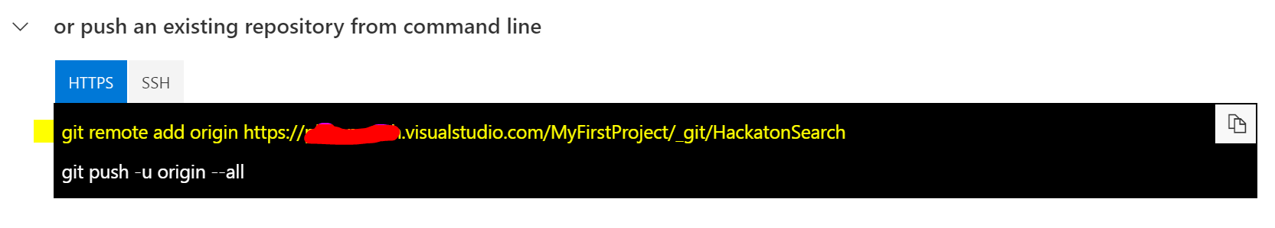
4. Next, copy the second command under the **Push an existing repository** heading, then paste it in your command window, and press the Enter key.  
     
   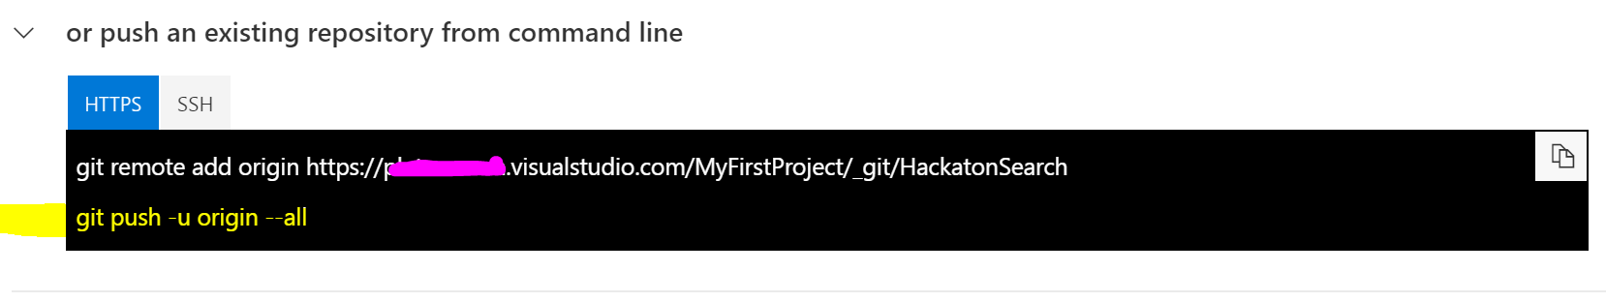
5. You should get a prompt to login with your Visual Studio Team Services credentials, which should be the same Microsoft account you used to create it.  
   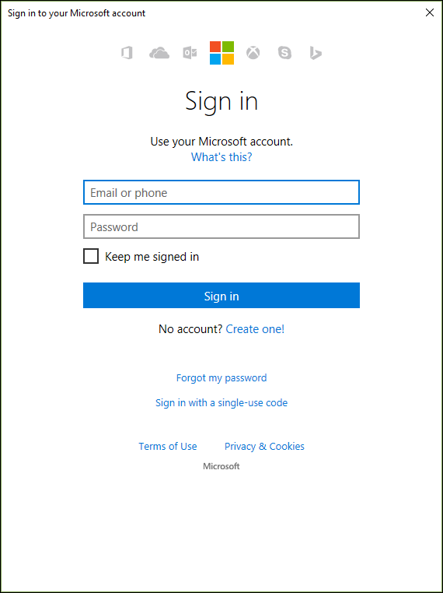
6. You should see some output similar to this after you have logged in.  
     
   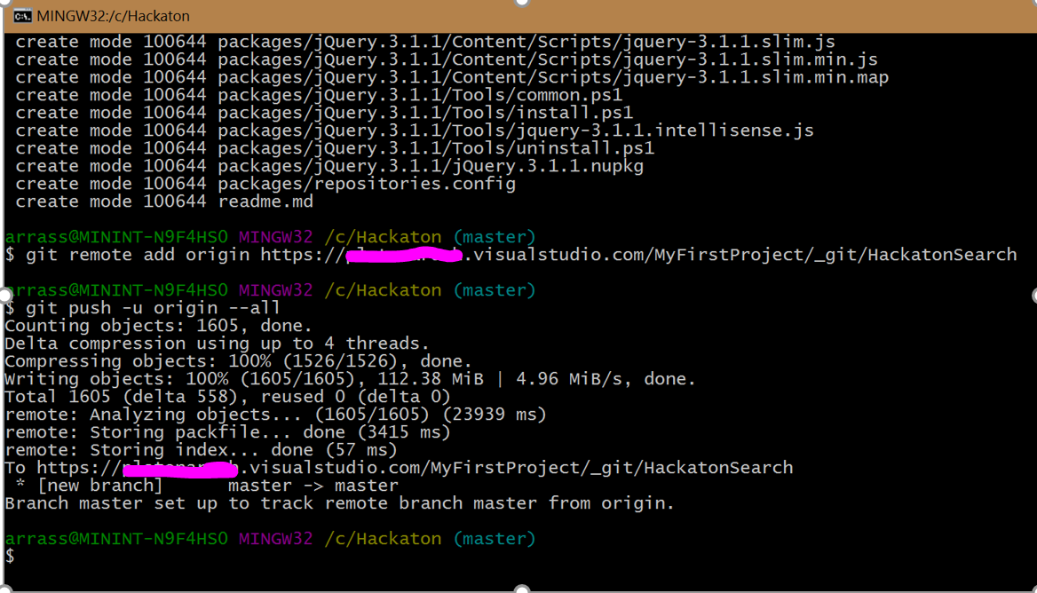
7. Go back to the web browser window for Visual Studio Team Services and click on the **Files** link. You should see your source code now appearing inside of Visual Studio Team Services.

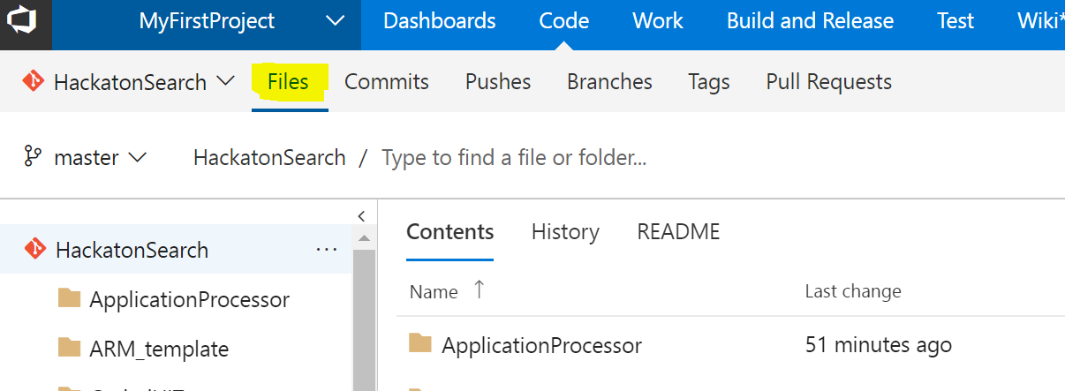

1. Within VTST, on the **Code** screen, click on **Branches.**

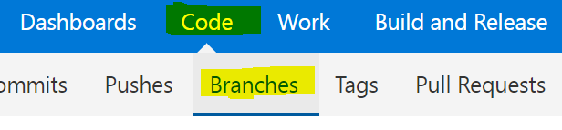

1. Click on **New branch**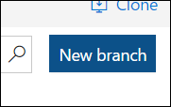
2. Enter **development** into the name field and click **Create branch**.  
   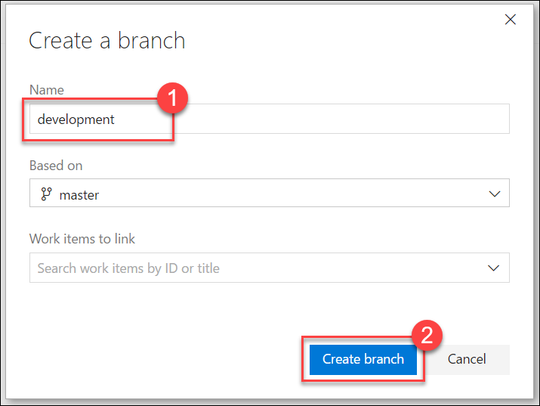

### Summary

In this exercise, you created a Visual Studio Team Services account where the Hackaton Search repositories will be stored online. You then configured Git source control for the Hackaton Search source code and pushed this source code into Visual Studio Team Services.

## Exercise 5: Configure Continuous Delivery for the App Service

### Overview

In this exercise, you will continue the work you started in the previous tasks by configuring the continuous delivery feature for the App Service web app.

### Task 1: Configure continuous delivery from Visual Studio Team Services to the web app

1. Open the resource group in Azure that contains your web app and then click on the web app that you created in the first exercise.
2. Go to **Deployment slots -> Add Slot**

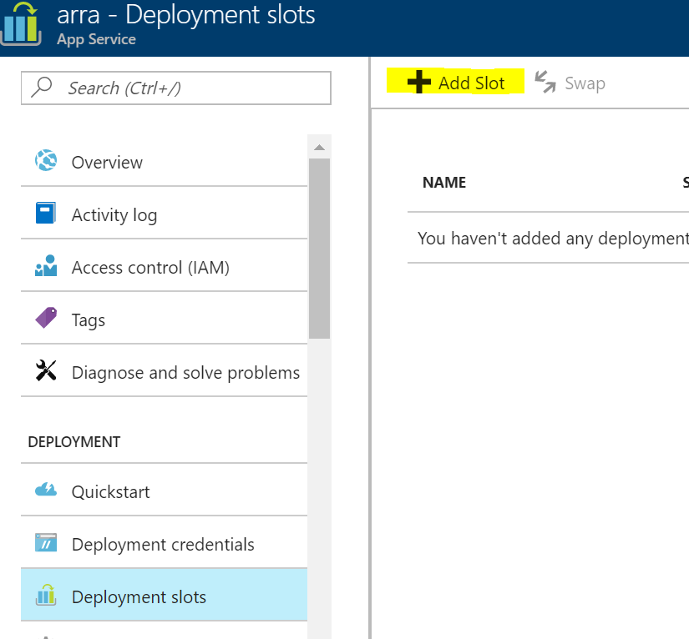

1. Add slot **wa-dev**, “Don’t clone configuration from an existing slot”
2. Add slot **wa-staging, “**Don’t clone configuration from an existing slot”
3. Select the Webapp you created:

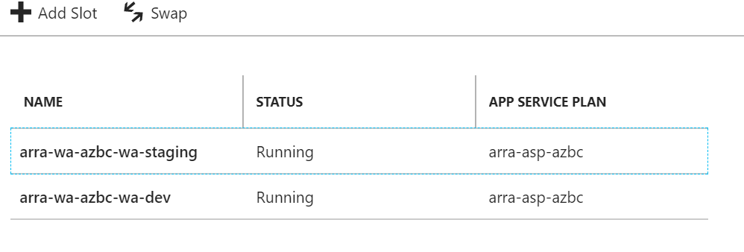

1. Do the same for the API (in this example arra-api-azbc and name the slots
   * **api-dev**
   * **api-staging**

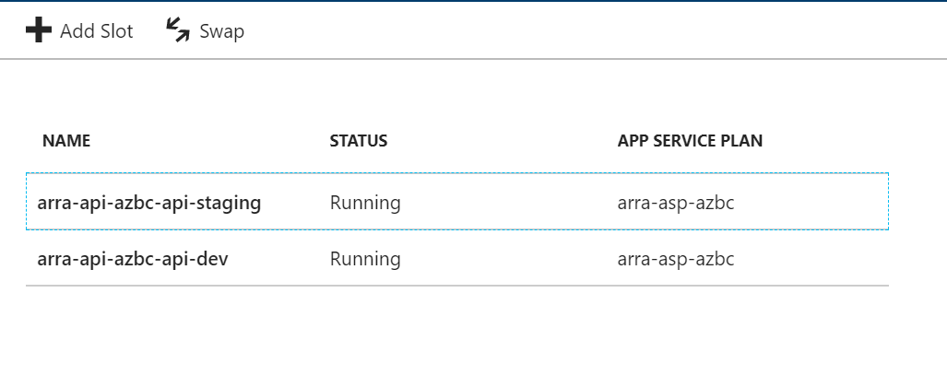

1. Click on your Web App service **(<***>-wa-azbc**). When it opens, click on the Continuous Delivery item in the list of links.

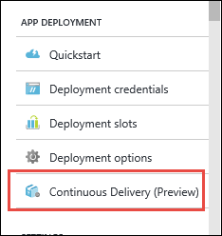

1. On the page that opens, click Configure.  
     
   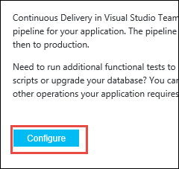
2. Click the Source code link at the top. In the **Code repository**, chose “Visual Studio Team Service”. Then, choose your account name, the Hackaton Search project, and repository, and choose the **master** **branch**. Then, click **OK** at the bottom.

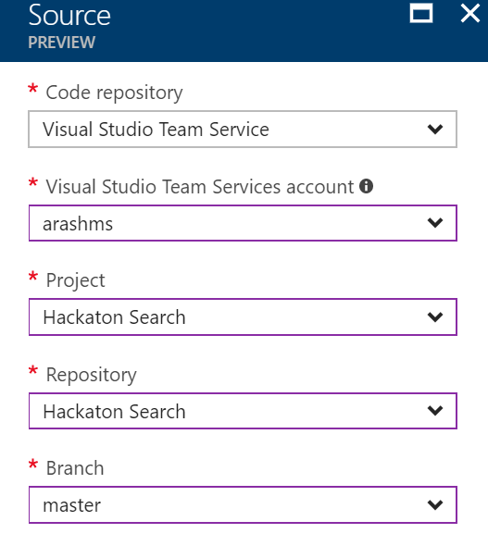

1. Click on the Build link, and choose “ASP.NET”. Then click **OK**.  
     
   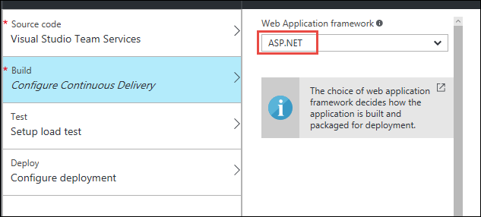
2. Skip the test link, and click on the Deploy link instead. Click **YES** on the deploy to staging option. Choose “create new” and create a slot called **wa-staging** for the web app. Do the same for the API but call the deployment slot **api-staging**.

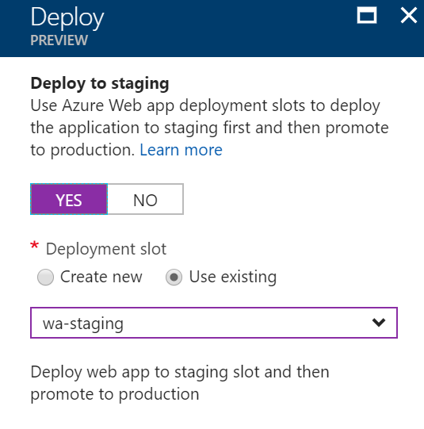

1. Then, click OK at the bottom of the continuous delivery window.  
     
   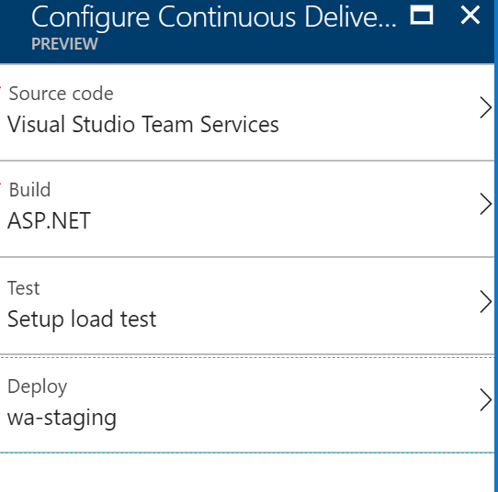
2. The system will automatically connect to source control, build the code in the master branch, run the tests, and deploy the code to the production deployment slot. After a few minutes, you will see some output like this. In this case, with the default settings, since all the builds and tests passed, it automatically swapped the staging and production slots.
3. The release will fail because there are two potential projects that can be deployed so you will get an error (shown below). To fix this click on the **Release** configuration marked yellow below:  
     
   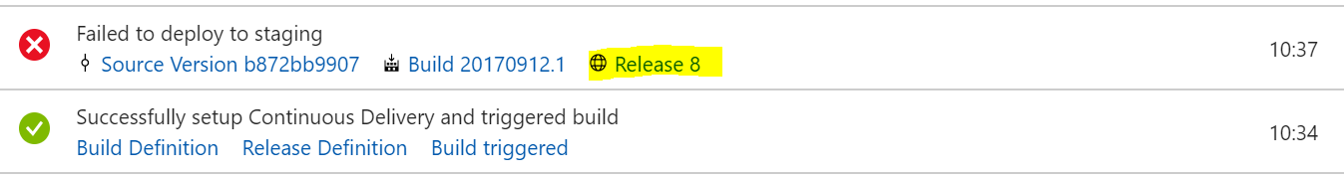
4. You will enter the VSTS and then click on the … and then Edit.

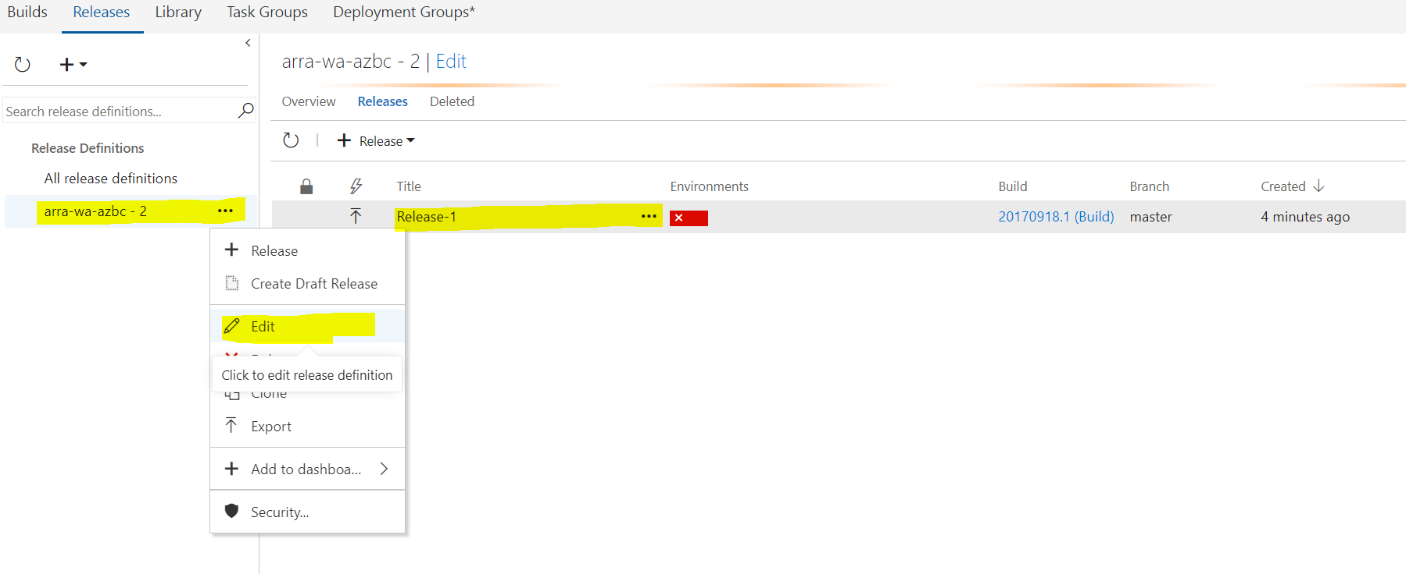

1. Then click on **1 phase, 2 tasks.**

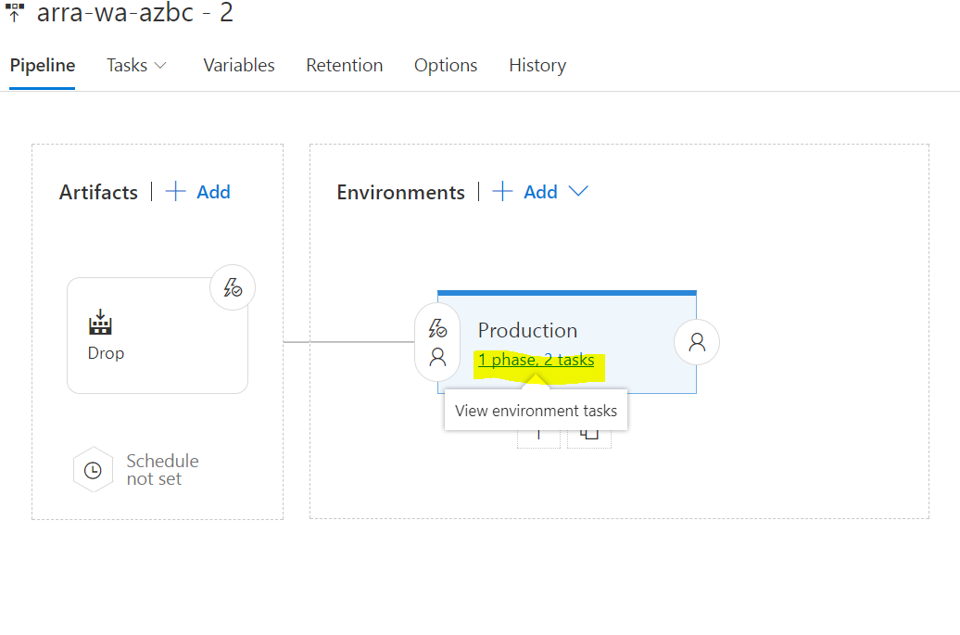

1. Change the **package zip** file to be deployed by clicking on the **Deploy Azure App Service to Slot** and then on the **…** and choose the **NYCJobsWeb_student.zip**

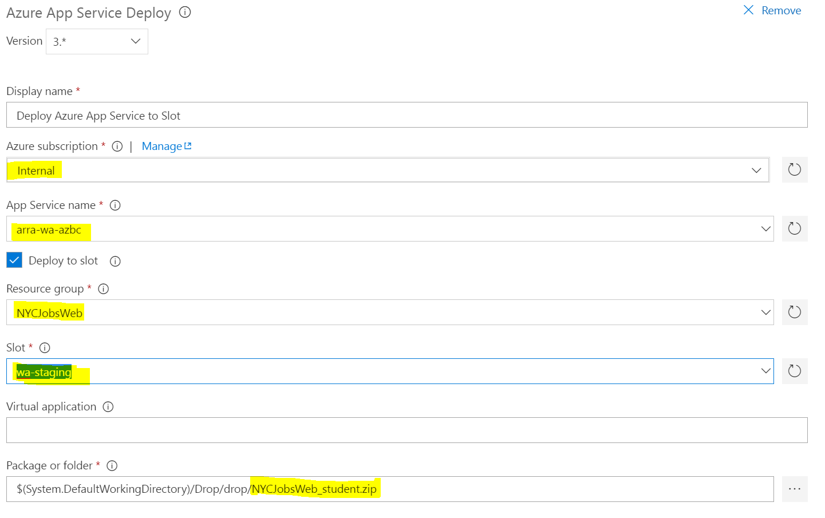

1. Then click **Save** in the right corner.
2. Trigger a new Build and Release by checking out **any file** and making a small change and commit and push the file to VSTS.

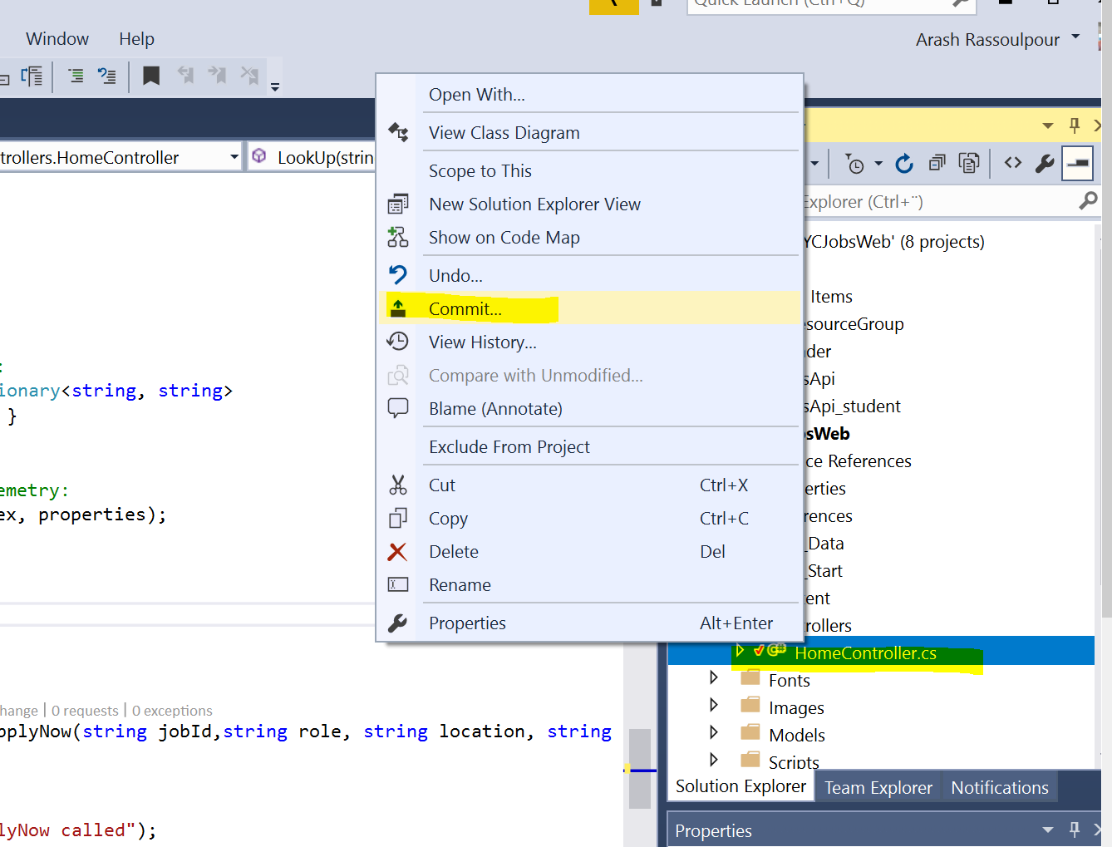

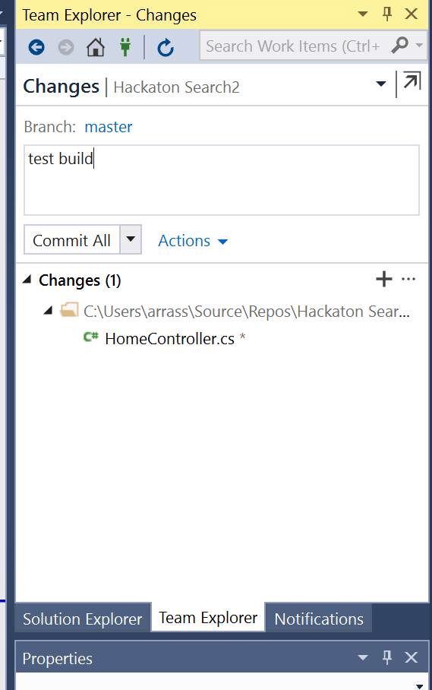

1. **Push** you current changes to VSTS.

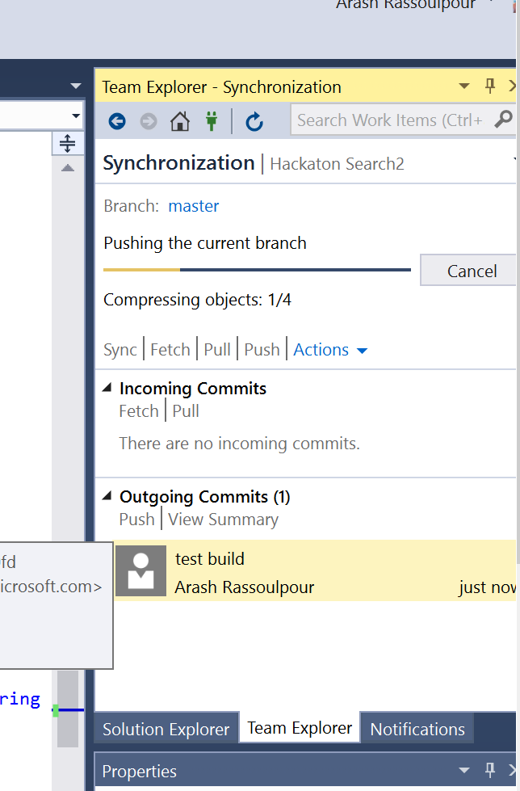

1. Go to Builds in your VSTS. You should now have a successful Build and successful Release.

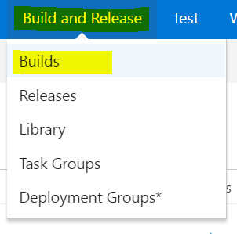

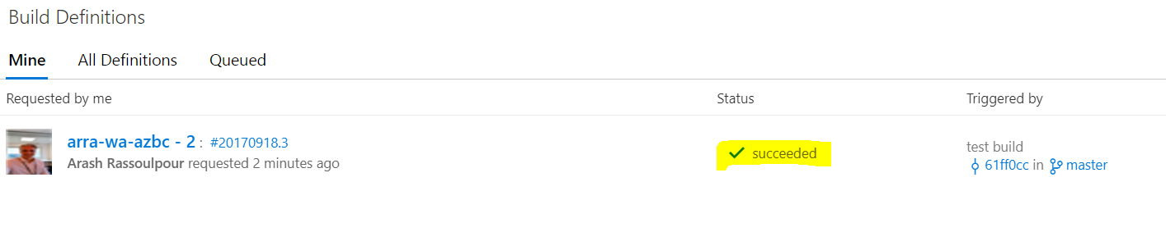

1. We successfully triggered a Build just as before, now we need to check Releases. Go to **Releases**.

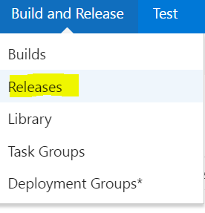

You should have the new successful build because we changed the Zip-file of the release to be on the WebApp.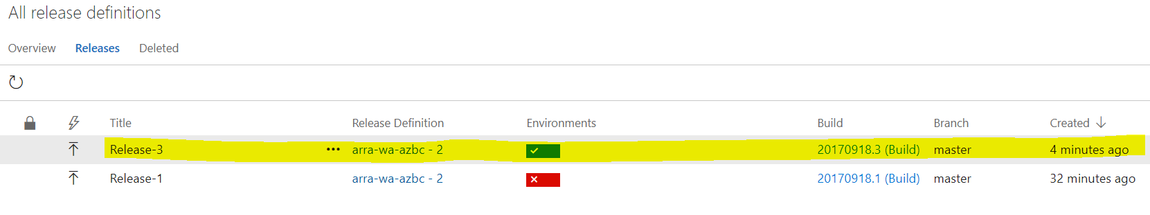

### Task 2: Configure continuous delivery for the **development** slot.

1. Now we have completed the Web App to be automatically built and released. Let’s add the API as well. **Edit the Release definition** in Visual Studio Team Services.

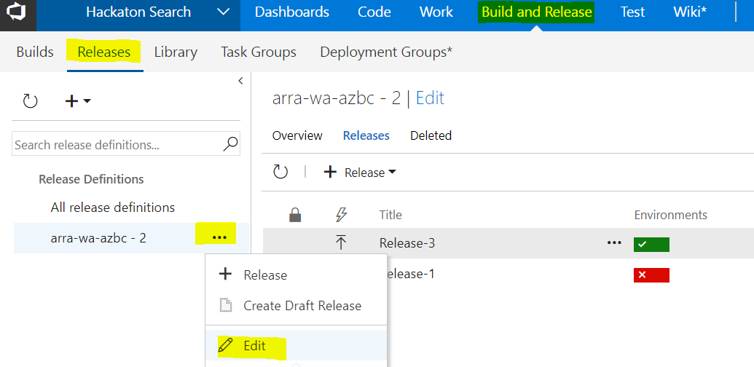

1. Click on the **1 phase, 2 tasks**

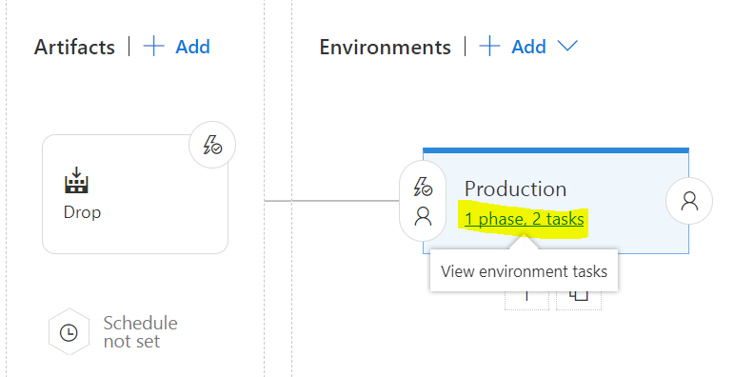

1. Add a new task by clicking on the **+** and **Azure App Service Deploy** and then **Add.**

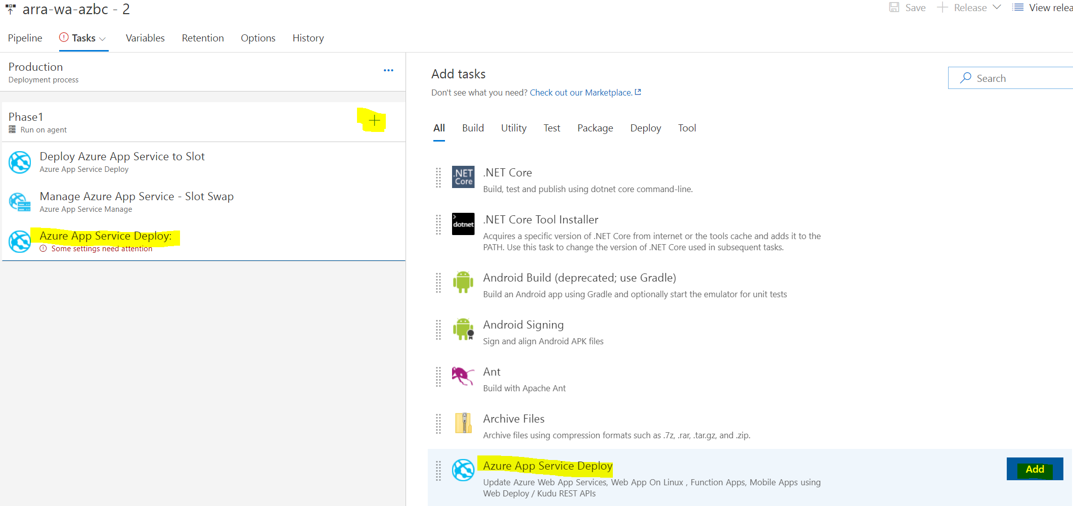

1. Fill in the subscription, App Service name of your **API - ****-api-azbc,** Resource group and slot name **api-staging**.

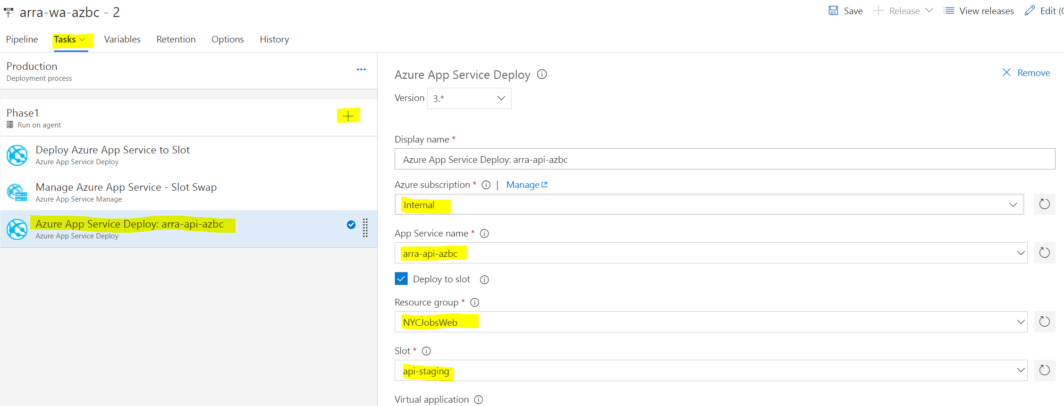

1. Click on the **+** again and add **Azure App Service Manage**.

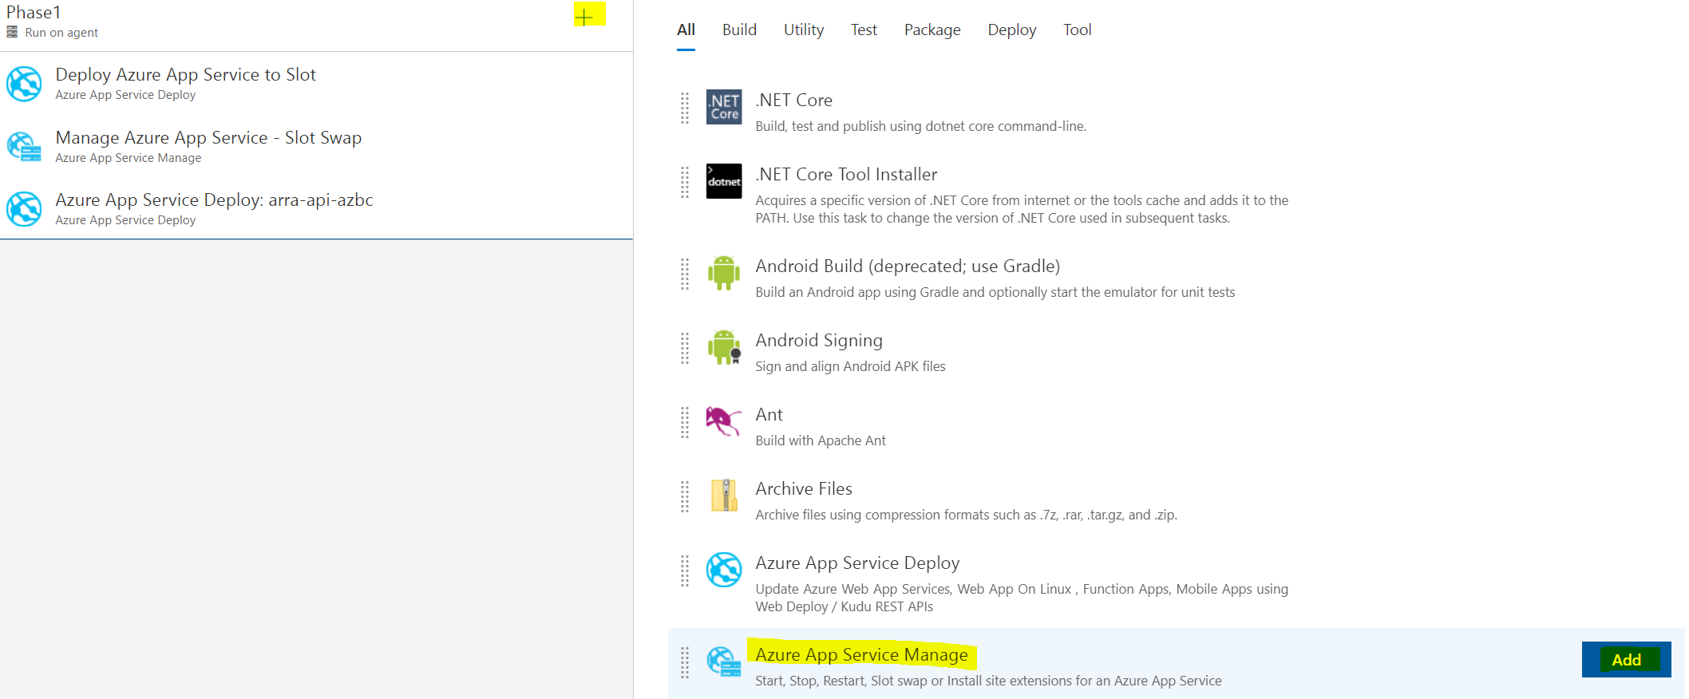

1. Change to **your subscription**, **Swap Slots**, **\*\*\*\*-api-azbc**, Resource Group and source slot **api-staging**.

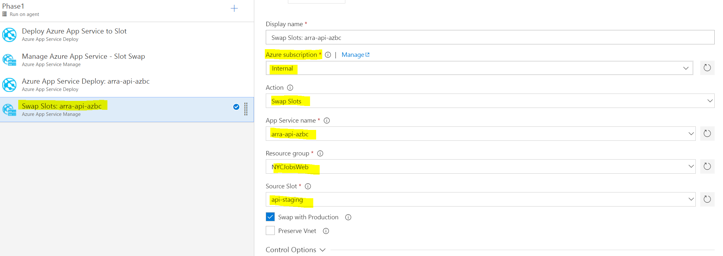

1. Click Save.
2. Trigger a build by changing a file and pushing it source control.
3. Check your builds and see that it has been built.

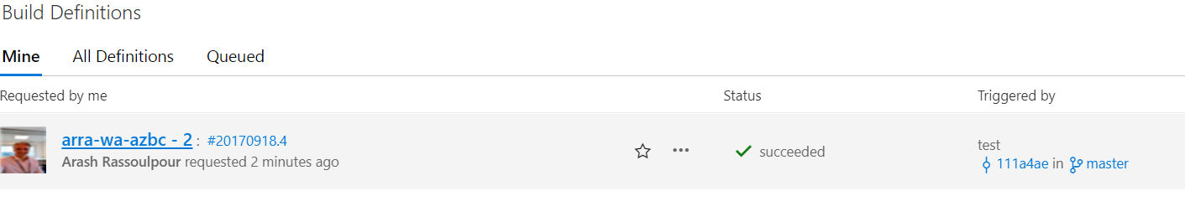

1. After the build, check the Releases and confirm that the API has been deployed by seeing the green status of the Release.

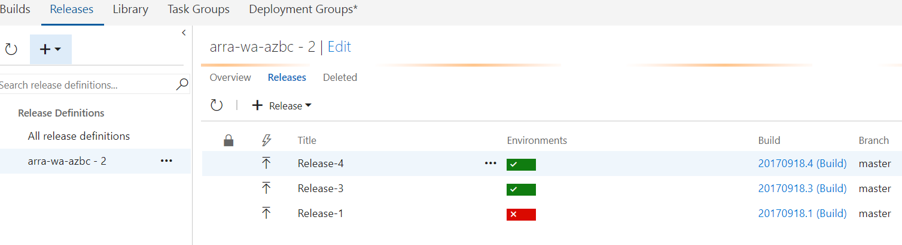

### Task 3: Configure continuous delivery for the development slots.

1. Now we have completed the Web App to be deployed and automatically built.
2. From the same screen as the last step, click on the link with the build number. This will take you to the builds section of Visual Studio Team Services.
3. Near the top of the page, hover over “Build & Release” and then choose “Builds”.  
     
   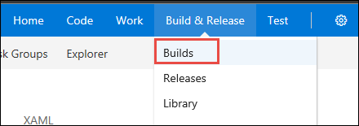
4. Click the ellipsis next to the existing build definition, and choose “Clone”.  
     
   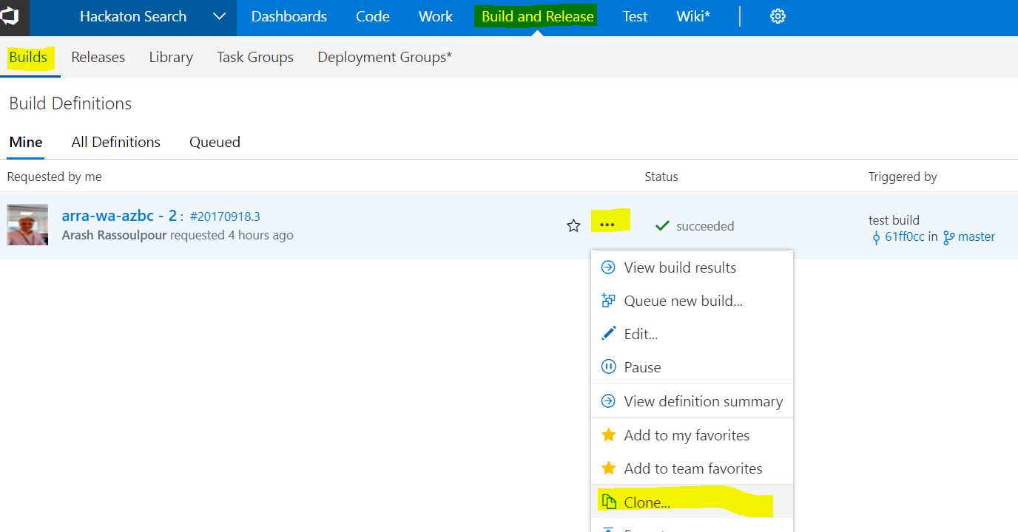
5. Click on the “Repository” link, and change the Default branch from “master” to “development”.

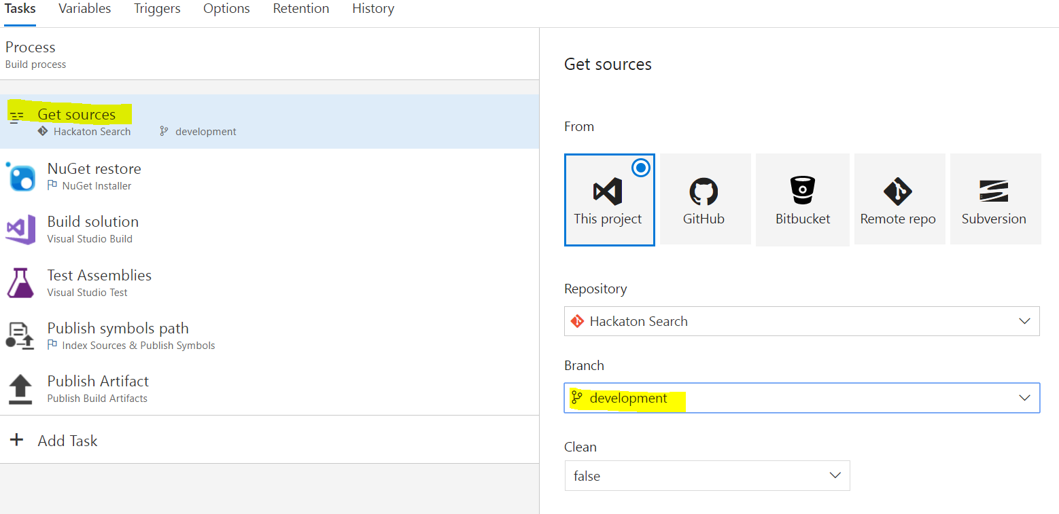

1. Click on “Triggers” and click on “Continuous integration (CI)”.  
     
   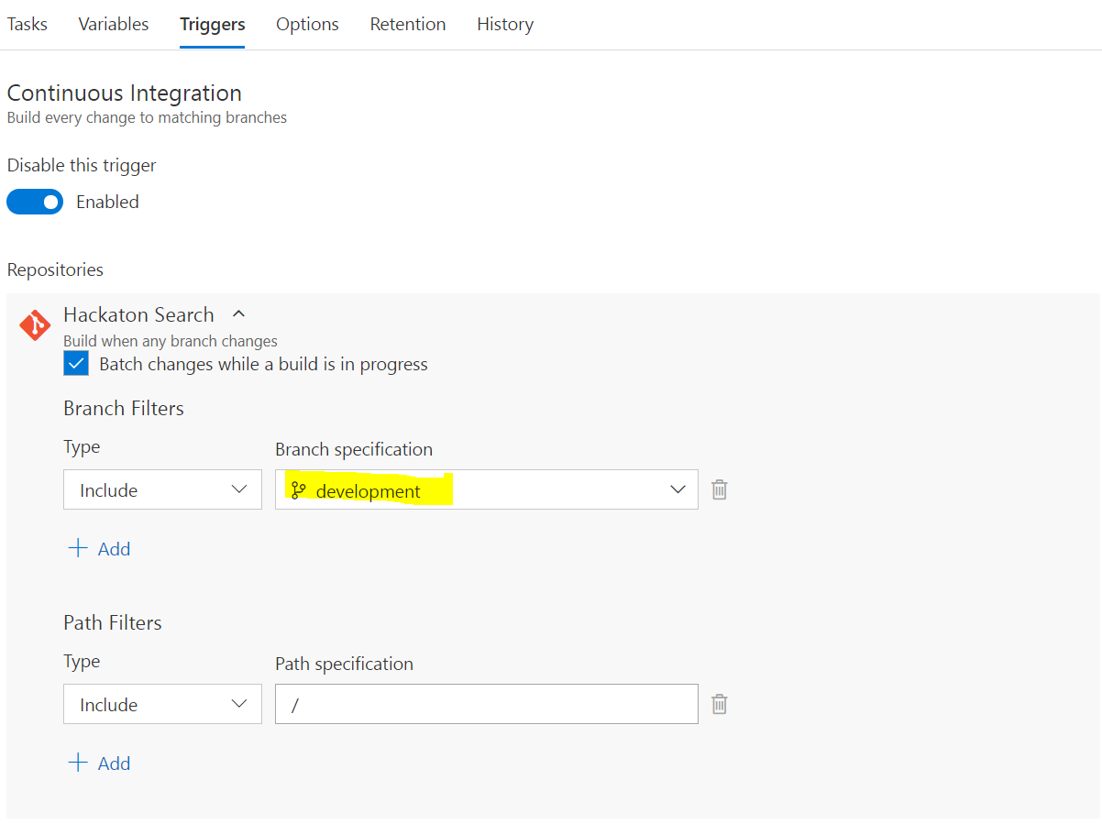
2. Then, click on the Save button near the top-left.  
     
   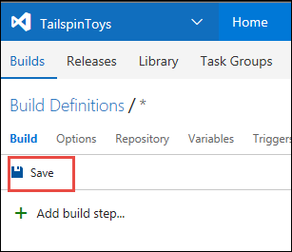
3. You should have two build definitions now.

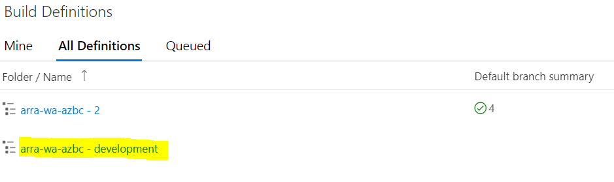

1. Next, go back to the “Build & Release” link and this time choose **Releases**.  
     
   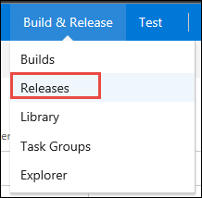
2. Find the release definition on the left, click the ellipsis again, and choose **Clone**.  
     
   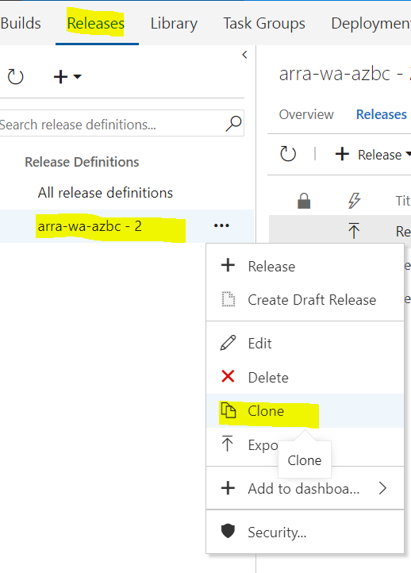
3. Click the name at the top and change it to “**\*\*\*\*-wa-azbc - Development**”.  
     
   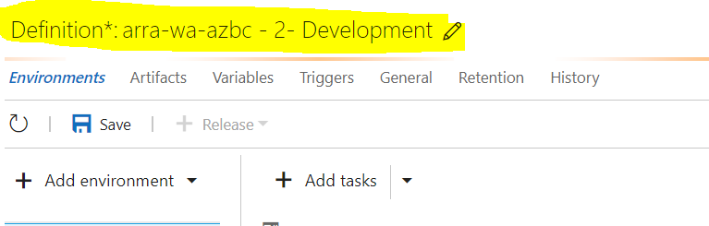
4. On the main screen, change the **Slot** from “**staging**” to “**development**” and make sure you choose the Package or Folder again to point to the zip-file **$(System.DefaultWorkingDirectory)/****-wa-azbc - development/drop/NYCJobsWeb_student.zip.**   
     
   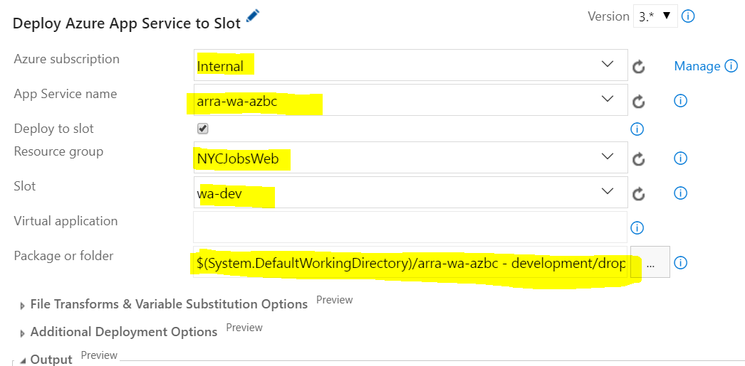
5. Delete the second step of the build by clicking the red “X” symbol next to it. We do not want an auto-swap for the development build process.  
     
   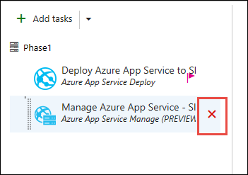
6. Do the same for the API by selecting the second **Azure App Service Deploy -** **\*\*\*\*-arra-api-azbc** then click **Save**.

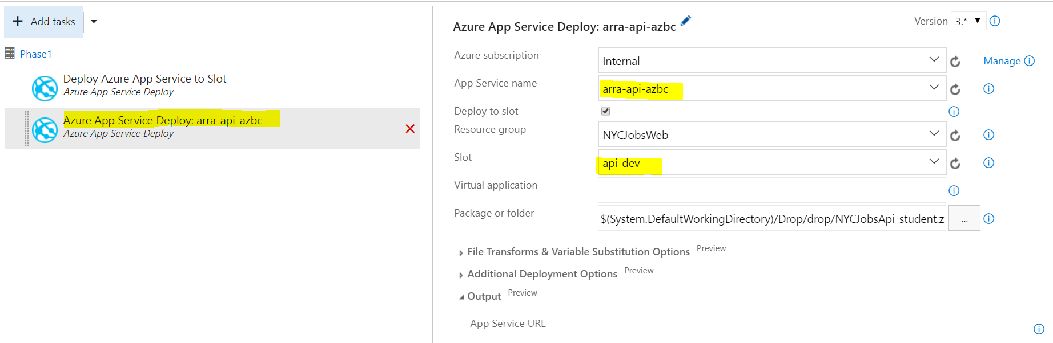

1. Click on the Artifacts link near the top.  
     
   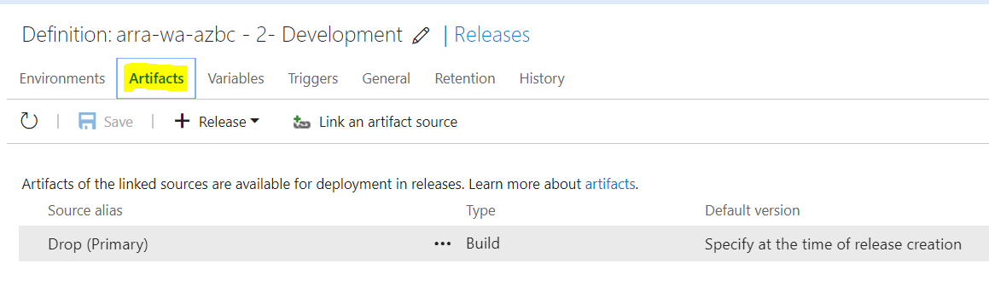
2. Then, click “Link an artifact source”.  
     
   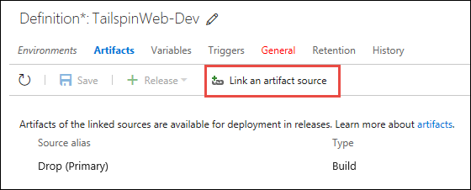
3. On the window that pops up, change the build definition to your development build, then click **Link**.  
   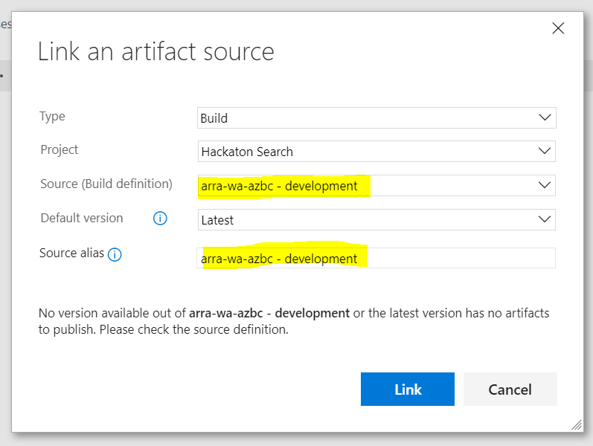
4. Next, remove the “Drop (Primary”) artifact from the list.  
     
   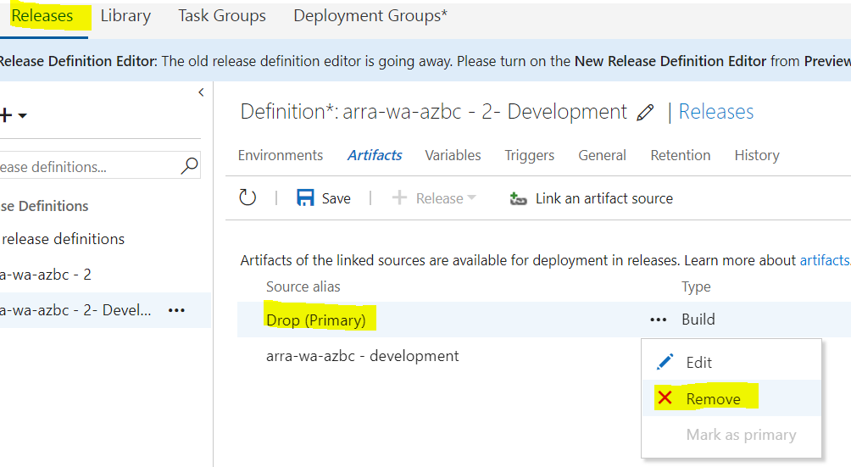
5. Then, choose the “Triggers” link at the top.   
     
   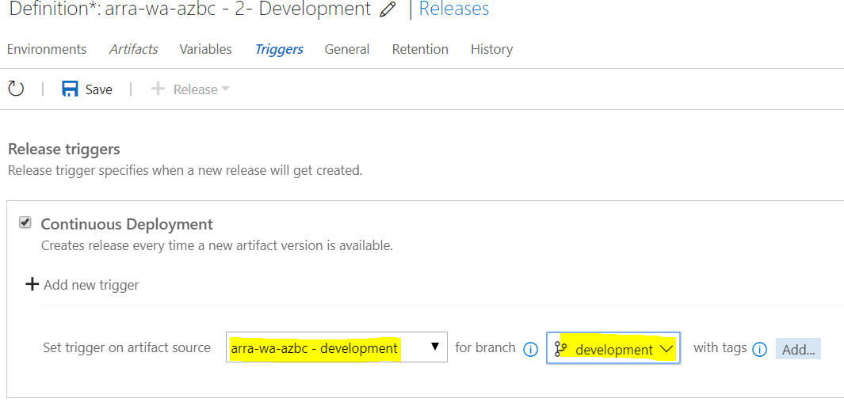
6. Then, choose the new “**arra-wa-azbz - Development**” artifact and the “**development**” source control branch.
7. Next, click on the “General” link at the top.  
     
   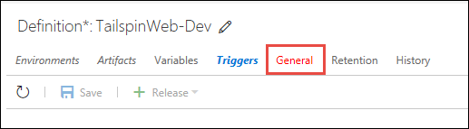
8. In the “Release name format” box type this value:

DevRelease-$(rev:r)

1. Then, click the **Save** button. Click **OK** at the next prompt.  
     
   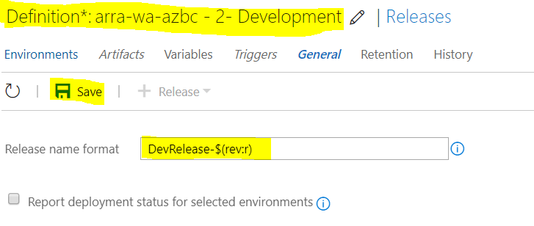
2. Now, with all of these configured, you can push code changes to master, which will trigger a build, with unit tests, deploy to the staging slot and automatically swap with the production slot if everything was successful. You can push code to the development branch, which will automatically build, with unit tests, and deploy to the development deployment slot.

### Task 4: Test the deployment process

1. Open Visual Studio and the **NYCJobsWeb** solution and go to **Team Explorer** and open **remotes/origin.** You might need to refresh Visual Studio. Choose **Checkout**.

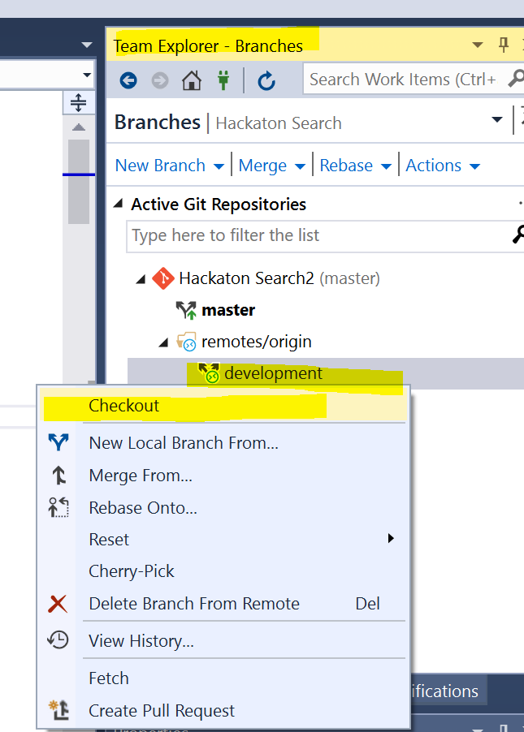

1. At the bottom-right of the window, click the branch and change it to “development”.

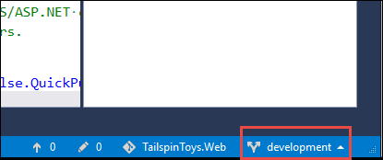

1. Then, in Solution Explorer, open the **_Layout.cshtml** view under the **Views/Shared** directory.  
     
   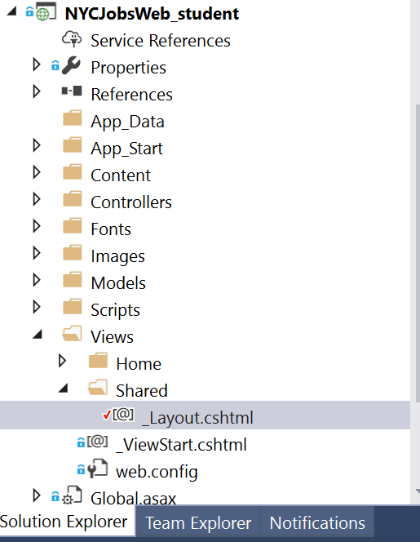
2. Above the existing **<title>** element, add this code. Save your files.

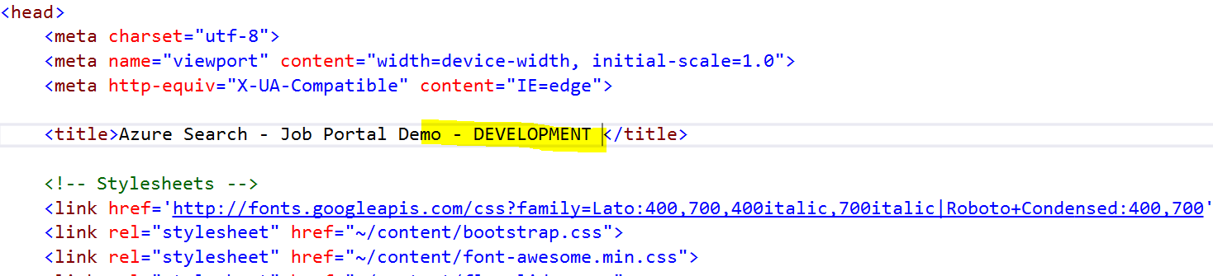

1. Click on Team Explorer, click Changes, and commit the change with a brief description.

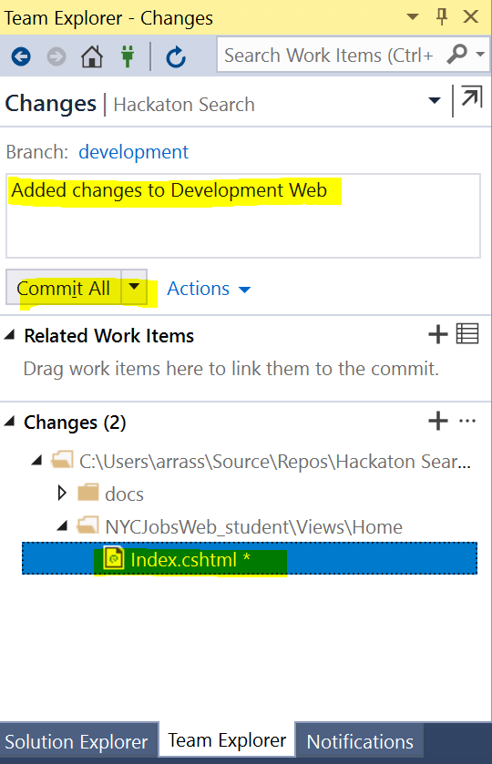

1. Then, go to the Sync section and push your changes.  
     
   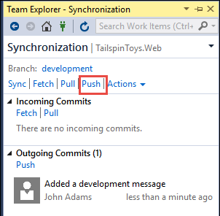
2. Now, navigate back to the Visual Studio Team Services web portal and go the builds page. You should see something like this, showing that it found your change and started a build.  
   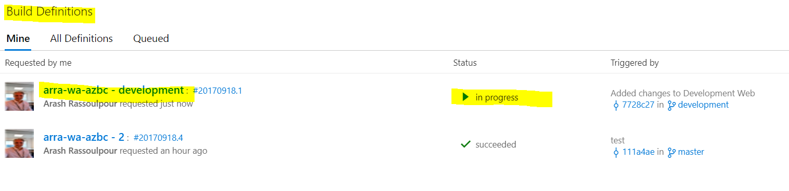
3. Once it succeeds, go to the releases section of this Visual Studio Team Services portal, and check the release process. You should see the **DevRelease** in progress like in this screen shot.  
   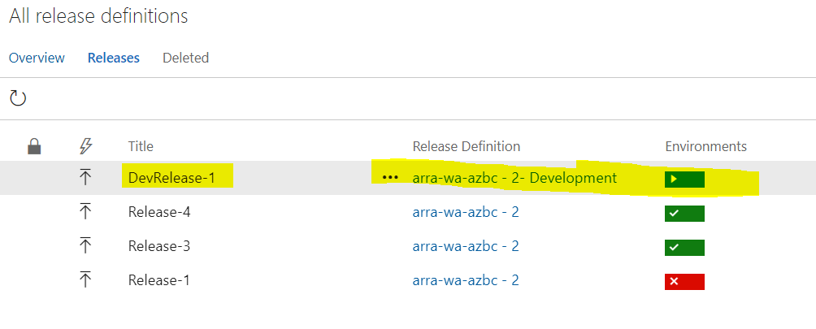

1. Once it completes, go back to the Azure portal, find your resource group, and click on the development slot.

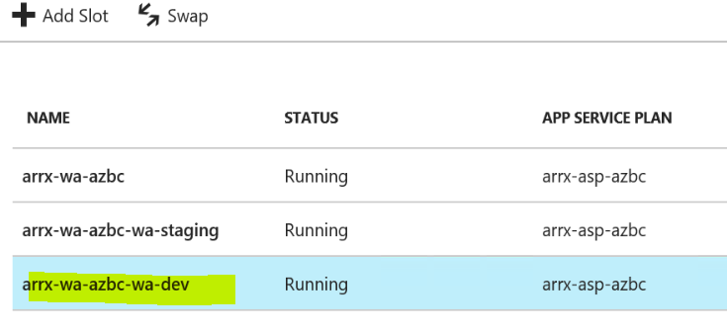

1. Click the hyperlink at the top to see the site. Your changes should be live.  
     
   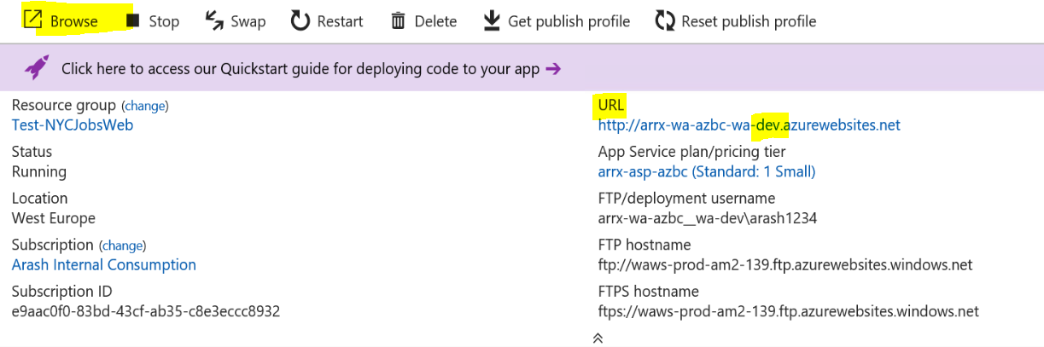
2. You can see your text, which is only in this branch, at the top.  
     
     
   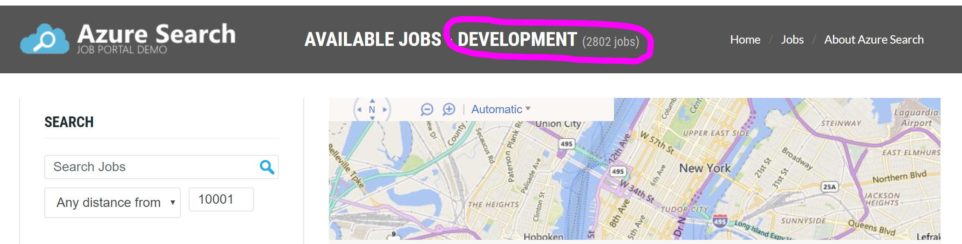

### Summary

In this hackathon lab, you created deployment slots inside of an Azure App Service web app that were designed to accommodate multiple branches of source code. You then configured continuous deployment for each slot from a specific branch of a Git repository in Visual Studio Team Services.

## Exercise 6: (advanced): Use Application Insight Analytics for machine learning

### Apply Application Insight to Website, API and Azure Function

1. Add the Application Insight Nuget package to the website project in Visual Studio. Make sure they have version 2.2 Beta or greater. You will get an ApplicationInsight.config file in the main directory.

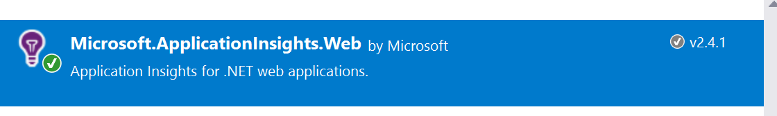

1. Go to Application Insight in Azure and get the Instrumentation Key from properties.
2. Add the instrumentation key to the ApplicationInsight.config file.
3. Do the same for the API application.
4. Add “APPINSIGHTS_INSTRUMENTATIONKEY” and the instrumationkey to the Application Settings for the Website, API and also Azure Function. You can find the Application settings for the Azure function in the main page of the Azure function.
5. Open Application Insight artifact in the Azure portal. Go to Live Stream. Start surfing on the Web site and watch data appear.
6. To add your customized telemetry to application insight, see the API: <https://docs.microsoft.com/en-us/azure/application-insights/app-insights-api-custom-events-metrics>
7. Create a telemetry client to the Web site and API in the C# code and start tracking **events**, **exceptions**, **trace.** See <https://docs.microsoft.com/en-us/azure/application-insights/app-insights-api-custom-events-metrics> for examples.
8. Publish the Web site and API with the new code changes.
9. Surf to the Website and watch the Live Stream in Application Insight and your events, traces and events.
10. The telemetry in the above steps are sent from events on the server side (blue and yellow picture below) and not from the client side (dotted blue).

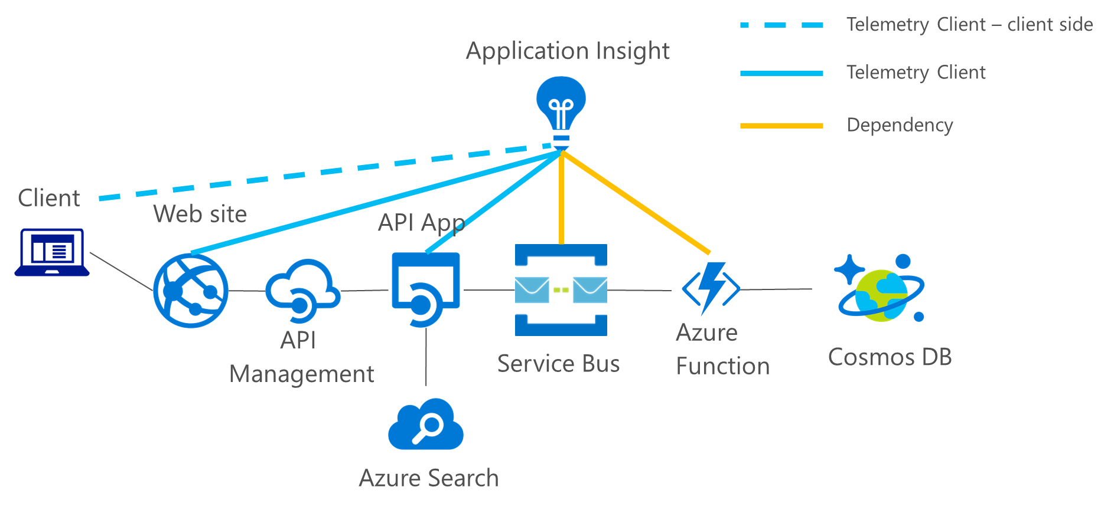

1. To enable the client side telemetry, go to Azure Application Insight “Getting started” Copy the script to _Layout.cshtml before </html>

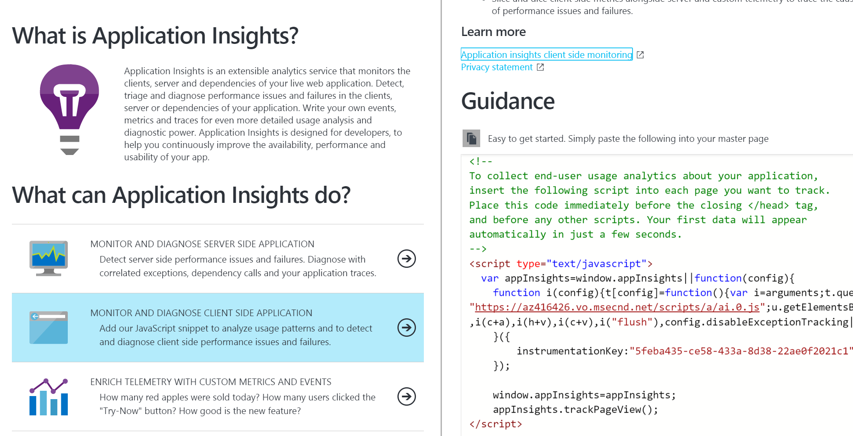

1. Publish the Web site with the updated java script to Azure. Surf around on the website and watch pageviews from client side appear in the Live Stream.
2. Add Application Insight for each operation in the java script to track the client side events. For example open Index.cshtml and add:

function Search() {

// track event

appInsights.trackEvent("Javascript Search called");

….

}

1. Publish the Web site with the updated java script to Azure. Surf around on the website and watch tracked events from client side appear in the “Search” section in Application Insight.

### Performance testing and profiling

Profiling is a way for Application Insight to get a deeper insight to your code and setup and point to possible points where the application seems to appear strange. <https://docs.microsoft.com/en-us/azure/application-insights/app-insights-profiler>

1. Add profiling to Web site, API and Azure Function. Open “Application Insight->Performance”. Then click on “Profiler”.

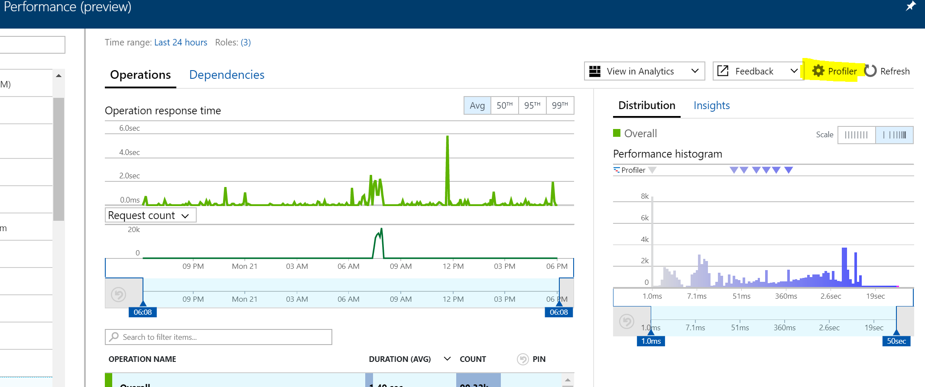

1. Add Website, API and Azure function to the profiler and make sure it’s running and green icon.

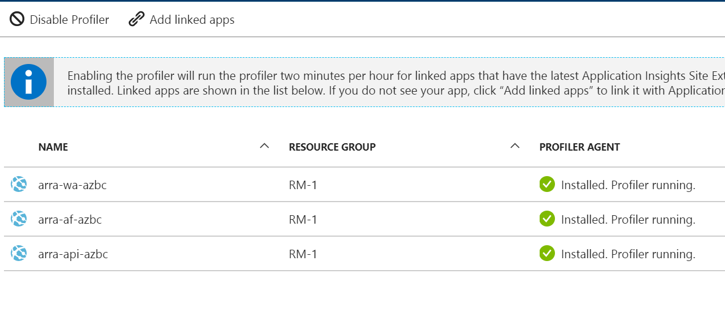

1. Open Visual Studio and add a “Web and Performance and Load Test Project”

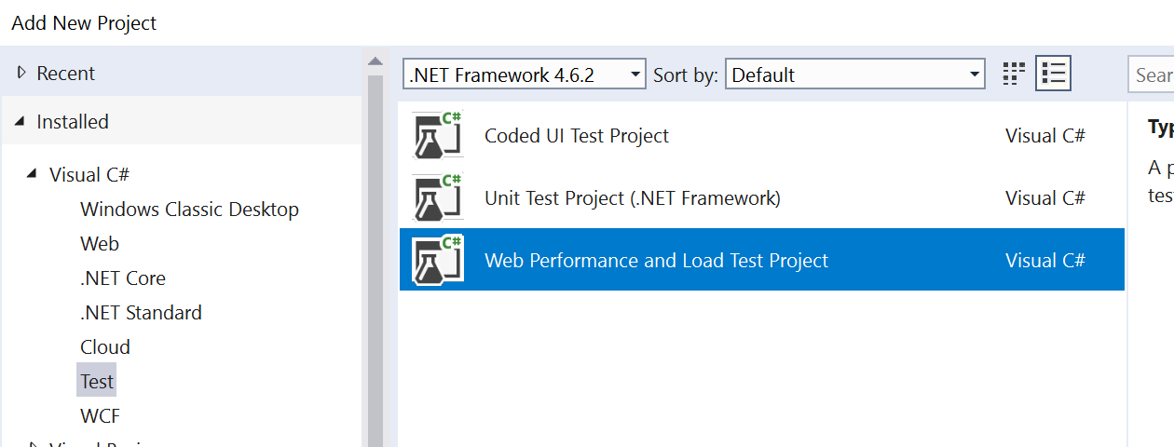

1. Click “Add Recording” and surf to the Website and make some 15-20 different operations from search and apply. Save the webtest when you are done.
2. Open “Application Insight->Performance Testing” and click “New”. Choose the same datacenter that your application resides in, user load 500 and 15 min and choose the Visual Studio Web test you just generated.

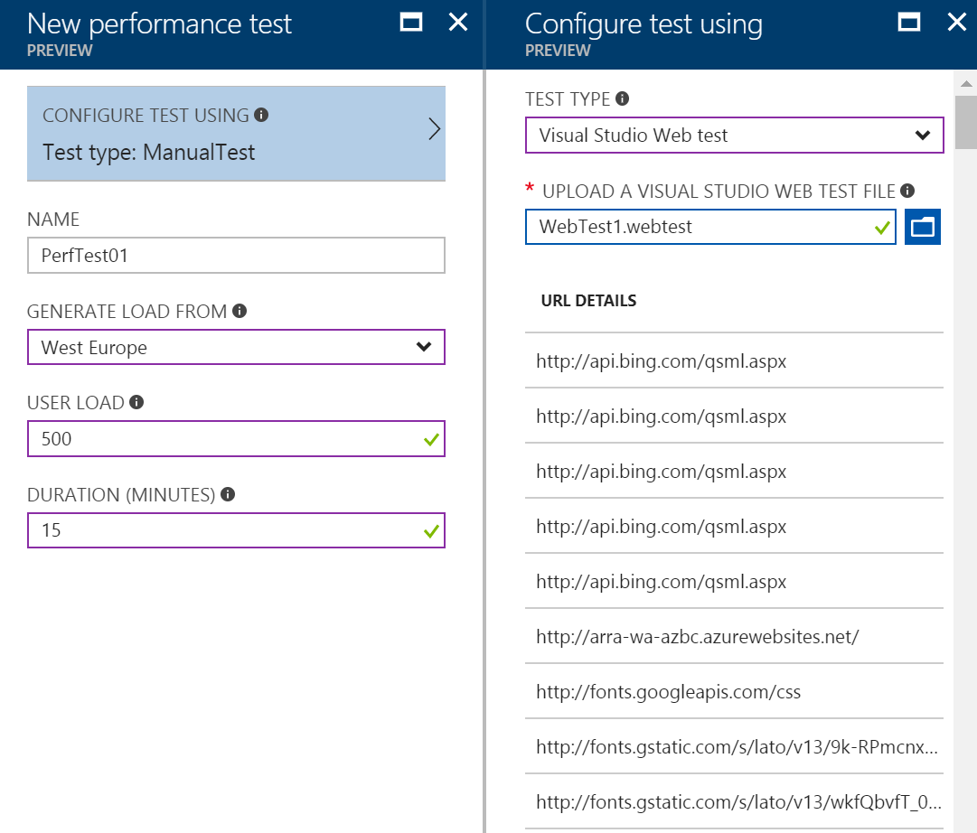

1. Run the test, go and get a coffee for some 15 min. 
2. Go to “Application Insight -> Performance” and watch the curves move. Click on “Operations” and “Dependencies” on the top of the page, it will show performance for your internal operations as well dependencies that Application Insight picks up for you.

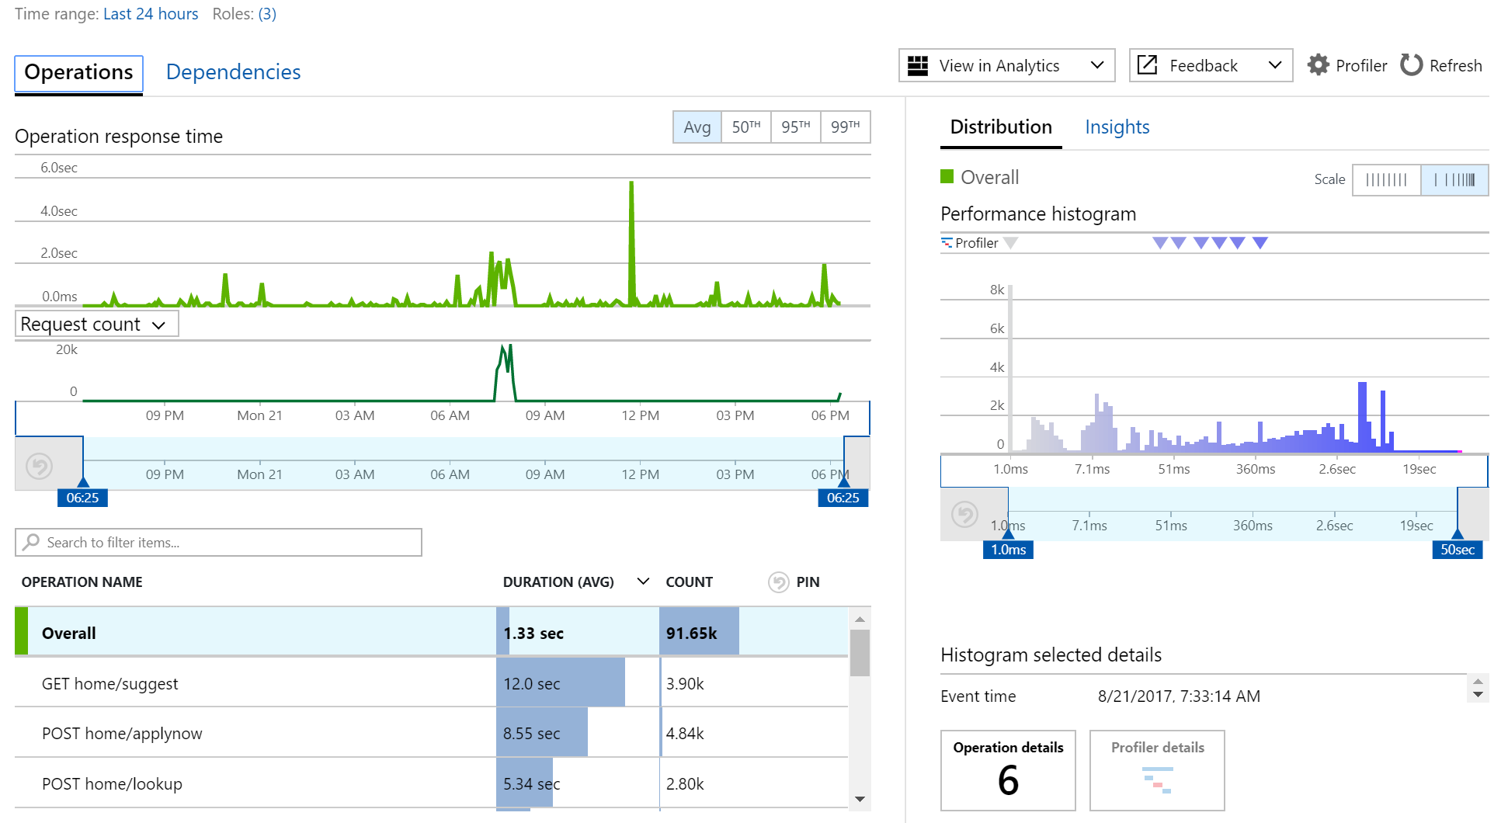

Compare the times of times spent in Operation and Dependencies by clicking on the respective link in the top. In the Dependencies you should see both Azure Search and API Management times spent in the execution. ***By clicking in the graphs, what would you say the application spend most of it’s time? Your code or dependencies? What would you do for scaling the application in the first step?***

***Discuss this in groups.***

1. Add caching in API-Management to the call that made up the most time.

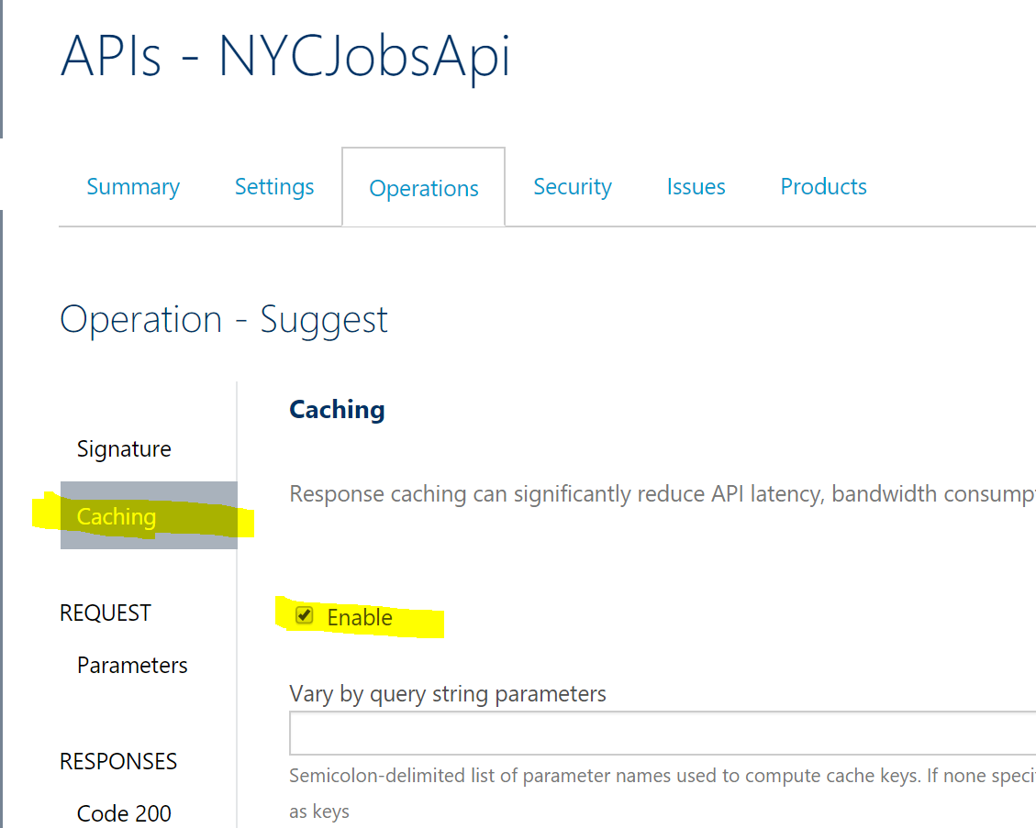

1. Re-run the test and check the response time for the method you added caching to. Consider pro’s and con’s of adding cache to services, when to add cache and when not to add a cache.
2. Open the to “Application Insight -> Performance” and select the method taking the most time. Click on the “Profiler details” in the right lower corner. This will open the profiler that has made profiling on your code during the performance testing.

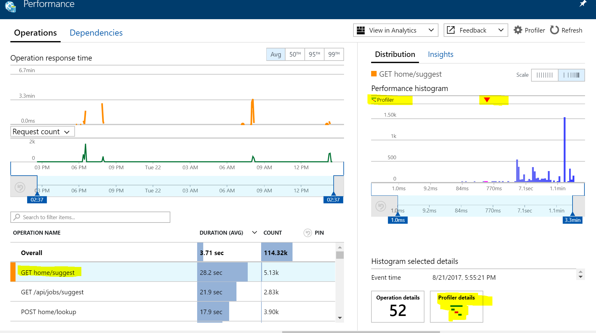

1. Try to figure out which method that is taking out the most time in the execution. You can even watch the dependencies time for execution as well.

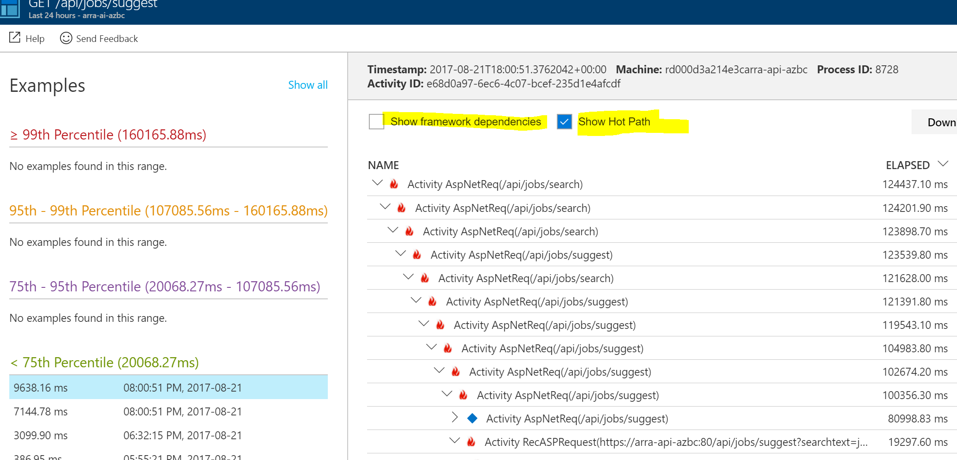

1. Extra Task: When you have identified which method that takes out most time in your code, try to find C# code in the Visual Studio solution that contains some suspicious code. Change the code and re-deploy.
2. Re-run the performance test of 500 users and 15 min and note the result. How did it affect your application?
3. Open the App Service plan. Compare CPU and Memory to HTTP Have a look at the HTTP Queue Length and Disk Queue for the App Service plan. To lower these values we need to scale up and out.
4. Raise the App Service plan to S3 instance by choosing the App service plan and choose “Scale Up”.
5. Then choose “Scale out” and set it to by 2 instances to maximum 3 instances by Autoscale when the HTTP Queue Length is greater than 100 as average and let it run for 10 min with cooldown of 5 min.

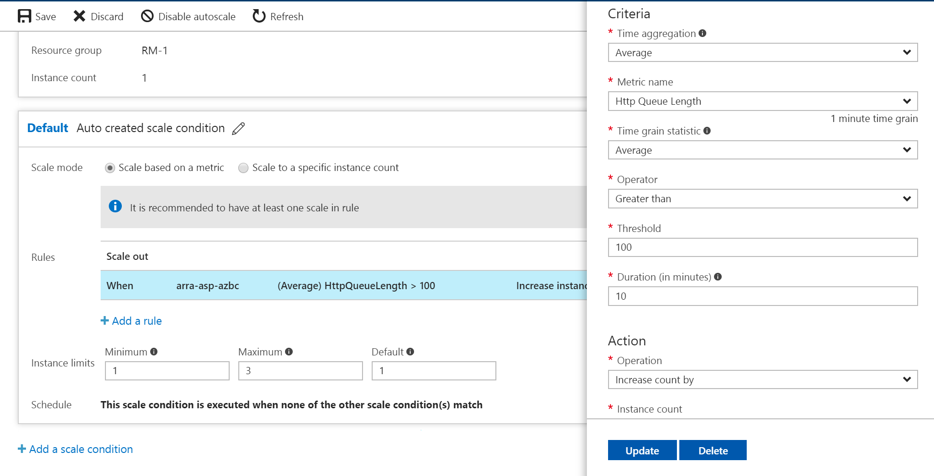

1. Re-run the test and watch the average return call time. Which Azure artifact is now the limit of your execution?

## Exercise 7: (advanced): Debugging in production - done

Azure websites offers the ability to debug you application while running in production. This is a dream come true for a lot of hardcore developers and a nightmare for hard core operations but it’s a killer feature for killing those bugs. This feature is part of Application Insight and is in preview but will be in General Availability later.

1. Install Snapshot debugger in Visual Studio 2017: <https://marketplace.visualstudio.com/items?itemName=SnapshotDebuggerTeam.MicrosoftSnapshotDebugger>
2. Inlcude the **Microsoft.ApplicationInsight.SnapshotCollector** nugetpackage to the NYCJobAPI project.
3. Review the default options that the package added to ApplicationInsight.config:

<TelemetryProcessors>

<Add Type="Microsoft.ApplicationInsights.SnapshotCollector.SnapshotCollectorTelemetryProcessor, Microsoft.ApplicationInsights.SnapshotCollector">

<!-- The default is true, but you can disable Snapshot Debugging by setting it to false -->

<IsEnabled>true</IsEnabled>

<!-- Snapshot Debugging is usually disabled in developer mode, but you can enable it by setting this to true. -->

<!-- DeveloperMode is a property on the active TelemetryChannel. -->

<IsEnabledInDeveloperMode>false</IsEnabledInDeveloperMode>

<!-- How many times we need to see an exception before we ask for snapshots. -->

<ThresholdForSnapshotting>5</ThresholdForSnapshotting>

<!-- The maximum number of examples we create for a single problem. -->

<MaximumSnapshotsRequired>3</MaximumSnapshotsRequired>

<!-- The maximum number of problems that we can be tracking at any time. -->

<MaximumCollectionPlanSize>50</MaximumCollectionPlanSize>

<!-- How often to reset problem counters. -->

<ProblemCounterResetInterval>06:00:00</ProblemCounterResetInterval>

<!-- The maximum number of snapshots allowed in one minute. -->

<SnapshotsPerMinuteLimit>2</SnapshotsPerMinuteLimit>

<!-- The maximum number of snapshots allowed per day. -->

<SnapshotsPerDayLimit>50</SnapshotsPerDayLimit>

</Add>

</TelemetryProcessors>

1. Snapshots are collected only on exceptions that are reported to Application Insights. In some cases (for example, older versions of the .NET platform), you might need to [configure exception collection](https://docs.microsoft.com/en-us/azure/application-insights/app-insights-asp-net-exceptions#exceptions) to see exceptions with snapshots in the portal like below:

try {

…

}

catch (Exception ex)

{

**telemetry.TrackException(ex);**

throw new HttpResponseException(new HttpResponseMessage(HttpStatusCode.InternalServerError)

{

Content = new StringContent(context.Exception.ToString()),

ReasonPhrase = ex.Message

});

}

#### Grant permissions

Owners of the Azure subscription can inspect snapshots. Other users must be granted permission by an owner.

To grant permission, assign the Application Insights Snapshot Debugger role to users who will inspect snapshots. This role can be assigned to individual users or groups by subscription owners for the target Application Insights resource or its resource group or subscription.

1. Open the Access Control (IAM) blade.
2. Click the +Add button.
3. Select Application Insights Snapshot Debugger from the Roles drop-down list.
4. Search for and enter a name for the user to add.
5. Click the Save button to add the user to the role.

#### Debug snapshots with Visual Studio 2017 Enterprise

1. Lets create a bug in our code, open NYCJobAPI project. Add the following awful code to your JobController.cs in the NYCJobAPI project:

// Code to showcase exception profile dump in production

int creatingDump = 0;

int dumpMe = 5 / creatingDump;

// Code to showcase exception profile dump in production

1. Publish the API and run the Search method in the API via the swagger interface: https://**<your_extension>**-api-azbc.azurewebsites.net/swagger/ui/index#!/Jobs/Search

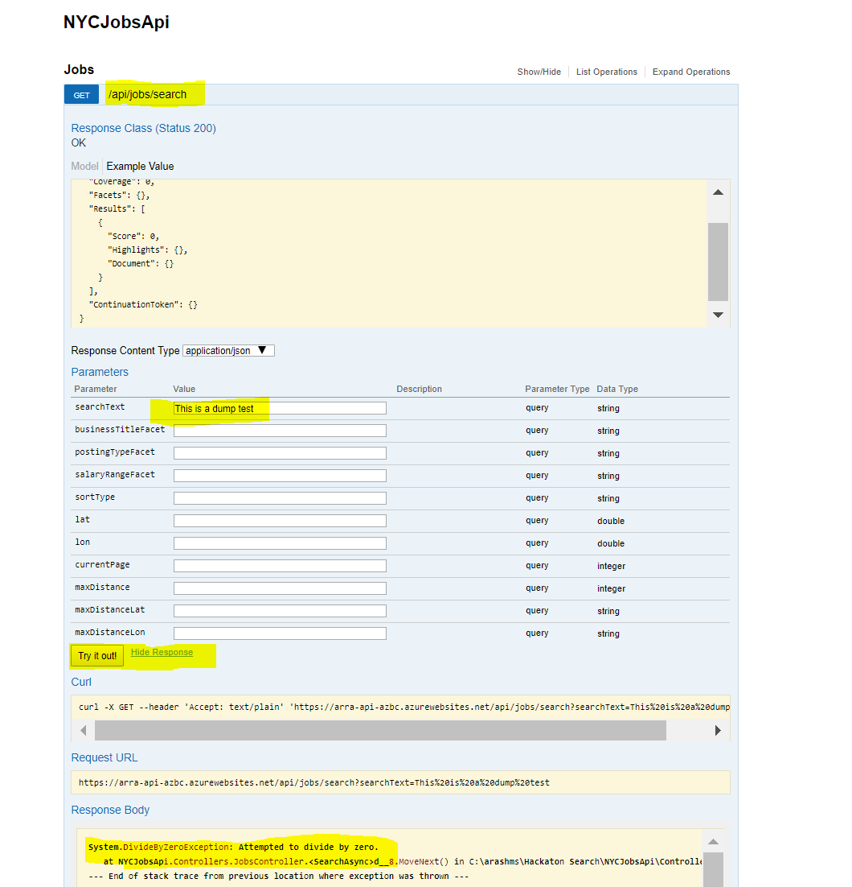

1. The method resulted in a Divide by zero exception. Go to Application Insight and look for only exceptions. Application Insight -> Search, then filter out to only see exceptions. Enter **ai.snapshot.id** in the Search field and you will get the record containing the dump. It takes some time for the dump to get created and displayed.

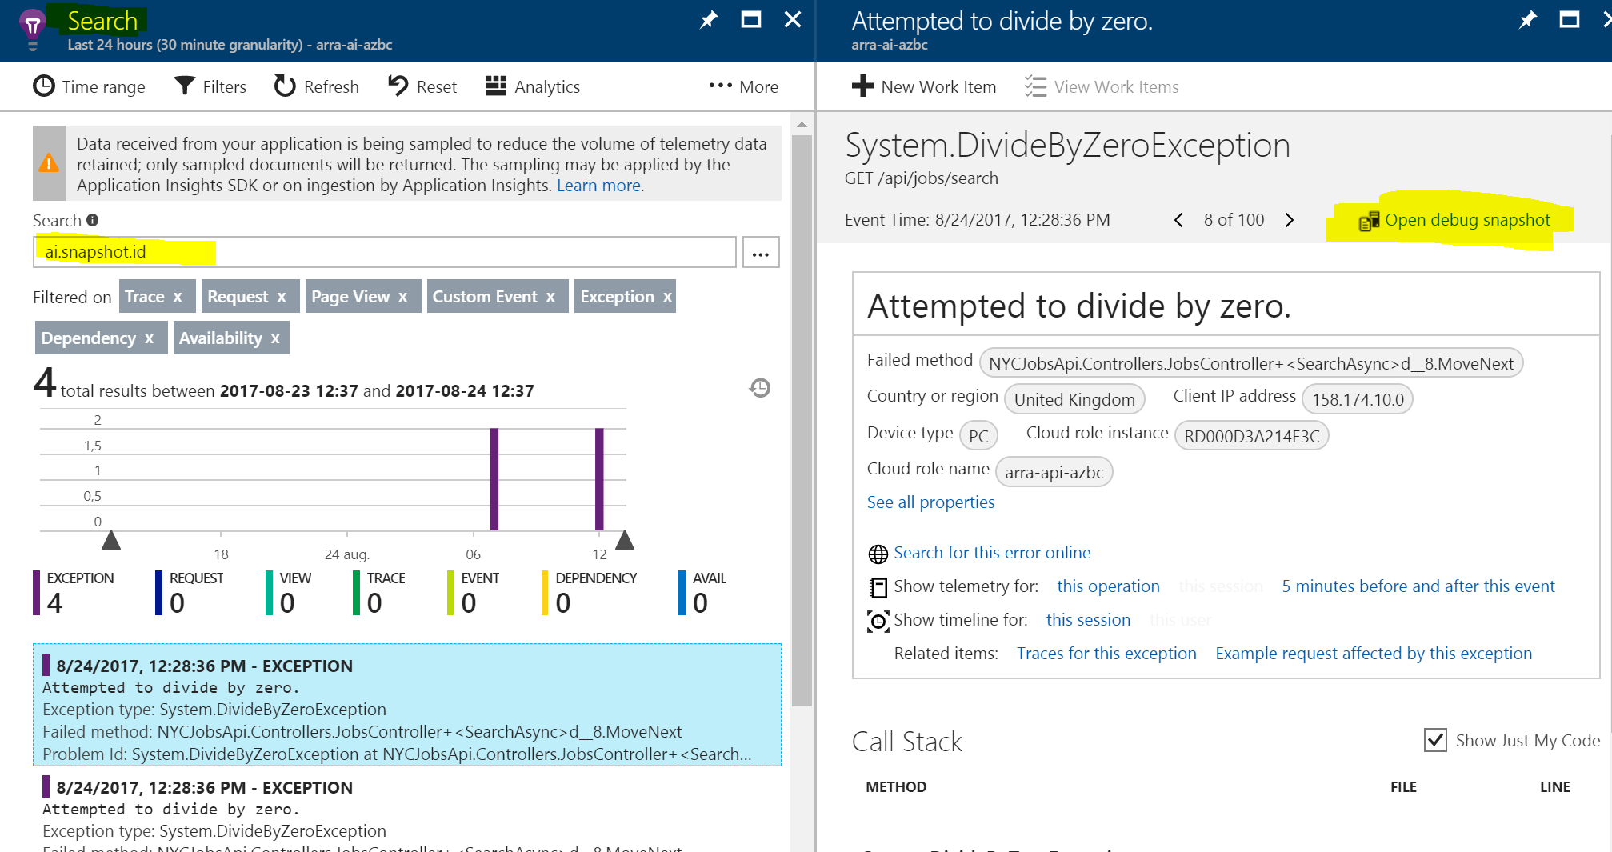

1. If you don’t see the dump open the Azure portal-> Your API -> Advanced Tools-> Go.

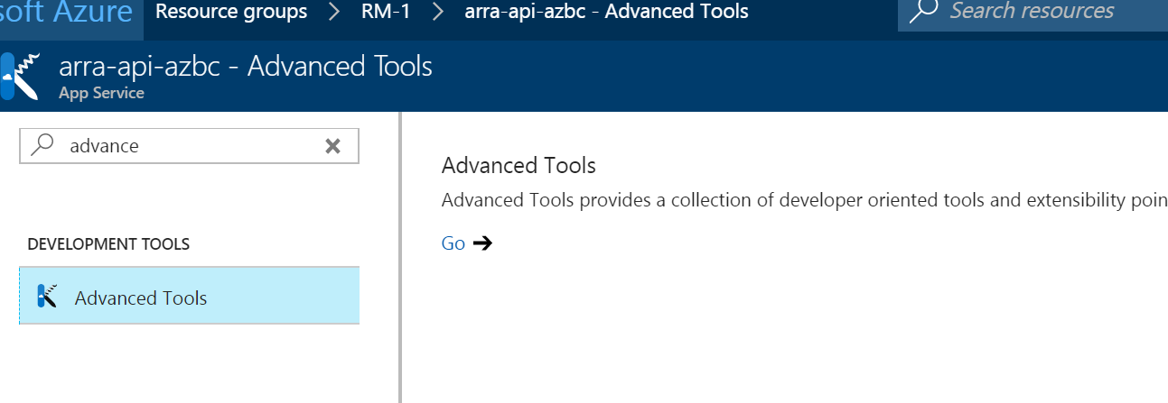

1. Select Debug Console -> CMD. Look into the folder “LogFiles”. There should be a logfile named “Uploader_*.log” with the timestamp of the exception. If not, wait 10 min.

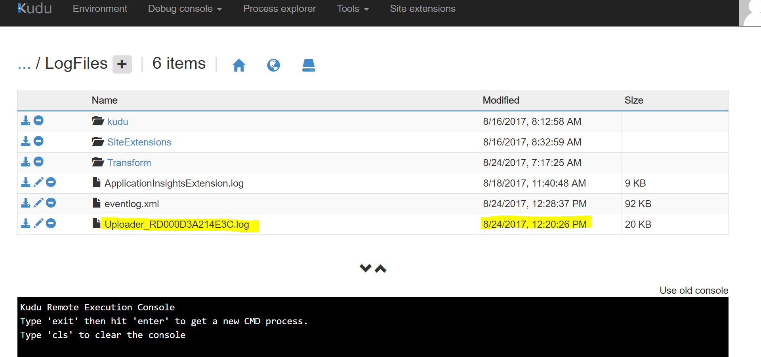

1. Click on “Open debug snapshot” in the Search window.
2. Then click on the “Download snapshot” button to download the dump and open in Visual Studio.

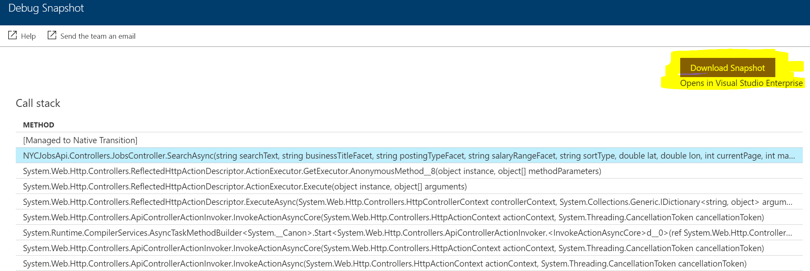

1. Open the “**\*.diagsession**” file in Visual Studio 2017 Enterprise with the Snapshot debugger installed (done in previous steps).
2. Click on “Debug with Managed Code Only”
3. Now you are able to see all variables and callstack when the exception occurred 😊
4. 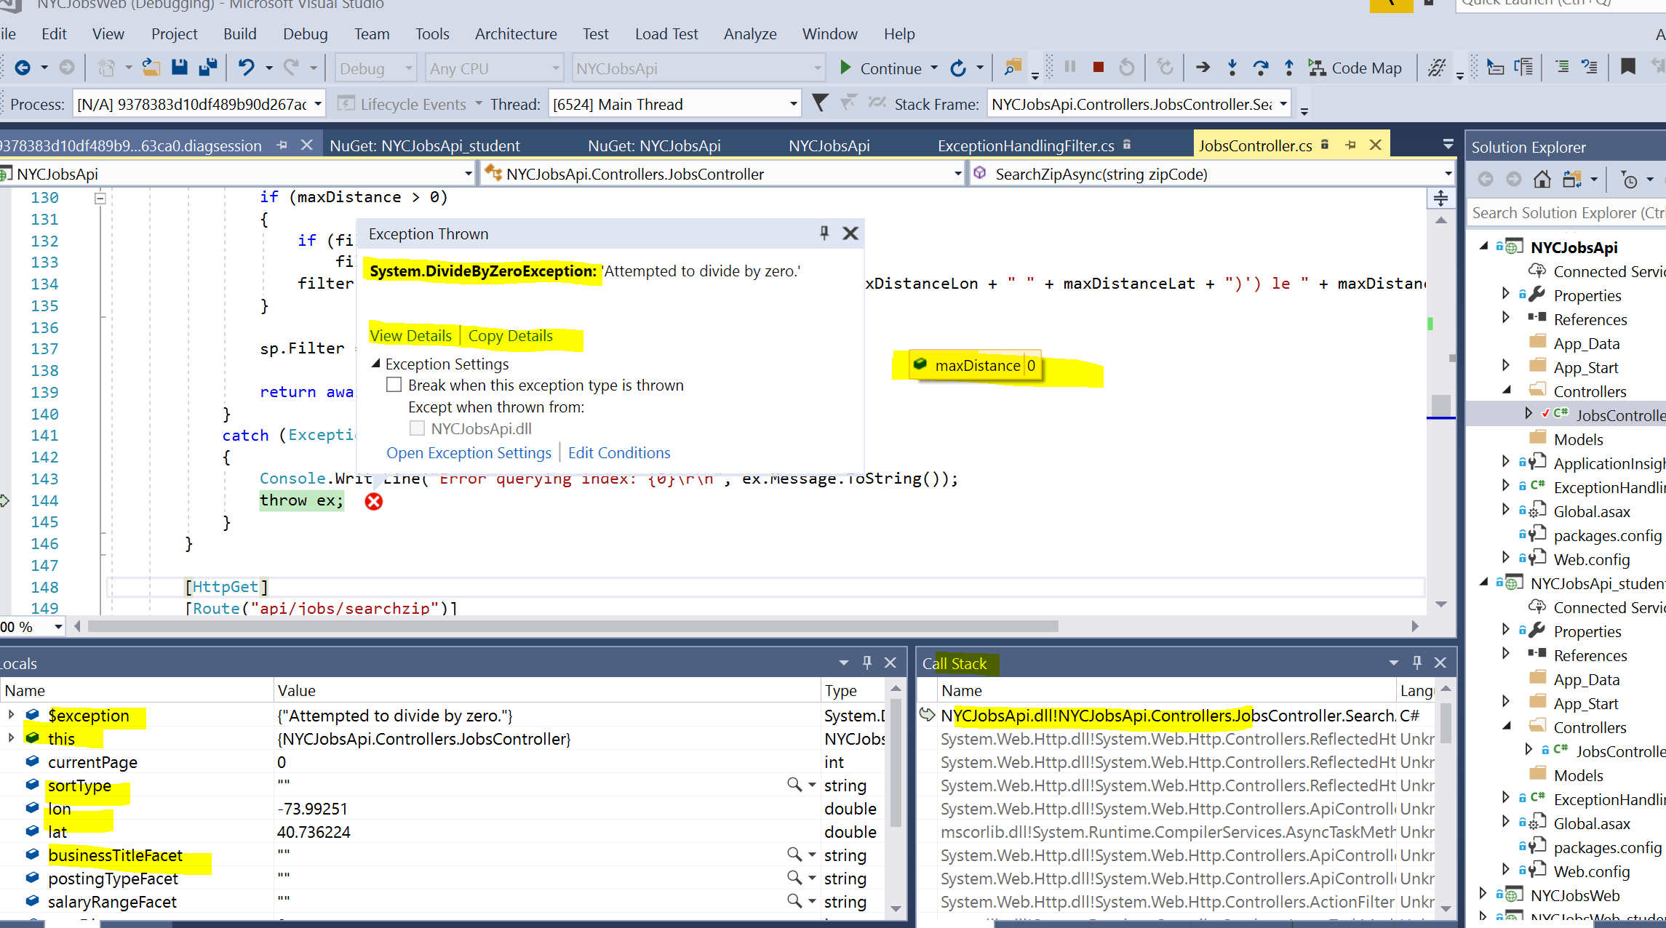

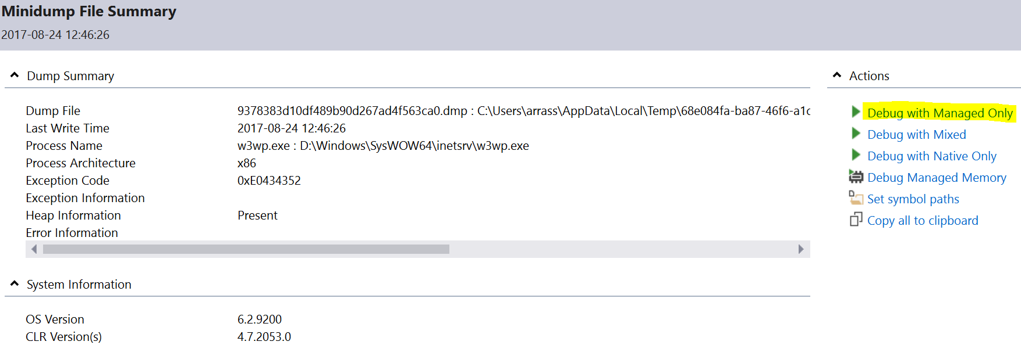

1. **You are done!**

mission accomplished